**FUNDAMENTAL STUDY ON VR SYSTEM FOR SECURING AND DEVELOPING SUCCESSORS IN MOUNTAIN TUNNEL CONSTRUCTION**

Y. Okazaki*,a, D. Ajikia, H. Hayashib, N. Hirosea and M. Ohyaa

a Department of Civil and Environmental Engineering, National Institute of Technology,

Matsue College, Matsue, Japan

b Integrated System Engineering Department, Faculty of Engineering,

Nishinippon Institute of Technology, Miyako, Japan

*E-Mail : okazaki@matsue-ct.jp

**Abstract**

**In recent years, the aging of workers and the decrease in young human resources have progressed in the Japanese construction industry. Therefore, the lack of future successors has become a serious problem. In particular, it is difficult to secure successors in the Japanese tunnel industry due to the low recognition among young human resources and civil engineering students. Under the circumstances, it is necessary to have young people and civil engineering students recognize and understand about the tunnel industry in order to properly construct and maintain tunnels and hand down the technology to the next generation. And, it is essential to develop tools that support the early success of young successors and promote their retention in the tunnel industry. In order to solve such problems, simulated experience tools that utilize Cross Reality (XR) technology have been widely used in the construction industry. For example, in the Japan's tunnel industry as well, several VR tools have been developed for the purpose of safety education and saving labor during tunnel construction. However, the tools have not been sufficiently developed for the purpose of securing successors in the tunnel industry and supporting their early success. Therefore, in this study, a basic Virtual Reality (VR) system that can simulate the situation (Especially, during tunnel face observation) during mountain tunnel construction was developed by using three dimensional (3D) model created based on photogrammetry and the Unity of game engine. And, in order to confirm usefulness of the developed VR system, a total of 18 male and female students (14 civil engineering students and 4 non-civil engineering students) from National Institute of Technology, Matsue College experienced this VR system and conducted questionnaire surveys. As a result, it was clear that it was useful for enhancing recognition of the tunnel industry and initial education for young human resources by utilizing this VR system.**

**Keywords:** *mountain tunnel construction, education, VR, unity, questionnaire survey*

**Introduction**

In recent years, the aging of workers and the decrease in young human resources have progressed in the Japanese construction industry. Therefore, the lack of future successors has become a serious problem. In particular, it is difficult to secure successors in the Japanese tunnel industry due to the low recognition among young human resources and civil engineering students. Under the circumstances, it is necessary to have young people and civil engineering students recognize and understand about the tunnel industry in order to properly construct and maintain tunnels and hand down the technology to the next generation. And, it is essential to develop tools that support the early success of young successors and promote their retention in the tunnel industry.

Simulated experience tools that utilize the Cross Reality (XR) technology is one of the tools that can solve these problems. In recent years, this technology has been widely used in the construction industry. For example, the tools for architecture visualization and design education and for construction safety education have been developed by utilizing the virtual reality (VR) technology (Wang et al., 2018). In Japan, several VR tools have been suggested for the purpose of education and labor saving of bridge inspection (e.g., Baba et al., 2019; Saito et al., 2021). In the Japan's tunnel industry as well, although several VR tools have been developed for the purpose of safety education and saving labor during tunnel construction, the tools have not been sufficiently developed for the purpose of securing successors and supporting their early success.

Therefore, in this study, a basic Virtual Reality (VR) system that can simulate the situation (Especially, during tunnel face observation) during mountain tunnel construction was developed by using three dimensional (3D) model created based on photogrammetry and the Unity of game engine. And, questionnaire surveys targeting students was conducted in order to confirm the usefulness of this VR system.

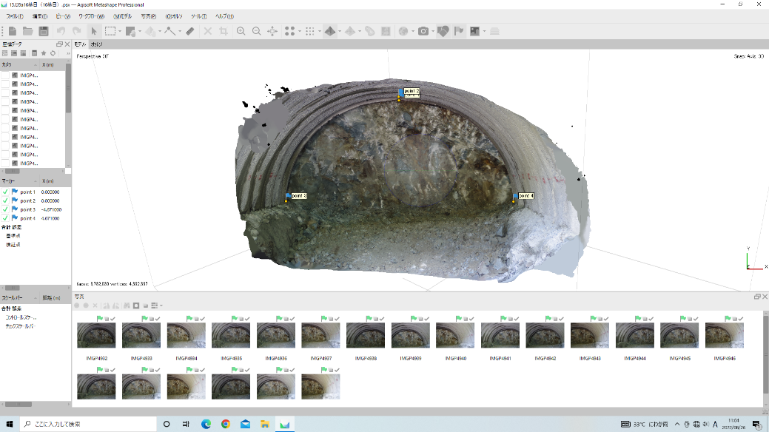

Photo 1 The 3D model around the tunnel face generated by Agisoft Metashape.

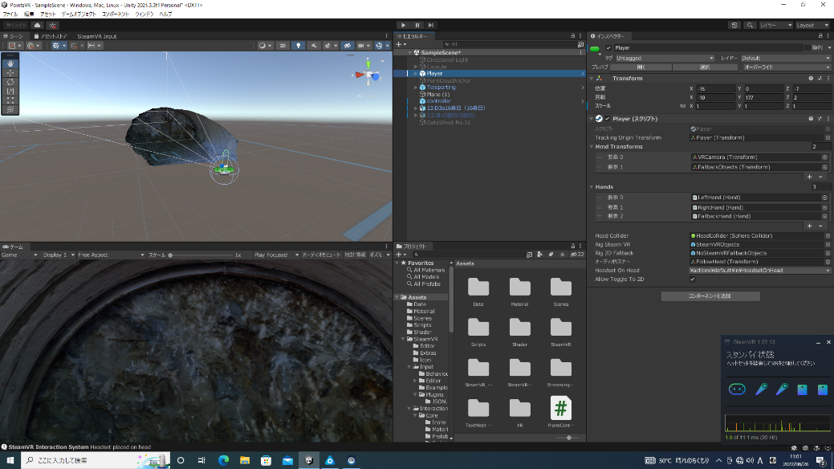

Photo 2 The 3D model around the tunnel face imported into the VR space of Unity.

**Building Methods and Contents of VR System**

VR system of this study was built by focusing on the tunnel face during mountain tunnel construction. The tunnel face is the tip part of tunnel excavation that requires regular observation for safe construction of mountain tunnels. Non construction workers can seldom experience its observation. The building procedure of VR system is as follows.

First, a 3D model (OBJ format) around the tunnel face was generated using Agisoft Metashape for photographic images of the tunnel face in mountain tunnel (see Photo 1). Agisoft Metashape is software that can generate various 3D models after automatically combining the photographic images by distinguishing the color tone and gradation of each pixel of them.

Then, the generated 3D model was imported into a VR space created by the game engine Unity from Unity Technologies (see Photo 2). Finally, various functions such as the teleport function were implemented in the VR space. Thus, visualization of the built VR system was performed by HTC Vive Cosmos Elite, which is VR-HMD (Head Mounted Display) from HTC shown in Photo 3. Table 1 shows the detail of a hardware and names of all software used to perform this VR system.

The detail of implemented functions is as follows. First, the teleport function was implemented so that the user of this VR system could move freely and smoothly in the VR space. And, the pointer function was also implemented so that the user could point out the position of cracks and geological change on the tunnel face in the VR space (see Photo 4). Then, the function that cracks were colored (i.e. the function that the correct/wrong

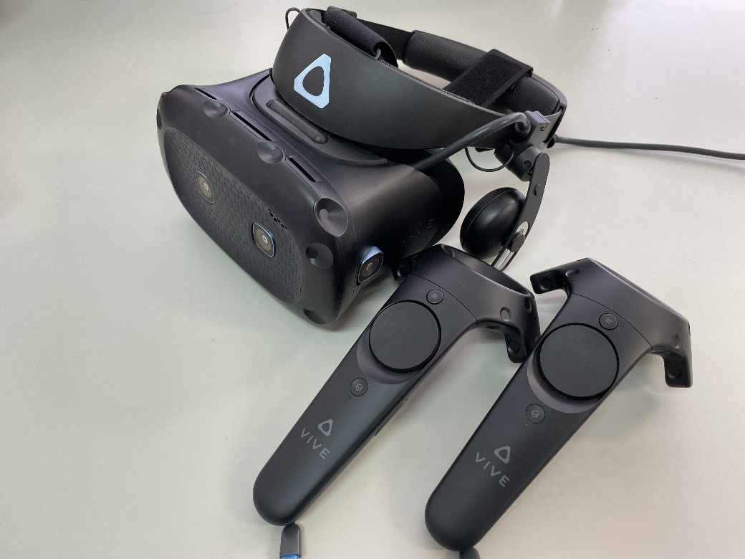

Photo 3 VR-HMD HTC Vive Cosmos Elite.

Table 1 Hardware and software used in the VR system.

|  |  |
| --- | --- |
| Hardware | OS：Windows 10 Pro  CPU：Intel(R) Core(TM) i9-12900KF  RAM：128GB  Disk space：465GB  GPU：NVIDIA GeForce GTX 1650 |
| Software | ・Unity  ・Microsoft Visual Studio C#  ・SteamVR  ・SteamVR Plugin  ・Agisoft Metashape Professinal |

Photo 4 VR system user's viewpoint when using the pointer function.

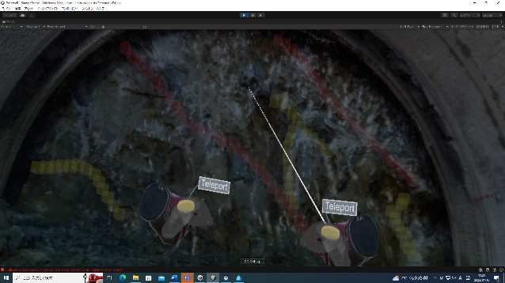

Photo 5 VR system user's viewpoint after the cracks were colored.

judgment of position of cracks was outputted) was implemented when the user pulled the trigger of controller while pointing the pointer function at the



Figure 1 An example of tunnel face sketch in the tunnel face observation data sheet

position of cracks determined by experienced engineers (see Photo 5). In addition, the tunnel face observation data sheet (PNG format) evaluated by experienced engineers was also introduced as a reference for users to observe the tunnel face and evaluate ground conditions in the VR space (see left side of Photo 4). Fig. 1 shows the tunnel face sketch part of the tunnel face observation data sheet in Photo 4.

**Results and Discussion of Questionnaire Survey**

In order to confirm usefulness of the built VR system, a total of 18 male and female students (14 civil engineering students and 4 non-civil engineering students) from National Institute of Technology, Matsue College experienced the VR system and conducted questionnaire surveys. Photo 6 shows an example of scene experiencing the VR system. Table 1 shows each item and choice of the questionnaire. Each item of the questionnaire was created to confirm the experience in mountain tunnel construction of experienced person of the VR system (item (a)), the visibility of the VR system (item (b)~(d)), and the usefulness for developing young engineers (item (e)). At the end of the questionnaire, other opinions such as impressions and improvements were invited by providing an additional comment column.

Figure 2 shows the results of obtained questionnaire survey. It can be confirmed from Figure 2(a) that most of the students experienced the VR system have never stood in front of a tunnel face without shotcrete. In addition, it is clear from Figure 2(b)(c) that it is possible to moderately visualize cracks and rock types similar to the tunnel face observation data sheet evaluated by experienced engineers in the built VR system. From these results, it seems that even inexperienced persons in mountain tunnel construction can easily simulate the situation during tunnel face observation by utilizing this VR system. Therefore, it is considered that it can contribute to enhancing of recognition about the tunnel industry by having young people and civil engineering students experience this VR system more.

On the other hand, it is obvious from Figure 2(d) that it is difficult to visualize spring water similar to that in the tunnel face observation data sheet in this VR system. This may be improved by raising resolution of the 3D model. However, there is a possibility that it is not

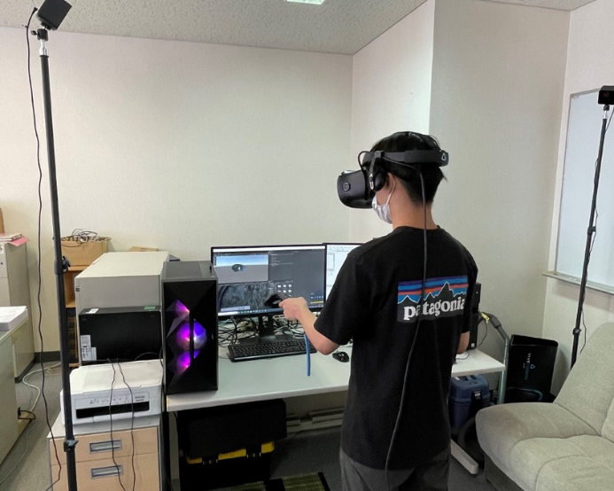

Photo 6 The example of scene experiencing the VR system.

Table 1 Each item and choice of the questionnaire.

|  |  |
| --- | --- |
| (a) | Q : Have you ever stood in front of a tunnel face without shotcrete?  A : (1) Yes (2) No |
| (b) | Q : Was it possible to confirm cracks in the VR space similar to those in the tunnel face observation data sheet evaluated by experienced engineers?  A : (1) Extremely confirmed  (2) Moderately confirmed  (3) Neither  (4) Not very confirmed  (5) Not at all confirmed |
| (c) | Q : Was it possible to confirm rock types in the VR space similar to those in the tunnel face observation data sheet evaluated by experienced engineers?  A : (1) Extremely confirmed  (2) Moderately confirmed  (3) Neither  (4) Not very confirmed  (5) Not at all confirmed |
| (d) | Q : Was it possible to confirm spring water in the VR space similar to that in the tunnel face observation data sheet evaluated by experienced engineers?  A : (1) Extremely confirmed  (2) Moderately confirmed  (3) Neither  (4) Not very confirmed  (5) Not at all confirmed |
| (e) | Q : Did you think that the function that the correct/wrong judgment of position of cracks was outputted was useful for initial education of tunnel face observation?  A : (1) Agree  (2) Moderately agree  (3) Neither  (4) Not very agree  (5) Disagree |

suitable for visualizing by VR because there are cases like seepage in the spring water on the tunnel face. In



(a) Have you ever stood in front of a tunnel face without shotcrete?



(b) Was it possible to confirm cracks in the VR space similar to those in the tunnel face observation data sheet evaluated by experienced engineers?



(c) Was it possible to confirm rock types in the VR space similar to those in the tunnel face observation data sheet evaluated by experienced engineers?



(d) Was it possible to confirm spring water in the VR space similar to that in the tunnel face observation data sheet evaluated by experienced engineers?



(e) Did you think that the function that the correct/wrong judgment of position of cracks was outputted was useful for initial education of tunnel face observation?

Figure 2 The Results of questionnaire survey (n = 18)

addition, there were opinions from the additional comment column that it was difficult to see characters on the tunnel face observation data sheet and to understand described section of rock types on it. Although there are some problems as described above, it was clear from Figure 2(e) that the function that the correct/wrong judgment of position of cracks was outputted was useful for initial education of tunnel face observation for young human resources.

**Conclusions**

In this study, the basic VR system that can simulate the situation during tunnel face observation in mountain tunnel construction was developed by using 3D model created based on photogrammetry and the Unity of game engine. And, questionnaire surveys targeting students was conducted in order to confirm the usefulness of this VR system. As a result, it was clear that it was useful for enhancing recognition of the tunnel industry and initial education for young human resources by utilizing this VR system.

In future, this VR system will be enhanced by improving the resolution of 3D model and conducting questionnaire surveys for experienced tunnel engineers.

**Acknowledgements**

I would like to thank Shimane Prefectural Government for providing photographic images of tunnel face.

**References**

Baba, Y., Tanikawa, S., Emoto, H., Nakamura, H. & Kawamura, K. (2019). Development of the bridge inspection education system using MR head mounted display. *Journal of Japan Society of Civil Engineers, ser. F3 Civil Engineering informatics*, 75(2), II_34-II_42. (in Japanese)

Saito, S., Fujiu, M. & Hukuoka, T. (2021). Examination of the possibility of bridge inspection in a 4D environment using AI and VR technology. *Journal of Artificial Intelligence and Data Science*, 2(J2), 362-369. (in Japanese)

Wang, P., Wu, P., Wang, J., Chi, H.L. & Wang, X. (2018). A critical review of the use of virtual reality in construction engineering education and training. *International Journal of Environmental Research and Public Health*, 15(6), 1204.