**Enhanced Learning Performance and Learning Experience in Differential Equations using Adaptive Learning Technology**

Cheng Sheau Chin*,a, and Dr Kong Wai Mingb

a Nanyang Polytechnic/School of Engineering, Smart Connected Solutions Centre, Singapore

b Nanyang Polytechnic/ School of Engineering, Biomedical Engineering & Materials Group, Singapore

* cheng_sheau_chin@nyp.edu.sg

**Abstract**

**Classrooms today have learners with diverse learning preferences and backgrounds, making the traditional teaching methods inadequate. These methods disregard individual learning styles, pace, and strengths, causing some learners to fall behind or lose interest. To effectively support learning, personalized and inclusive teaching strategies are crucial. Adaptive learning personalizes education by providing tailored content, targeted focus on specific areas and frequent practice, resulting in immediate feedback, leading to improved learning outcomes.**

**In this study, we used the adaptive learning process in Brightspace AI suite to design lessons on two topics related to Differential Equations for 86 learners from the Diploma in Electronic & Computer Engineering at Nanyang Polytechnic in Singapore. The adaptive system adjusted the content to each learner's strengths and weaknesses, providing personalized questions for practice and assessment. Learners were able to track their progress and identify areas for improvement. If learners answered a question incorrectly, the adaptive system provides the correct answer and suggests additional reading materials for learners to gain better understanding.**

**Learners’ performance in the two topics and their learning experience were evaluated through pre- and post-tests and a survey. The results showed a significant improvement in learners’ performance and many positive intangible benefits, such as an improved confidence level in solving mathematical problems and more efficient use of time in learning. This paper presents findings and recommendations for implementing adaptive learning in education.**

**Keywords:** adaptive learning,digital transformation in engineering education, personalised learning plan, self-learning

**Introduction**

A review of the literature shows learning as a class is not always ideal and effective because each learner has different learning pace and needs (Kaminskiene & DeUrraza, 2020). Our learners at the School of Engineering, Nanyang Polytechnic, come from diverse educational backgrounds, including GCE ‘O’ and ‘A’ level holders, Institute of Technical Education (ITE) graduates, Integrated Programmed (IP) students, and adult learners from the industry. Teaching at the right pace is challenging due to the diversity of learners in our classes. With an average class size of twenty-two learners per teacher, it can be difficult to give individual attention to each learner (Ministry of Education, 2020). Structured curriculum and lesson time also limits learners’ ability to reflect, internalise, and apply their learning (Kapp, 2016). There is an increasing demand for a more innovative and effective approach using technology to address diversity in the classroom, to meet learning expectations and improve learning outcomes.

Adaptive learning is an approach that utilizes technology or systems to monitor learner progress and use data to modify teaching content based on individual learner behaviour and needs (Becker et al., 2018). This approach aims to provide a personalized learning experience for each learner, which is tailored to their unique needs, abilities, and learning styles. To achieve this, real-time assessment, data analysis, and machine learning techniques are used to continuously adjust the learning path based on ongoing feedback from the learner (Baker, 2012). AI-driven assessments are particularly useful in providing feedback on learner performance and progress (Chassignol et al., 2018). Based on the ‘report card’, the adaptive learning tool generates personalised study paths for the learners, recommending the most relevant materials to bridge gaps in knowledge and focus on areas where they need improvement. Brightspace LeaP is an adaptive learning technology that allows instructors to personalize learning for each learner by creating a knowledge map that outlines adaptive pathways (Schaffhauser, 2014). This adaptive feature is made possible by AI analytics that monitor learner progress and automatically adjust the learning path based on their results. This personalized approach can help learners achieve better outcomes and improve their overall learning experience. However, this technology is relatively new to the polytechnic educators and more research is needed to fully understand its impact.

**Approach and Implementation**

Nanyang Polytechnic adopted the Brightspace Learning Management System in April 2022. Brightspace suites come with intelligent agents that allow the instructor to provide personalized learning paths for learners.

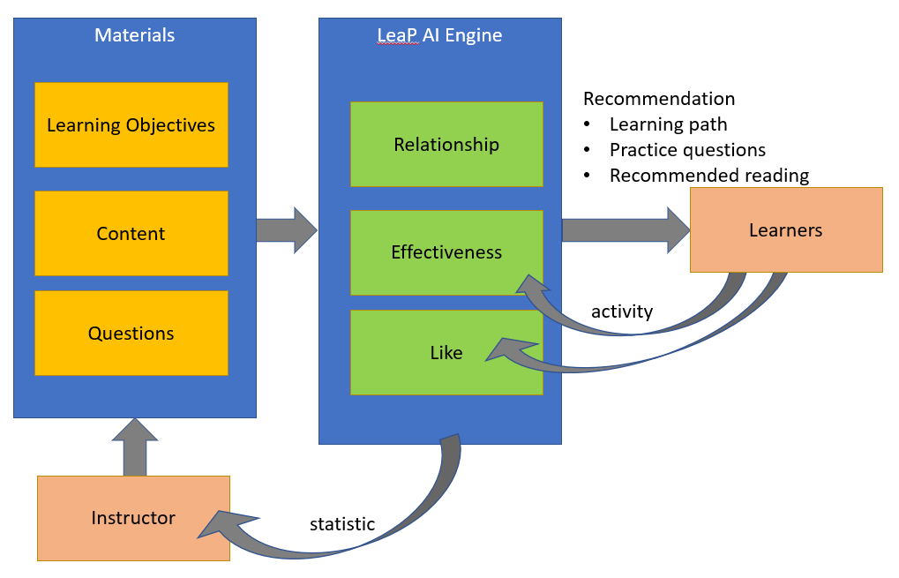

Figure 1 Adaptive Learning AI

The approach to develop the adaptive learning using Brightspace is as follows:

1. The instructor is to define the learning objectives to track the knowledge that learners acquire in the learning.

Table 1 Define Learning Objectives

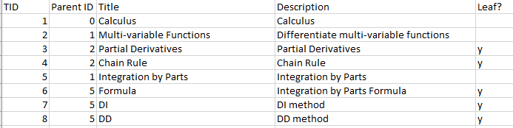

2. Using Brightspace’s AI suite, the adaptive learning engine maps the content materials and questions in the question bank to the learning objectives semantically. (see Figure 2)

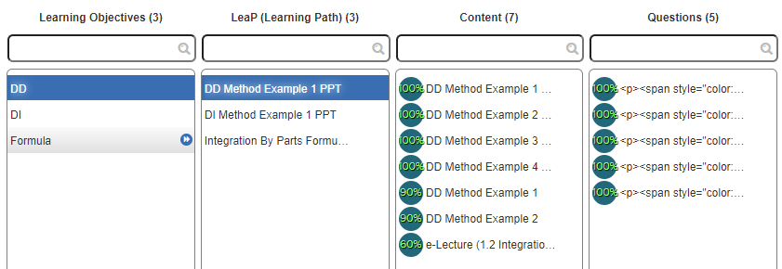

Figure 2 Automatic mapping of content and questions to learning objectives using AI

3. Learners are required to take a diagnostic test when they first launch the adaptive learning program. Based on the diagnostic test results, the AI filters out content related to learning objectives that a learner has already demonstrated knowledge of, so that the learner only needs to focus on what he does not know specifically.

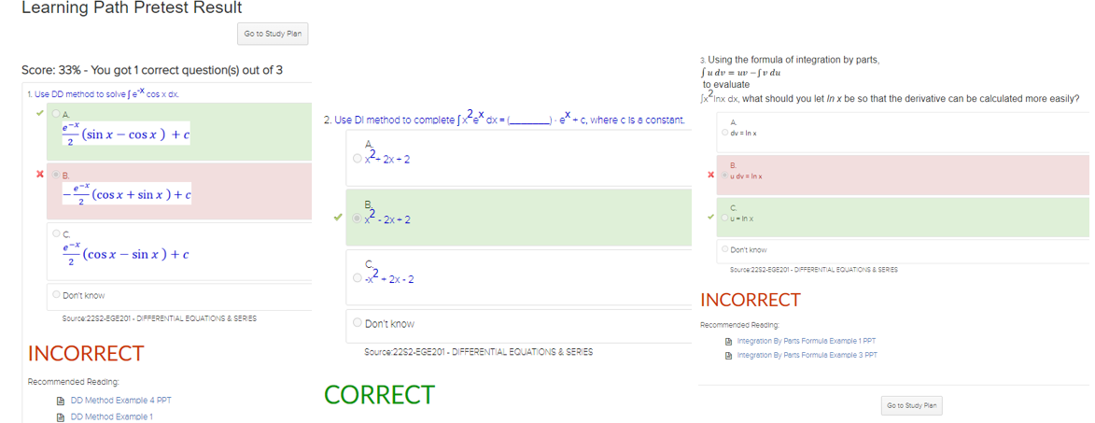

Figure 3 Diagnostic test

4. The adaptive engine generates personalised learning plan (learning path) for each learner based on the success rate of learners answering the test questions. It suggests recommended study materials based on relevance to the learning objectives, effectiveness in helping the learner answer questions correctly, and the number of "likes" awarded by other learners.

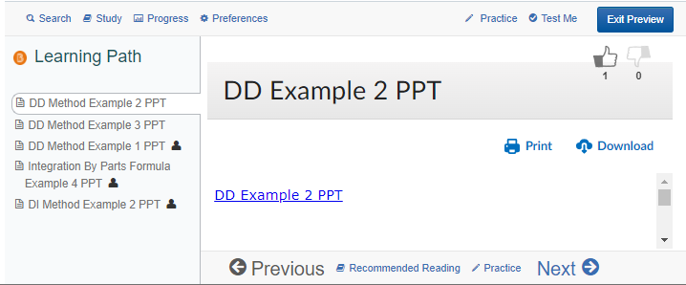

Figure 4 Personalised Learning Plan

5. Learners have the option to access additional recommended readings and practice questions to further improve their understanding. The "learning-testing-reinforcing" cycles guide the learner towards mastery of the material.

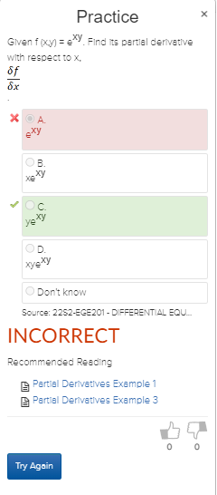

Figure 5 Practice Questions

**Participants**

This study involved 86 second-year learners, aged 18 to 25, from the Diploma in Electronic & Computer Engineering (DECE). The average class size was 22, with 7% of the participants repeating the module and 6% having special learning needs. The learners' GPA ranged from 0.74 to 3.91, representing a diverse range of academic abilities.

**Methodology**

The research design for this study was a pre-post test within group design, which was suitable for evaluating the impact of an intervention using adaptive learning tool on a dependent variable (learners’ performance). The study encompassed two topics in the Engineering Mathematics module: Differential Equations and Series. The control group in this study consists of learners who attended the same lecturer and tutorials but did not use the adaptive learning tool. The learners attended lectures and tutorials, followed by a pre-test on the topic covered. They used lecture notes and tutorial materials to study for the test. Subsequently, the experimental group, which consists of the same group of learners, was introduced to the adaptive learning tool and given a week to use it to improve their understanding. After a week, a post-test was administered to assess their performance. This process was repeated for the second topic to observe any differences in results. At the end of the study, learners completed a survey to assess their learning experience.

**Results and Discussion**

The data revealed that adaptive learning improves learning outcomes. Average scores increased by 16%, passing rate by 20%, and a higher number of learners scored grade B and above. This shows that adaptive learning leads to better performance for learners.

Based on the data captured, we found a more significant improvement among learners who scored less than 50% in the pre-test. Their scores improved by an average of 35.4%. Adaptive learning reduces the performance gap between the low and high performers by helping the learners to progress towards mastery.

T-tests revealed a significant difference between pre-test and post-test performance for both topics. For topic 1, the t-value was 3.12 which gave a p-value of 0.0011; For topic 2, the t-value was 3.10 which gave a p-value of 0.0012; A p-value of less than 0.05 is customarily deemed as statistically significant. Therefore, the results demonstrate an overall significant difference between the pre-test and post-test. The outcomes are consistent for both topics. This indicates adaptive learning is effective in improving learners’ performance.

Table 2 Data analysis (T-test)

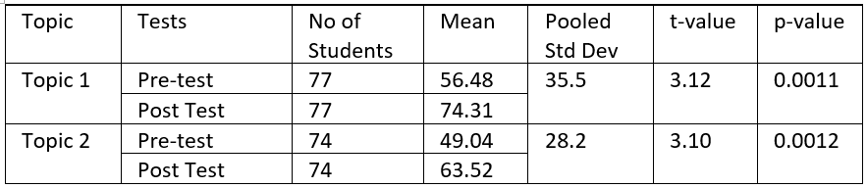

The survey showed that learners had a positive experience with adaptive learning, finding it useful and easy to use. Over 95% agreed personalised learning helps them understand concepts and apply them. They feel that this approach makes learning simpler, easier to understand and more appealing. The learners appreciate the immediate feedback that the adaptive tool provides, which helps them identify their knowledge gaps and reinforce their learning independently. Additionally, the ability to focus on the most effective material for each learner per learning objective allows them to clarify any uncertainty and build their confidence in their understanding of the material. As a result, the learners felt more confident and motivated to keep on their learning journey. More than 80% of the learners preferred individualised learning paths and focused remediation over the traditional one-size-fits-all approach. Despite the limited scope of this study, which only piloted two topics, the learners involved expressed a desire for adaptive learning to be extended to cover more topics. This feedback suggests that adaptive learning can be a valuable and effective tool for enhancing the learning experience. The results of this research provide evidence that supports the use of adaptive learning in education.

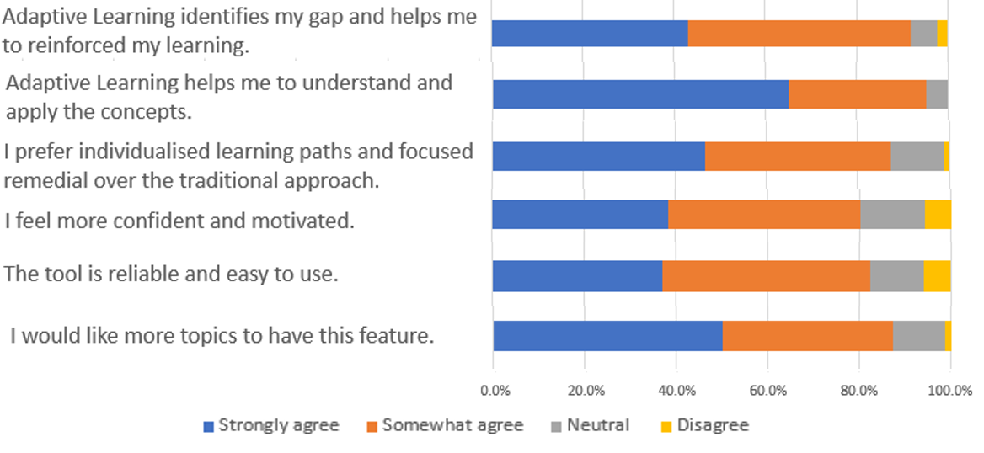

Figure 6 Survey results

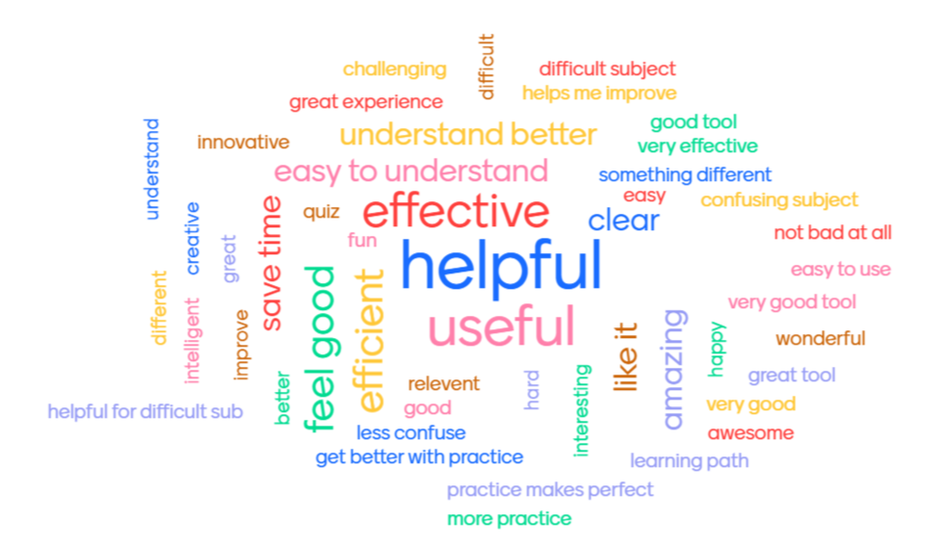

Figure 7 Word cloud on how the learners feel about adaptive learning

Another important aspect of adaptive learning is data analysis. This involves using the data from learner performance and interactions with the system to identify patterns and trends. This information can then be used to adjust the learning for individual learners, or to identify areas where the curriculum needs to be improved.

Adaptive learning also offers advantages from the teacher's perspective. By generating learning analytics, Brightspace provides valuable feedback that allows teachers to make decisions about their teaching strategies. Brightspace provides teachers with an activity report that displays the viewer rate of each learning objective. A higher viewer rate for a specific learning objective suggests that most learners may be finding that learning objective challenging and may benefit from additional support or clarification. The teacher can then allocate more time during face-to-face lessons to clarify these concepts.

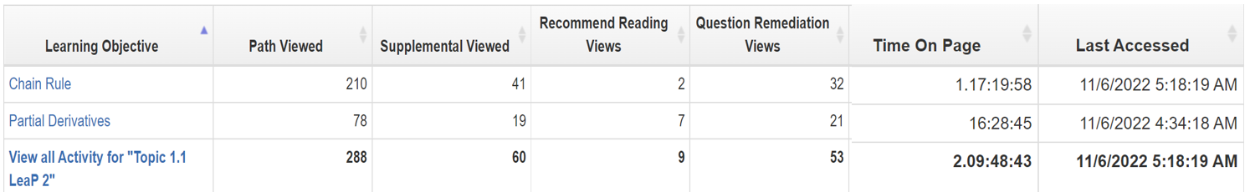

Figure 8 Activity Report

Brightspace also provides teachers with detailed information on individual learners' progress towards the learning objectives, enabling them to track each learner’s performance and monitor the materials they have accessed. By identifying learners who have not made sufficient progress, teachers can provide targeted interventions and support, enabling them to achieve better learning outcomes. For example, teachers could arrange for struggling learners to attend peer tutoring or face-to-face supplementary lessons that target specific areas of difficulty. By leveraging the data generated by Brightspace, teachers can take proactive measures to help these students achieve their learning goals.

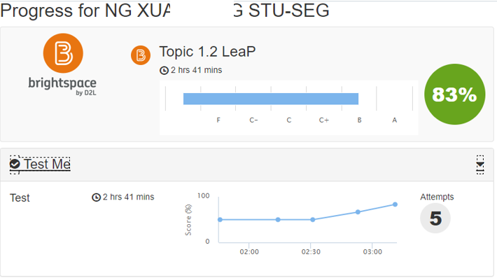

Figure 9 Learner’s Progress Report

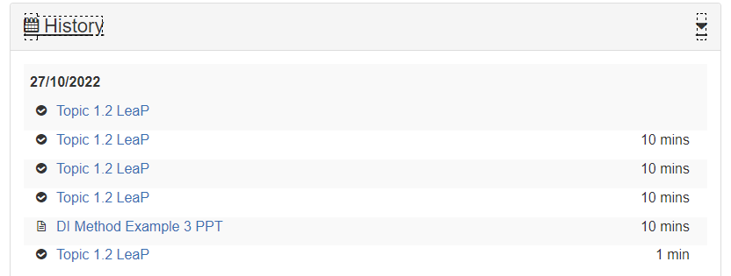

Figure 10 Learner’s Viewing History

Additionally, Brightspace’s ability to filter data by class allows teachers to identify the class learning profile and customise their classroom management techniques to better support their learners.

**Conclusions**

Adaptive learning benefits both learners and educators. It helps learners by improving their understanding of the material, increasing their engagement, and improving overall performance. It is time-efficient as learners only focus on what they don't know, skipping the learning objectives they already attained. Both statistical improvements in the scores and the survey results suggest that adaptive learning is preferred over the traditional one-size-fits-all approach. For educators, adaptive learning helps to improve teaching effectiveness and identify areas where the curriculum needs improvement. Adaptive learning is well-received by both learners and educators and can be used in most courses. Adaptive learning is a powerful learner-centric tool that revolutionizes the teaching and learning experience. With encouraging results from this investigation, educators are encouraged to use adaptive learning to support learning.

**Acknowledgements**

The authors would like to thank the Centre for Teaching & Learning Development at Nanyang Polytechnic for their valuable technical expertise, and the School of Engineering for the support in the study.

**References**

Baker, D. S., & Stewart, G. T. (2012). Adaptive behavioral outcomes: Assurance of learning and

assessment. *American Journal of Business Education (Online), 5(1), 55*. Retrieved from

<http://search.proquest.com/docview/1418437720?accountid=144789>

Becker, S. A., Brown, M., Dahlstrom, E., Davis, A., DePaul, K., Diaz, V., & Pomerantz, J. (2018). *CMN Horizon report: 2018 Higher education edition*.

Retrieved from

<https://library.educause.edu/~/media/files/library/2018/8/2018horizonreport.pdf>.

Chassignol, M., Khoroshavin, A., Klimova, A., & Bilyatdinova, A. (2018). Artificial Intelligence trends in education: a narrative overview. *Procedia Computer Science*, 136, 16-24.

Kaminskiene, L. & DeUrraza, M. J. (2020). The Flexibility of Curriculum for Personalised Learning. *Proceedings of the International Scientific Conference 3*(2020),266-273.

Kapp, K. M. (2016). Create Personalized Instruction. In: Murphy, M., Redding, S. & Twyman, J. S. (Eds.), *Handbook on Personalized Learning for States, Districts, and Schools* (pp. 131-144). Center on Innovations in Learning.

Schaffhauser, D. (2014). D2L Intros Revamped Platform 'Brightspace' with Adaptive Learning. *Learning management Systems News (Online), 2014*. Retrieved from <https://campustechnology.com/articles/2014/07/14/d2l-intros-revamped-platform-brightspace-with-adaptive-learning.aspx?admgarea=news>