Educational Practice of Finite Element Methods in National Institute of Technology

K. Endo^{*,a}, S. Kikuchi ^{b} and T. Itaya ^{b}

ª National Institute of Technology, Anan College, JAPAN
^{b} National Institute of Technology, Suzuka College, JAPAN

*E-Mail：k_endo@anan-nct.ac.jp

Abstract

CAE analysis software is widely used among engineers. However, because the mathematical theory used in CAE analysis is treated as a black box, there have been cases where CAE analysis is not used correctly. CAE analysis software is also used in graduation research and special activities at National institute of technology (KOSEN), but since the mathematical theory of CAE analysis is not included in the model core curriculum of KOSEN, there is a problem that students cannot understand the mechanism of CAE analysis even if they are taught how to use the software. If you want to learn the mathematical principles, the educational materials for engineers often focus on calculation methods, and the part about mathematical principles is not described in detail. On the other hand, educational materials for mathematicians often have a style of rigorously building up theories, which can be difficult for engineers to approach.
In order to improve engineering technology in Japan, practical education that interpolates engineering and pure mathematics is considered necessary in future educational courses. Therefore, we are currently conducting a course to understand the mathematical theory of the finite element method, which is the basis of CAE analysis, as part of the advancement of technical college education. The course is implemented by means of online lectures and online learning materials for students belonging to five technical colleges: Suzuka College, Sasebo College, Nara College, Kurume College, and Oita College. To interpolate engineering and pure mathematics, we adapt the method of “learning calculation methods while clarifying what is black boxed” and then “understanding the mathematical theory that was black boxed” in this education.
In this study, we discuss educational contents and effects of the “understanding the mathematical theory that was a black box” part.

Keywords: CAE analysis, Finite element method, Differential equation, Galerkin method, KOSEN

Introduction
The Finite Element Method (FEM) is a numerical technique used to find approximate solutions for differential equations. This method is employed in CAE analysis and widely used among engineers. However, the mathematical principles underlying this method are often treated as a black box, leading to instances where experimental results do not coincide with those obtained through CAE analysis. When we teach CAE analysis to students for their graduation research topics, only a few students have an inherent understanding of how the accuracy of the approximate solution can be improved by properly cutting the mesh and adjusting the number of meshes. Hence it is desirable that the education for Finite Element method is taught in National Institute of Technology (KOSEN).
In order to deal with Finite Element Method in KOSEN, we have to teach mathematical contents not included in the model core curriculum. Many engineering textbooks for the finite element method are written with basic linear algebra (matrix calculations) as prerequisite knowledge. However, to understand the mathematical principles of the finite element method, basic linear algebra alone is not sufficient. Since the computation itself is possible as long as basic linear algebra are understood, many students are still doing the computation without a good understanding of the principles. Thus, we adapt the method of “learning calculation methods while clarifying what is black boxed” and then “understanding the mathematical theory that was black boxed” in this education.
In this study, we discuss educational contents and effects of the “understanding the mathematical theory that was a black box” part.

Materials and Methods or pedagogy

We give online lectures and online learning materials for students belonging to five National Institute of Technology: Suzuka College, Sasebo College, Nara College, Kurume College, and Oita College. The contents of lectures are as follows:

1. What is “Finite Element Method”?
2. Calculations by Finite Element Method and Black box points (1)
3. Calculations by Finite Element Method and Black box points (2)
4. Summary of Calculations by Finite Element Method and Black box points
5. Linear algebra (1): Matrix and its properties
6. Linear algebra (2): Linear spaces
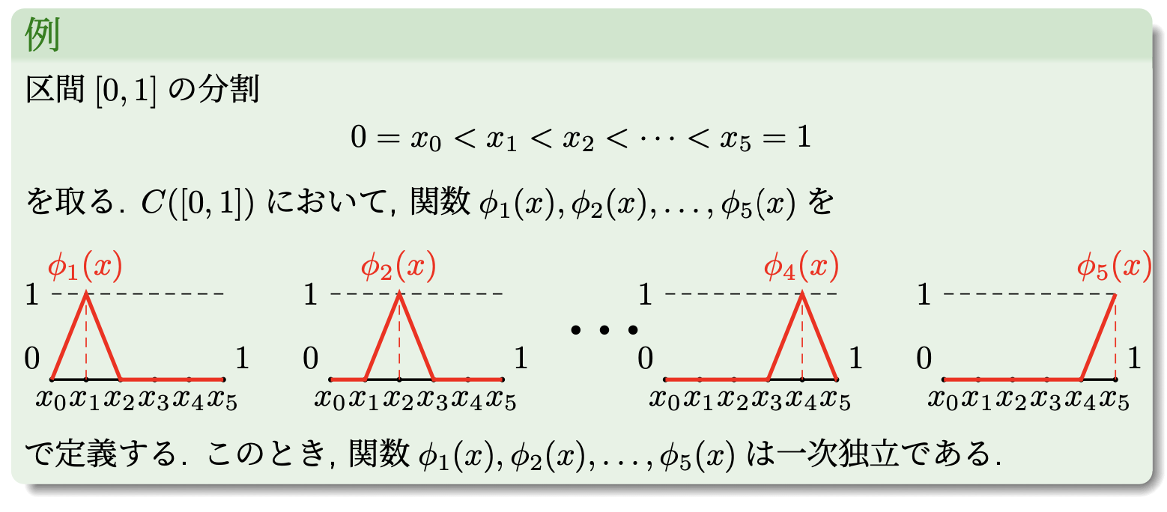
Figure 2. Lecture for linear spaces
7. Galerkin method (1-1): The existence of approximate solution
8. Galerkin method (1-2): The existence of approximate solution
9. Galerkin method (2-1): Error estimate for approximate solution
10. Galerkin method (2-2): Error estimate for approximate solution
11. Error Estimate for the approximate solution calculated by Finite Element Method.
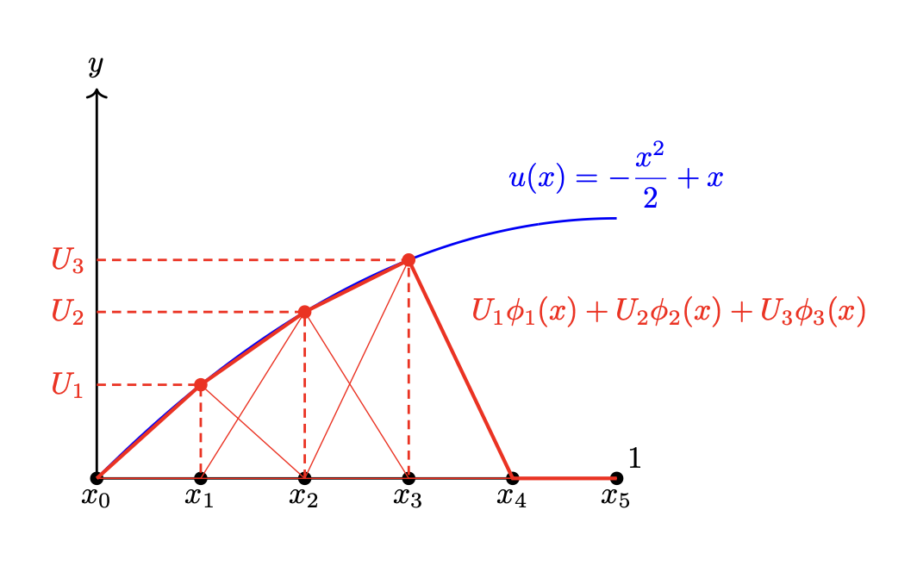
Figure 3. the approximate solution and the exact solution

In the curriculum of KOSEN, the students only learn the differential equations having explicitly computable solution. They do not learn the existence and uniqueness of solutions for differential equations in detail. Hence, in the lectures, we started to teach the difficulty of solving differential equations and usefulness of approximate solutions to motivate the finite element method. The contents from Lecture 1 to 4 are from motivation to calculation method of finite element method. These lectures have been conducted and the results were presented at National Convention record I.E.E. Japan (2023). Figure 1 is an atmosphere of an online lecture.
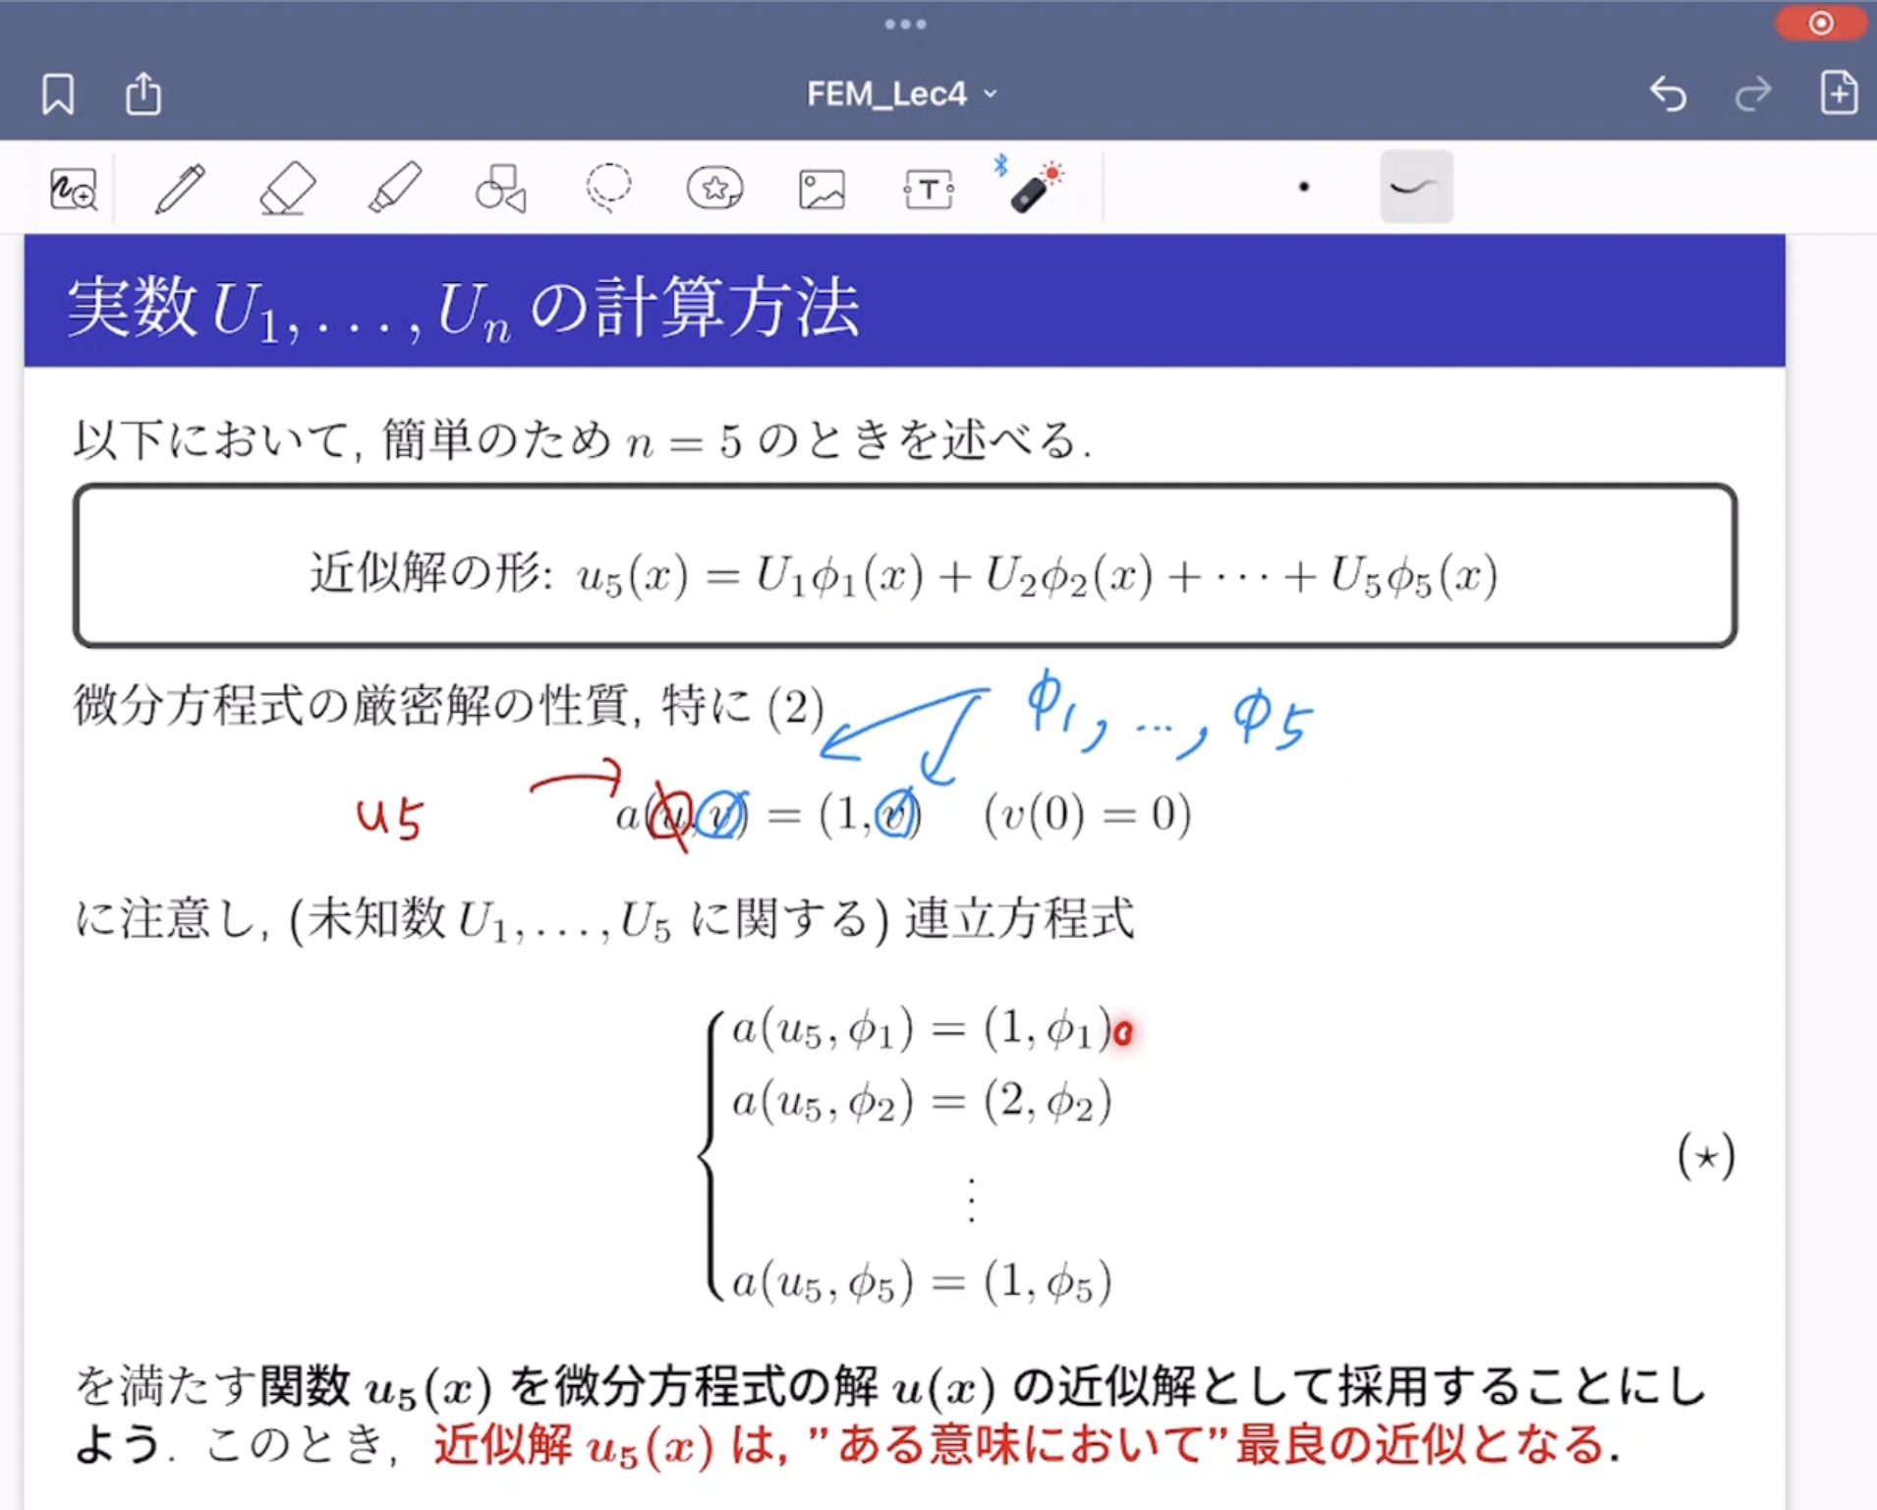
Figure1. An atmosphere of an online lecture
The main contents of this article are the following:

1. The existence of approximate solution
2. Error estimate for approximate solution

1. The existence of approximate solution

The educational materials for engineers often focus on calculation methods, and the part about mathematical principles is not described in detail. In the previous lectures, we clarified a black box part and teach how to calculate approximate solutions for differential equations only. Why the approximate solutions exist have been treated as a block box.
To explain the existence of approximate solution, we need to teach linear algebra and a part of functional analysis. In model core curriculum in KOSEN (2023), although matrix calculations and the linear transformation of coordinates were included, the linear spaces did not include. Hence, we added linear algebra to lectures. Figure 2 is a part of the lectures. Functional analysis is a generalization of linear algebra. Finite Element Method needs the theory of Sobolev spaces which is a part of functional analysis. Although we explain the details about the mathematical principles, we taught in a way that didn't contradict intuition while utilizing knowledge of linear spaces. Moreover, we need matrix calculations to get the approximate solution. In this lecture, we could show students how matrix calculations they learned in KOSEN are helpful. We compare the approximate solution obtained by Finite Element Method with the exact solution visually (see Figure 3).

2. Error estimate for approximate solution

The accuracy of the approximate solution obtained by Finite Element Method is the most important part for engineers. To improve skills for CAE analysis, we had better understand the following:

  - What criterion or measure is used to determine how well the approximate solution approximates the exact solution?
  - How close is the approximate solution to the exact solution?
  - The relation between the approximate solution and meshes.

2-1. What criterion or measure is used to determine how well the approximate solution approximates the exact solution?

In mathematics, there exists the concept of “norm”. This is a tool to introduce “distance” for vector spaces.
In this lecture, we introduced “L²-norm” (see Figure 4) which is one of the most important mathematical concepts in function spaces. Moreover, we explained that L²-norm is used to measure the proximity between approximate solutions and exact solutions. In the definition of L²-norm, we use the integral. The integral can represent the size of objects, such as “length” and “area”. By emphasizing this fact, we tried to help students understand more deeply.
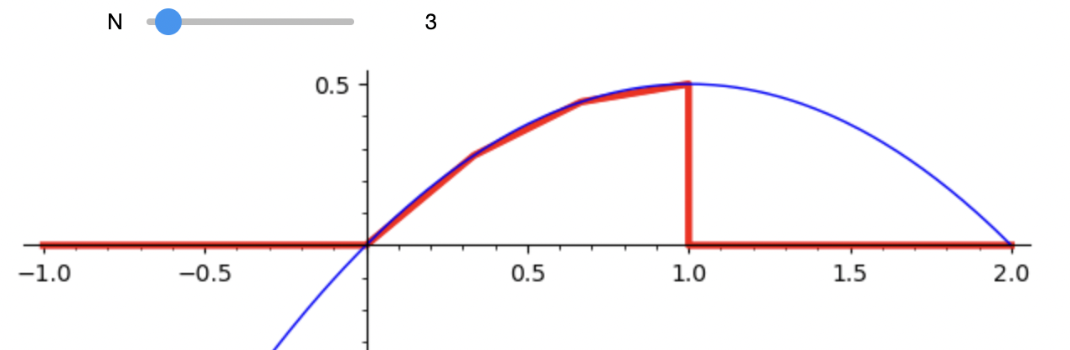
Figure 6. Dynamically materials by Sagemath
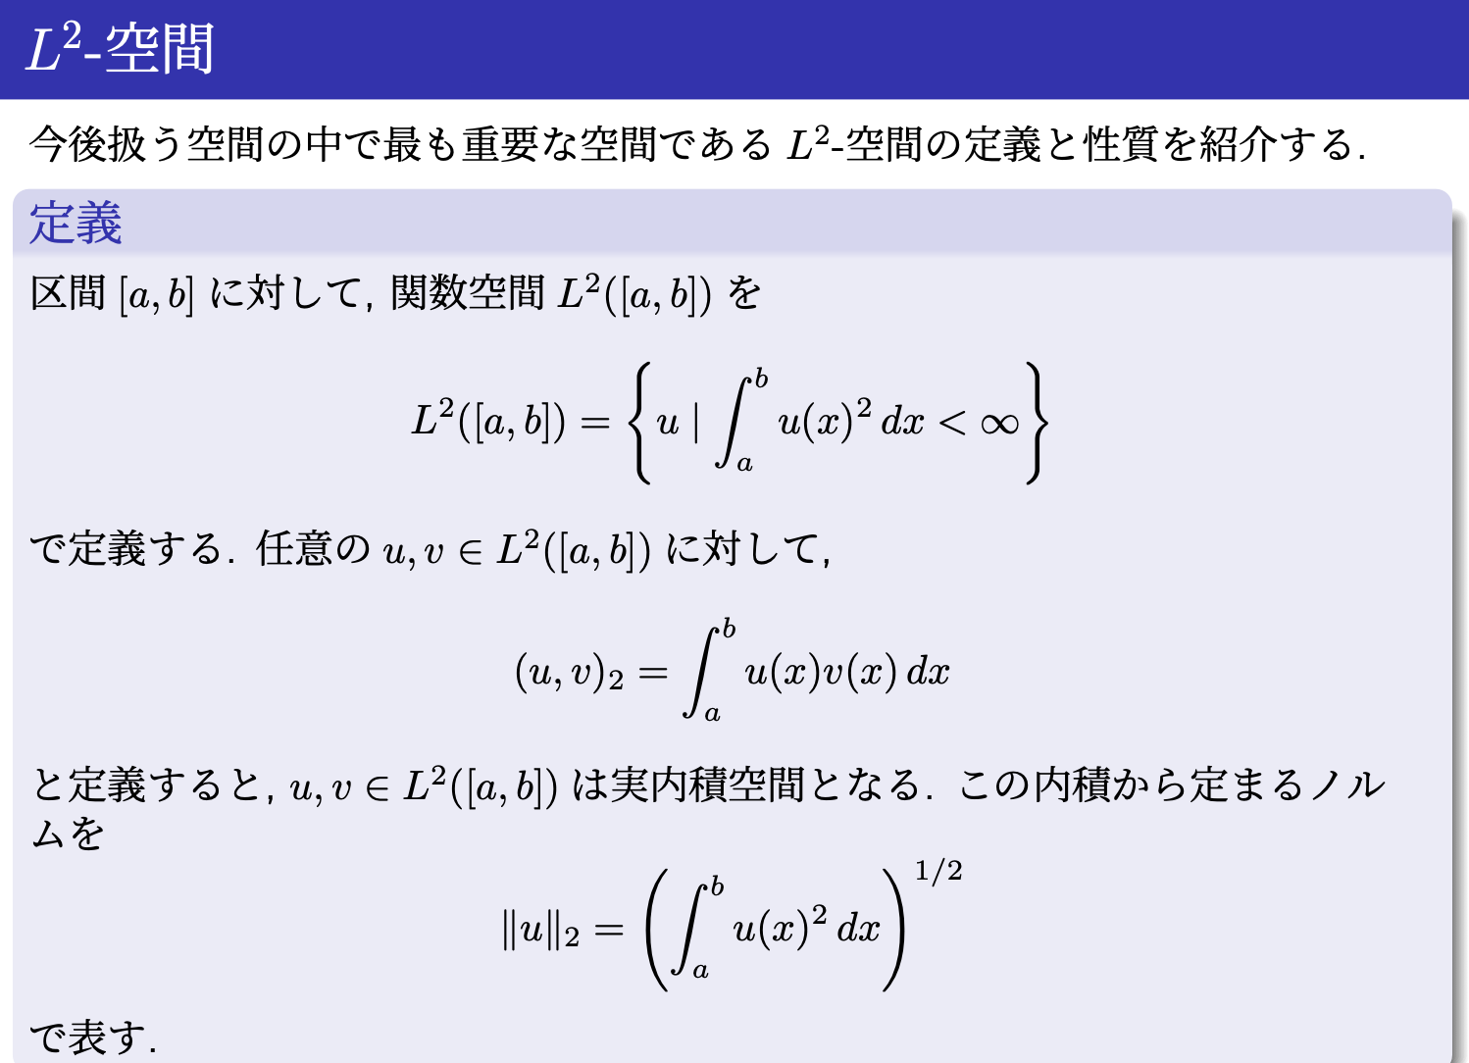
Figure 4. Definition of $L^{2}$-norm

2-2. How close is the approximate solution to the exact solution?
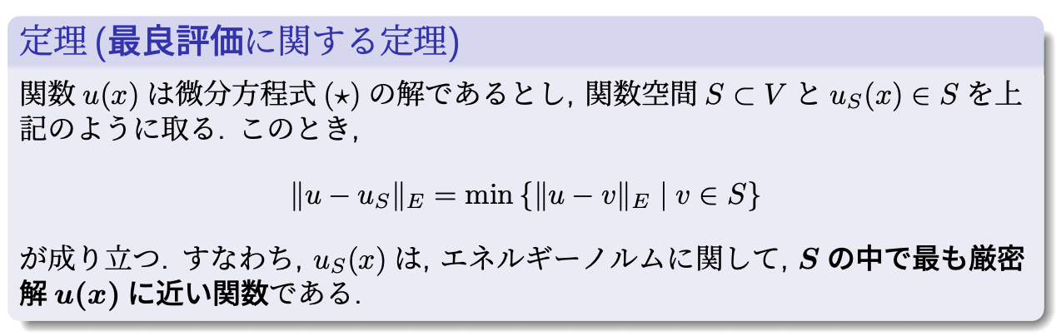
Figure 5. Lecture for the Error Estimate
In the section 2-1, we introduce “L²-norm” which is a distance in function spaces. Taking the difference between approximate solutions and exact solutions in the sense of L²-norm, we get error terms. This error term has a parameter that is determined by the mesh generation and the number of meshes. To get this error term, we introduced a new norm “energy norm” which is similar to L²-norm. We showed the approximate solution obtained by Finite Element Method is the closest solution to the exact solution in the sense of energy norm (see Figure 5).

2-3. The relation between the approximate solution and meshes.

The more the number of meshes increase, the better the accuracy of the approximate solution is. We used SageMath, a free and open-source mathematics software, to create educational materials that enable users to dynamically observe how the accuracy of the approximate solution improves based on the mesh generation and the number of meshes. We show an example of dynamical materials in Figure 6. In Figure 6, we also find that Finite Element Method can only be applied locally.

Results and Discussion

Certain educational effects were obtained for understanding the mathematical principle of Finite Element Method. Many students found it difficult to accept the peculiar and technical language used in mathematics. This is a point that should be corrected in the future. We have not been able to provide hands-on training in CAE analysis, so we would like to work on this in our future educational activities.

Conclusions

We were able to carry out educational activities that had never been done at KOSEN before. We consider that in the near future, we can incorporate this into the classes.

References

S. Brenner & L. Scott, The Mathematical Theory of Finite Element Method, 3rd edition, Springer New York, 2008.

K. Endo, S. Kikuchi and T. Itaya, Education research of Finite Element Method in Kosen, National Convention record I.E.E. Japan, 2023.

F. Kikuchi, Finite Element Method, SAIENSU - SHA Co.,Ltd., 1999 (in Japanese).

