**ENHANCING Professional Identity Formation VIA INTERNSHIP using cdio framework**

Sin-Moh CHEAH*, S.T. Phua

Singapore Polytechnic, Singapore

*smcheah@sp.edu.sg

**Abstract**

**Internship had always been considered a means for students to develop their professional identify. This paper shares the outcomes of a study aimed at determining a sense of professional identity among students from the Diploma in Chemical Engineering (DCHE) after they completed their internship. This is especially important as recent studies on the impact of Covid-19 pandemic has shown potentially negative influences on professional identity formation, as many students were largely confined to working from home. This paper first provides a literature review of how internship can enhance professional identity development. It then presents the DCHE spiral curriculum that strives to prepare students for the chemical process industries where professional identity is assumed to develop naturally as students went through their studies in campus. This is followed by a discussion of a survey findings (number of responses, n = 53) aimed at finding out the students’ impression of how well the DCHE course had prepared them for the development of their sense of professional identity as a chemical engineering technologist. These students had spent a good part of their internship working from home during the pandemic. This survey follows from an earlier focus group discussion that the author was involved in with a small group of 22 DCHE students who informed of the disorientation they faced and anxiety during their internship; over what they can learn when they were kept away from the workplace due to Covid-19. The survey findings indicated that while a good number of students reported on still having positive experiences, their feedback also indicate that more needs to be done. This paper concludes with ways in which the CDIO Framework can be used to leverage on other modules in the DCHE curriculum to enhance students’ professional identity formation during their studies in campus that support its continued development during internship.**

**Keywords:** *Professional identity, chemical engineering, internship, CDIO Framework*

**Introduction**

In the simplest form, professional identity is the concept which describes how we perceives ourselves within our occupational context and how we communicate this to others (Neary, 2014). It is implicitly assumed that students will appreciate their professional identity through various learning tasks experienced over the duration of their study.

Rees & Monrouxe (2018) noted that professional identities are of utmost importance to any profession, as they are the cornerstone of professionalism, providing a professional with ethical frameworks within which he or she works. Possessing a strong professional identity can foster confidence in a practitioner, and others in that person. A lack of professional identity clarity has been found to have a significant impact on a profession’s perceived value and on a practitioner’s confidence in advocating for his/her professional opinions.

Among many disruptions brought about by the Covid-19 Pandemic, the one of interest in this paper is on the internship for students. Mustafa, Willems & Cheah (2022) reported on a focus group discussion they conducted for a small group of students from the Diploma in Chemcal Engineering (DCHE) of Singapore Polytechnic (SP). The findings indicated that students in general felt disoriented due to the lack of interactions with working professionals when working from home, and/or working on projects with reduced scope or more “desk-bound” such as documentation review.

**Student Internship and Professional Identity**

Holdsworth, et al (2009) considers internship as a form of “capstone experiences” or “capstone subjects” that are useful in assisting students in transitioning to the professional workforce. Internships constitute the earliest professional experience right after or while students pursue their professional qualifications. As interns, students go through a process of discovering and constructing their professional self, finding frequent contradictions and problems along the way (Karaja & Martinez Del Rio, 2018). It provides students not only the knowledge and skills usually developed in engineering programs, but attitudes and self-beliefs toward being able to practice as an engineer (Mann, et al, 2009). Indeed, Trede (2012) likewise suggested that internship is an ideal space to develop professional identity and professionalism in students, which include learning professional roles, understanding workplace cultures, professionalizing and socializing into a community of practice. Similarly, Dehing, et al (2013) reported that workplace learning has an overall positive effect on engineering students’ development of clarity, i.e. they acquired a greater image of their professional future from such form of learning. Such “field experiences” (Hoffmann & Berg, 2014) gained provide the link students needed between classroom learning and actual workplace setting, and notion of professional identity thus develop from performing specific activities that are seen as core to the profession in question. This allows students to understand and adopt the attributes, beliefs, values, motives, and experiences of the profession. Recent works by Carvalho, et al (2021) also reaffirmed that work experiences played an important role in the meanings that students attributed to development of professional identify.

**Internship for Chemical Engineering Students**

Internship is a compulsory component for Year 3 DCHE students from SP. Its current form as a 22-week attachment (semester-long) to local companies is a direct response to the SkillsFuture Initiative; which in turn is the Singapore Government's national strategy to address the country's futrue developmental needs in Industry 4.0.

Internship is run on a “flip-flop” model, alongside the final year project; in which half of the cohort of 120 students will first complete the internship while the other half first complete the final year project. This is shown in Figure 1 for the DCHE course structure which follows a spiral curriculum. Prior to embraking on capstone project and internship, students go through 4 skills-based module in the first 2 years of study, one module per semester, as shown in Figure 1.

Increasing Level of Complexity

**Spiral curriculum**

**Stage 3A/B**

Outgoing Professional

Capstone Project

(Final Year Project)

**Stage 2B**

Chemical Product

Design & Development

**Stage 2A**

Introduction to Chemical Product Design

Process Operations

Skills 2

Process Operations

Skills 1

**Stage 1B**

Laboratory &

Process Skills 2

Internship

**Stage 1A**

Laboratory &

Process Skills 1

Incoming Novice

Introduction to

Chemical Engineering

Figure 1. The DCHE Spiral Curriculum

**The DCHE Curriculum and Professional Identity**

When we started back in 2007 to redesign the DCHE curriculum using the CDIO Framework (www.cdio.org), we did not make an explicit effort to develop any sense of professional identity among our students. Even as we had over the years made many changes to the curriculum (e.g. Cheah, et al, 2013; Cheah & Yang, 2018), we had left the internship module untouched. We had at one time, replaced the internship with a structured training at the Chemical Process Technology Centre (CPTC) in Jurong Island. Suffice to say, we had left our students to figure out for themselves their career choices in the chemical processing industries, assuming this will eventually “come to them”.

We started to pay attention to the question of professional identity when the SkillsFuture Initiative was introduced, as one of its key thrusts is to help Singaporeans made well-informed choices in education, training and careers (Cheah, 2016). One of the key focus in this area is the introduction of enhanced internship, which aimed to prvoide a more structured approach to training at sponsoring companies (Cheah & Yang, 2018). DCHE aligned its curriculum to the Skills Framework for Eneregy & Chemicals and introduced the 22-week internship in its present form. This also effectively replaced the training at CPTC which had ceased operation.

**Findings of Survey Results on Student Internship Experience and Professional Identity Formation**

A survey was administered to this cohort of students after their internship for the period September 14, 2020 to February 12, 2021. A total of 53 responses were collected, and some had to be discarded because they were either incomplete, or otherwise did not addressed the questions. The survey consists of 10 questions. Most of the questions are open-ended in nature, to allow students to pen down their answers in their own words. The first 2 questions (Q.1 and Q.2) tried to establish students’ “baseline” understanding of their professional role:

Q.1 What does it mean to you, to become a “chemical engineer”?

Q.2 In your opinion, how is a chemical engineer different from other form of engineering, e.g. civil, mechanical, electrical, etc?

A majority of responses to Q.1 (33 students) focused on what chemical engineers do, which revolved around manufacturing activities to make useful products using a range of equipment and processes; and related work such as problem-solving and troubleshooting. A small number (13 students) mentioned having the right knowledge, skills and/or attitudes. For Q.2, which serves to discern if students see distinctions between being a chemical engineer compared other engineering disciplines, there are 47 useful responses that addressed the questions. There were 6 responses that were discarded, which covered only very generic areas. The useful responses are those that were able to pinpoint the processes involved, and a wider career options not limited to the chemical processing industries. These results showed that our students have a good understanding what the field of chemical engineering is about.

The next question (Q.3) attempts to capture students’ notion of professional identity from their experiences in the first 2 years of study, where they completed 4 core skill-based modules, one in each semester (in Year 1 and in Year 2), using scenario-based learning as explained earlier (see Figure 1).

Q.3 Did you find the activities that you went through in the DCHE Laboratories (not including internship) gave you adequate understanding of the job functions of a chemical engineer? Did they help to shape your perception of the professional identity of a chemical engineer? If yes, explain with the help of examples what worked and why it worked. If no, explain why not.

Here 39 students who answered “yes” were able to cite module names and/or gave examples of activities they undertook, nearly all pertain to the 4 skills-based modules in the DCHE spiral curriculum. Although relevant, 5 responses were not included as students reported them as derived from their internship. These replies serve to validate that our laboratory activities indeed played a key part of helping to instill in students good understanding of the professional role of chemical engineers.

Next, in Q.4, we listed 9 statements, based on the Professional Identity Scale (Adams, et al, 2006) on how they felt about the profession using a 7-point Likert Scale from ‘1’ (Strongly Disagree) to ‘7’ (Strongly Agree) that is most representative of one’s sentiment. We emphasized that there is no right or wrong answer. The 9 statements (S.1 to S.9) are shown below:

S.1 I feel like I am a member of this profession

S.2 I feel I have strong ties with members of this profession

S.3 I am often ashamed to admit that I am studying for this profession

S.4 I find myself making excuses for belonging to this profession

S.5 I try to hide that I am studying to be part of this profession

S.6 I am pleased to belong to this profession

S.7 I can identify positively with members of this profession

S.8 Being a member of this profession is important to me

S.9 I feel I share characteristics with other members of the profession.

Students’ responses are shown in Figure 2. From the results it can be inferred that a large majority of students are probably still unsure of their identity as chemical engineers (S.1, S.2, S.6, S.7, S.8 and S.9). Many gave high scores of ‘slightly agree’ and ‘neither agree nor disagree’; and most also do not express strong negative feelings of the professions (S.3, S.4 and S.5 with a large numbers who selected ‘strongly disagree’ and ‘disagree’). Among the majority of students, there is a significant number of students who responded positively in terms of being pleased to belong to the profession (S.6), able to identify positively with members of the profession (S.7), and sharing the characteristics with members of the profession (S.9). Many also expressed that they felt like a member of the profession (S.1). However the affinity to the profession can still be further developed, as many may not have seen the importance to oneself by being member of the profession (S.8), or the ties to members of the profession (S.2).

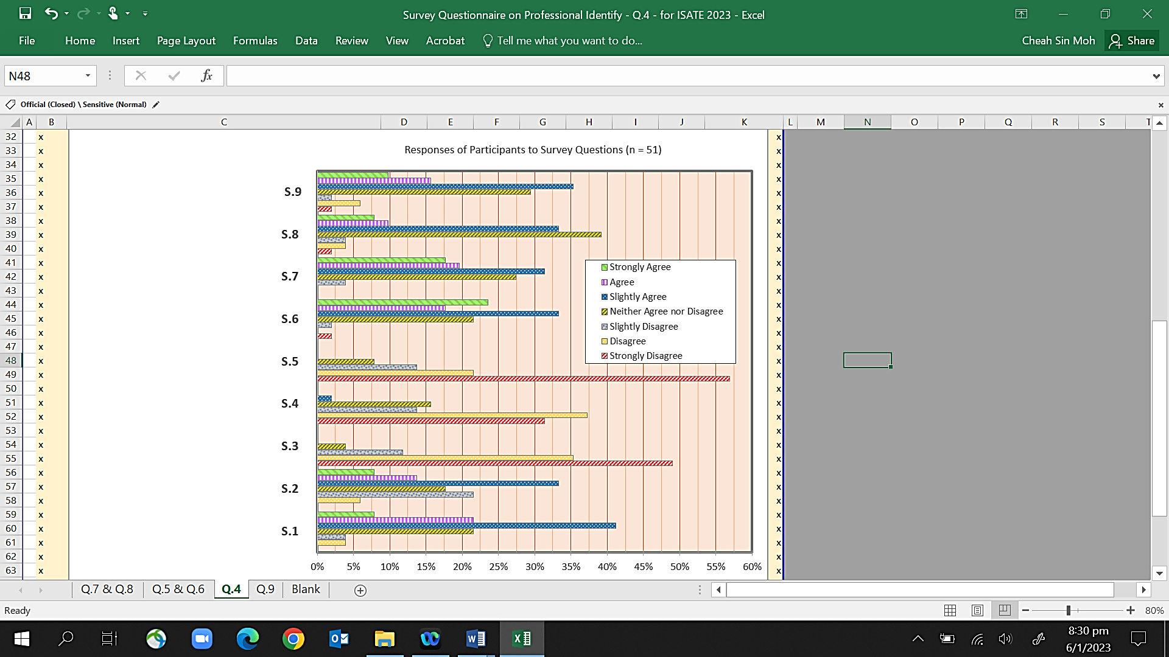

Figure 2. Students Reponses to survey

The next 2 questions (Q.5 and Q.6) strive to do a “before-and-after” comparison if students find the internship experience was aligned with their initial expectations.

Q.5 State up to 3 things you most looked forward to; when you first embark on the Internship program in September last year.

Q.6 Did the internship met your expectation? On a scale of “1 (Most Dissatisfied)” to “10 (Most Satisfied)”, please rate your experience in your internship with regard to the 3 things you identified above. Kindly explain your answer, for example, in what aspect of the internship that you felt your experience most satisfying or least satisfying.

For Q.5, students responses can be largely grouped into several main categories, some of which is a sharp contrast to another, for example in using the knowledge they learnt as compared to learning new things; gaining work experience in general, and hands-on experience more specifically; as compared to finding out one’s career interest. There are some who cited money as the motivator, while others look forward to building networks. This just shown the wide range of aspirations of our students from their internship.

In relation to Q.6, a majority of students gave high scores for level of satisfaction: there are a total of 41 students who gave a score of 7 or above, with up to 7 students gave perfect 10! These students invariably cited good working environment and relationships with supervisors and colleagues as the main factors. Even the 1 student who gave the lowest score of 1 acknowledged that it was the job scope that was boring that contributed to the low score. The student even took the trouble to explain that a score of 8 would have been given for “nice and friendly people”.

We are also acutely aware that not all our students get to work in chemical plants. Even when they were assigned to a chemical company, many ended up working in laboratories instead of doing field work in the chemical plant. Part of the reason is that most companies are not willing to take on additional risks of having non-employees in the processing areas; and perhaps to avoid any “inconvenient” responsibilities should the unfortunate happened. As such, the next 2 questions (Q.7 and Q.8) try to elicit students’ feeling in the situation that there is a “mismatch” between expected placement and actual posting; and how one reconcile his/her notion of professional identity.

Q.7 You may be assigned to a chemical company, but did not have the opportunity to work in the plant. For example, you are assigned to work in the laboratory instead, or doing some quality improvement related work, or you may be assigned to research institution. Did that change your perception of what it takes to be a Chemical Engineer? Explain in detail how you deal with this situation. On the other hand, if you are doing work in the plant, explain how that reinforced your perception of being a Chemical Engineer.

Q.8 On a scale of “1 (None at All)” to “10 (Very Much)”, rate how you feel your internship experience had contributed to your notion of professional identity of being a chemical engineer. Kindly explain your answers to the above, for example, in what aspect of the internship that you felt your experience most satisfying or least satisfying.

The findings showed that our students are rather ambivalent about not being able to actually set foot into chemical plants. Albeit 3 “questionable” entries, most still reported that their perception of what makes a chemical engineer remained unchanged. From the postings, many were in fact worked in the laboratories, mostly product testing and process improvements. Many explained that they understood the broad-based nature of chemical engineering, and see the posting as a means of gaining work experience. A handful of them linked their experience to laboratory works back in campus, and some also see the importance of their work as a form of quality assurance in relation to the overall manufacturing processes. This can be seen from Figure 3, where a significant percentage of students scored 7 to 10.

The second last question (Q.9) tries to ascertain if students can link their internship experience with development of professional identity as chemical engineer.

Q.9 Reflect on your overall internship experience in helping to develop or failing to develop the professional identity as a Chemical Engineer.

Explain aspects of your internship experience (e.g. the work that you do) that contribute to the development of your perception of professional identity as a chemical engineers.

On the other hand, if you felt your internship experience did not contribute much to your notion of professional identity of a chemical engineer, explain how you persist in completing the internship program, e.g. how you reconcile your internship experience with your study in DCHE.

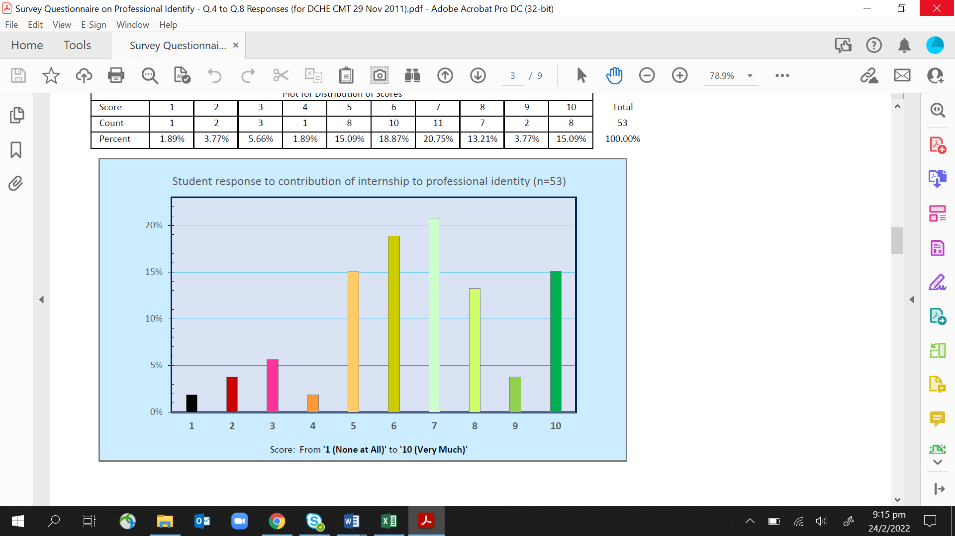

Figure 3. Contribution of Internship to Formation of Professional Identity

Here it becomes evident that students faced difficulty making the link between internship experience and professional identity. From the responses, 17 students did not addressed the question posed, and their input were discarded. There were 8 who felt that the internship did not contribute to their sense of professional identity, and reason cited were nature of work: mostly just laboratory work, manual work, sampling work, and doing work not related to chemical engineering. Of the 28 who responded positively, only 10 students mentioned continual improvement (quality assurance) and improving safety. The rest tend to associate the notion of professional identity with the broad job scope (6 responses) or immediate work done on specific tasks or area of focus (8 students). 3 students cited learning from others, and most interestingly, there is 1 student who said that while the internship provided him (or her) with a good sense of identity of a chemical engineer, the student had said that this will not be a career for him (or her).

The last question (Q.10) asked students for their views on how the internship program can be further improved.

Q.10 Is there any improvements that you think we can make to the Internship program or other modules in DCHE to enhance the development of professional identity as a Chemical Engineer? Please give us your suggestions and be as detailed as possible.

This question garnered the least responses, with 21 students replied ‘Nil”, or left the answer blank. 2 answers did not address the question and were discarded. For the rest, responses can be grouped under 3 main headings: (a) “Matching” issue (14 responses) of which 7 were related to issues on what was learnt in school compared to what they do at the workplace, and 7 on giving students more information upfront on the nature of internship, (b) course content that provides more exposures, e.g. laboratory hands-on sessions, different work scenarios, and physical plant visits (11 responses) and (c) Miscellaneous (5 responses). It can therefore be seen that notwithstanding that many students accepted laboratory work as part or bulk of their internship experience and gave high scores for their internship experience, the preference and greater interest still lies in process-related work. The most suggestions on “matching” issues centers around students wanting more internship placements relevant to the field of study. Many students also wanted to know the nature of work that they will be doing before commencement of internship.

The findings from this work indicated that experience from internship does shape the professional identity of our students. However, such development of an individual’s professional identity depends on a range of factors. The findings indicate that whilst internship can be a major contributing factor in its development, other themes did emerged that can influence the development of professional identity. Each internship experience is unique in its own way, affecting students to different extent in a range of outcomes not restricted to the development of one’s professional identity, for example, presence of company mentor, role of liaison officer, nature of job, expectation of students (including self-interest), company supervisor perception of students, just to name a few.

**Enhancing Formation of Professional Identity in Students: CDIO Revisited**

These findings indicate that we need to be more proactive in developing our students’ notion of professional identity. However, despite the abundance of publications on professional identity, there is currently a dearth of publication on how to systematically design an engineering curriculum to develop one. To this end, we again turn to the CDIO Framework to investigate how development of professional identity can be strengthened. The use of scenario-based learning in DCHE is a good start, and more effort can be invested to bring out unique aspects of chemical engineering that can help students shaped their professional identity during the course of engaging in these learning activities. This is done by revisiting the 2 components of the CDIO Framework, namely the Syllabus and Standards.

The CDIO Syllabus has quite comprehensively covered various aspects of skills and attitudes that students need to develop to become a professional, such as *2.5.2 Professional Behaviour*, and *2.5.4 Staying Current on the World of Engineering*. These are supported by various other personal and interpersonal skills and attitudes for example, *2.4.6 Lifelong Learning and Educating*, *2.5.1 Ethics, Integrity and Social Responsibility*, and 3.2.10 *Establishing Diverse Connections and Networking*. These outcomes had captured much of what the Royal Academy of Engineering (RAE) terms the “Engineering Habits of Mind” (RAE, 2014), even though the term professional identity is not used.

In terms of CDIO Standards, the DCHE internship can be seen as an extension of an in-campus integrated curriculum (Standard 3) to provide students with an initial exposure of the real-world working environment. Students are provided with first-hand opportunity to appreciate how the engineering education they received in school are applied in the actual manufacturing or production environment (Standard 1). The workplace itself can be considered as “beyond-the-school learning environment” for students (Standard 6). As interns, they can be viewed as engaging in workplace learning where they get to demonstrate in an authentic workplace setting various different personal, professional and interpersonal skills developed in school. In fact, a student’s daily interaction with company employees can be viewed as a form of Integrated Learning Experiences (Standard 7) where these skills are used in carrying out their assigned tasks. Needless to say, students are engaged in active learning (Standard 8) every day that they are in the workplace. As for the project component, the level of complexity varies in accordance with the project(s) requirements as assigned by the companies to the interns and ideally, can be viewed as Design-Implement Experiences (Standard 5) with different permutations of the elements of Conceive, Design, Implement and Operate. However, given that the internship only has a duration of 22 weeks, this may not provide sufficient time for students to be involved in all the four stages of conceiving, designing, implementing, and operating a process, product, system, or service. Existing internship assessment (Standard 11) especially that by the company supervisor, can be revised to focus more on demonstration of desired professional skills

Existing DCHE curriculum can be reviewed to provide a more seamless connection to prepare students for their internship experience in Year 3. What this entails is that modules in Year 1 and Year 2, including the 4 skills-based modules, need to be enhanced to help students make explicit connection to professional identity development from what they learn in each learning task. This can be as simple as tweaking existing integrated learning experiences to help inculcate a sense of professionalism in the work done. As noted earlier, with many tasks already designed for integrated learning experiences using scenario-based learning, it is not expected that many new learning tasks need to be designed from scratch. Insights can also be obtained from students’ internship project reports, reflection journals and weekly task records; which they had to submit. There is a wealth of information that can be mined from such documents to reveal various workplace scenarios that can be adapted for classroom learning, or as part of liaison officers’ briefing to students. Alternatively, a 1-day pre-internship workshop can be contemplated, with compulsory attendance by all students. Efforts can also be directed towards improving current approach to FYPs (Standard 5) to draw out aspects of professional identity from students’ work. This may be more challenging in view that all FYPs are obviously different to begin with, and not all are industry-sponsored.

Lastly, lecturers themselves need to be equipped with right skills to facilitate professional identity development in students, starting with a good working definition of professional identity for diploma-level graduates in the context of working in the chemical industry. Various staff development programs can be introduced for example in designing integrated learning experiences that present realistic workplace issues (Standard 10), or in mentoring students in carrying out effective reflections to achieve a deeper working understanding of their learning experience to make connections to professional identity as chemical engineers.

**Conclusions**

Post Covid-19, literatures had started appearing discussing the impact of the pandemic on professional identity formation. Most of them not surprisingly, are from the medical profession (see for example Luman et al, 2022; Moula, et al, 2022). The findings reported largely still positive impact perhaps because of the unique role played by members of this profession during the pandemic. This may not be the case for other disciplines, as our findings had shown. This paper argued that the development of professional identity among students needs to be planned, and that students need to be made explicitly aware of how their learning experiences not as students, but as future professionals. This paper shared how the CDIO Framework can be used to guide the review of existing DCHE curriculum to enhance the development of professional identity among its students during the entire duration of study, which is then further sharpened during their internship.

**References**

## Carvalho, L., de Amorim-Ribeiro, E.M.B., do Vale Cunha, M., & Mourão, L. (2021). Professional Identity and Experience of Undergraduate Students: An Analysis of Semantic Networks, *Psychology: Research and Review*, Vol.34(1):14, pp.1-13.

Cheah, S.M. (2016). Integrating Awareness of Career Prospects into Year 1 Chemical Engineering Curriculum, *Proceedings of the 12th International CDIO Conference*, Turku University of Applied Sciences, Turku, Finland.

Cheah, S.M., Phua, S.T. & Ng, C. (2013). The Chemical Engineering CDIO Experience after 5 Years of Implementation, *Proceedings of the 9th International CDIO Conference,* MIT-Harvard University, Cambridge, Massachusetts, USA.

Cheah, S.M. & Yang, K. (2018). CDIO Framework and SkillsFuture: Redesign of Chemical Engineering Curriculum after 10 Years of Implementing CDIO, *Proceedings of the 14th International CDIO Conference,* Kanazawa Institute of Technology, Kanazawa, Japan.

Dehing, A., Jochems, W. & Baartman, L. (2013). The Professional Development of Engineering Students Professional Identity during Workplace Learning in Industry, *Engineering Education*, Vol.8(1), pp.42-64.

Hoffmann, K. & Berg, S. (2014). “You Can’t Learn It in School”: Field Experiences and Their Contributions to Education and Professional Identity, *Canadian Journal of Information and Library Science*, Vol.38, No.3, pp.220-238.

Holdsworth, A., Watty, K. & Davies, M. (2009). *Developing Capstone Experiences*, Centre for the Study of Higher Education, University of Melbourne.

Karaja, K. & Martinez Del Rio, J. (2018). Professional Identity Creation: How Interns Build Their Identity in the Workplace, *Proceedings of* INTED2018, pp.6036-6042.

Luman, A.A., Bagley, M., Colbert-Getz, J.M., Christensen, T., Lindsley, J.E. & Chow, C.J. (2022). A Mixed-Methods Study of the Impact of the Initial Disruptions Caused by the COVID-19 Pandemic on Medical Student Professional Identity Formation, *Medical Science Educator,* Vol.32, pp.1387–1395.

Mann, L., Howard, P., Nouwens, F. & Martin, F. (2009). Influences on the Development of Students’ Professional Identity as an Engineer, *Proceedings of the Research in Engineering Education Symposium*, Queensland, Australia.

Moula, Z., Horsburgh, J., Scott, K., Rozier-Hope, T. & Kumar, S. (2022), The Impact of Covid‑19 on Professional Identity Formation: An International Qualitative Study of Medical Students’ Reflective Entries in a Global Creative Competition, *BMC Medical Education*, 22:545

Mustafa, R.M., Willems, T. & Cheah, S.M. (2022). Rethinking Engineering Internship in Times of Disruption, *Proceedings of the 12th International CDIO Conference*, Reykjavik University, Reykjavik, Iceland.

Neary, S. (2014). Professional Identity: What I Call Myself Defines Who I Am, *Career Matters*, Vol.2(3), pp.14-15.

Rees, R.E. & Monrouxe, L.V. (2018). Who Are You and Who Do You Want To Be? Key Considerations in Developing Professional Identities in Medicine, *Medical Journal of Australia*, 209(5), pp.202-203.e1

Trede, F., Macklin, R. & Bridges, D. (2012). Professional Identity Development: A Review of the Higher Education Literature, *Studies in Higher Education*, Vol.37(2), pp.365-384.