**THE EFFICACY OF 3D-PRINTED MODELS IN THE LEARNING OF SPATIAL CONCEPTS IN CHEMISTRY**

N. Sachdeva*,a, T.H. Chewb, J. Periasamyb, S. Mehrac

a Republic Polytechnic/School of Applied Science, Lecturer, Singapore

b Republic Polytechnic/School of Engineering, Senior Lecturer, Singapore

c Republic Polytechnic/School of Mass Communication, Principal Lecturer, Singapore

*nikhil_sachdeva@rp.edu.sg

**Abstract**

**Spatial concepts and intermolecular interactions play a pivotal role in chemistry. There is a dire need for supplementary approaches to support meaningful learning in chemistry. In this study, the employment of ball-and-spoke and space-filled type coloured 3D-printed models in explaining spatial concepts such as aromaticity, stereochemistry and substitution reaction were explored. Specifically, the study examines the learners’ motivation and perceived learning through mixed methods of quantitative survey and qualitative focus group discussion (FGD).**

**After a three-week exposure to three sets of 11 models, there is a statistically significant (p<0.05) increase in learners’ overall motivation. Data from the perceived learning survey confirmed: a) 3D-printed models help the learners in visualization of sub-microscopic spatial concepts; b) models were perceived to be useful for learning and c) dual usage of both ball-and-spoke and space-filled type models simultaneously helped them to remember substitution (SN) reaction. These results were triangulated by focus group discussion (FGD) which indicated that the learners find 3D-models aid clarity through 3D visualization; assist recollection of concepts through colour coding and add fun through interactions. The authors recommend the continued use of the 3D-printed models and the expansion to other lessons of the chemistry module.**

**Keywords:** *Interactive Seminar, 3D-printed models, motivation, Self-Efficacy, Perceived Learning*

**Introduction**

According to Johnstone’s triangle model (Johnstone, 1991; Johnstone, 1993), chemical information can be represented simultaneously at multiple levels, such as the visible macro level or description, the unseen sub-micro level or explanation, and the abstract symbolic level or representation. An expert instructor may find it easy to work with this perceptual triangle and change between levels, however, this may not be the same for a novice or learner (Johnstone, 1991; Johnstone, 1993). Some reasons could be attributed to the novice’s prior knowledge required in progressive learning (Lowe, 1999), attitudes to study including level of engagement and perception of relevance (Minasian, Lingard, & Prosser, 2005), as well as capacity to grasp abstract concepts (Dori & Barak, 2001). Moreover, introductory-level instructors find it difficult to teach the realm of macrocycles, chirality and molecular interactions beyond simple molecules (Mohamed-Salah, & Alain, 2016; Stull, Gainer, Padalkar & Hegarty, 2016). Hence, challenges for chemistry instructor include finding novel ways to simplify complex concepts, assist learners in overcoming 3D visualisation challenges, enhance learners’ motivation, and improve learners’ engagement in the learning process.

There appears to be a paradigm shift in chemistry education, over the last 15 years involving the use of supplements in instruction, such as 3D-printed models, educational games and laboratory simulations which have been trialled to engage learners in interactive and enjoyable learning (Samide & Wilson, 2014; Kaliakin et al., 2015; Castro-Godoy et al., 2018; Blackburn et al., 2019; Richards, 2019; Cevallos, 2020; Diaz-Allen & Sibbald, 2016). The need for supplemental approaches to support meaningful learning in science is pressing as the traditional methods of instruction and learning promote rote memorization which may lead to superficial understanding (Bhattacharyya, & Bodner, 2005; Grove & Lowery Bretz, 2012; Griffith et al., 2016; Carroll, 2010). The use of customized 3D-printed models allows educators to design rich learning experiences, impart skill development, boost interest and increase learner-teacher engagement (Berry et al., 2010). Moreover, 3D-printed models can provide unique insights to illustrate molecular structure enabling physical hands-on experience in rotating and translating the structures (Cooper & Oliver-Hoyo, 2017; Penny et al., 2017; Jones & Spencer, 2018; Van Wieren et al., 2017; Meyer, 2015). Though ball-and-spoke models have been used in teaching metal complexes and structures in excess of 15 carbon atoms become cumbersome, too large in size, expensive, and subject to mistakes and breaking (Van Wieren et al., 2017). To bridge this gap 3D-printed tactile models consisting of both ball-and-spoke as well as space-filled types were developed and deployed as cognitive tools in learning activities. Consequently, this study addresses the following research questions:

RQ1: What effects do 3D-printed models have on learners’ motivation with respect to task value (TV) and self-efficacy (SE)?

RQ 2: How do learners perceive their learning of chemistry concepts when 3D-printed models are used in learning activities?

*Development of physical molecular visualization models*

The 3D models were printed using the institution’s makerspace facility which is an open collaborative workspace with tools and technology. The models were designed according to Corey−Pauling−Koltun (CPK) color coding (white for hydrogen; black for carbon; blue for nitrogen; red for oxygen etc.). These 3D-printed models were aligned to facilitate learning of spatial concepts, namely, macrocycles, stereochemistry and stereospecific ligand-receptor binding, as well as reaction mechanisms. The composition of the models were ball-and-spoke type porphyrin and metal porphyrinate complexes (Figure 1) with light balls representing various metal ions like Mg2+, Fe2+; stereoisomers of cetirizine and tubocurarine contributing to the ball-and-spoke type (Figure 2); set of space-filled and commercially available ball-and-spoke models of primary, secondary, tertiary alkyl halides and a nucleophile (Figure 3).

Figure 1: *Ball-and-spoke* *models i) dual-color printed porphyrin; ii) textured metal porphyrinate model.*

Figure 2: *Textured models of cetirizine and tubocurarine stereoisomers*

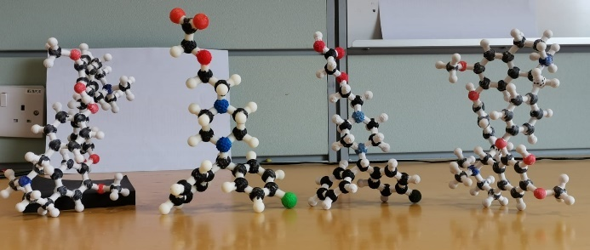

Figure 3: *Both space-filled models and ball-and-spoke models of a 1° / 2° / 3° alkyl halide* A picture containing toy, balloon, ball, indoor

Description automatically generated

**Methodology**

Learning activities were designed with these 3D models embedded in a second year Chemistry module. In week 2, learners discussed aromaticity, metal binding and color. In week 3, chirality in cetirizine and tubocurarine models and their stereospecific binding with receptor was incorporated in students’ case studies whereas learners were asked to explain the ease of SN2/ SN1 reaction for each of the substrate models in week 4. A survey measuring TV and SE were adopted from the Motivated strategies for Learning Questionnaire (MSLQ) (Duncan & McKeachie, 2005), on a 5-point Likert scale, was randomly administered to 87 second year Chemistry learners in week 1 (i.e., pre-intervention survey) and at the end of week 4 (i.e., post-intervention survey). Self-efficacy (SE), as proposed by Bandura (1986), is a person’s judgment about his or her ability to organize and execute courses of action to produce the desired outcome. Task value (TA) is defined as the incentive for engagement in academic activities (Wigfield & Eccles, 1992). Figure 4 lists the eight identical items that were used in the pre and post-interventional motivation survey. The paired t-tests were applied to analyse the change in learners’ motivation in TV and SE.

Figure 4: *Eight Likert statements in motivation survey*

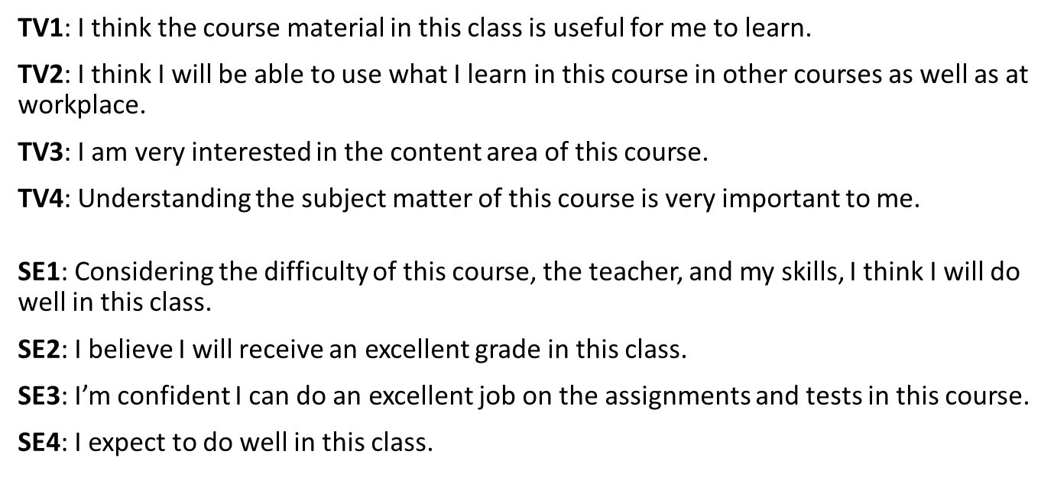

To measure perceived learning, a survey consisting of sixteen items, with 5-point Likert scale, adapted from Gogal et al. (2017), Barzilai & Blau (2014), Davis (1989), and Sousa Lima et al. (2019) were administered randomly as a post-survey to the second year Chemistry learners (N=87). This survey gleaned information related to learners’ perceptions of visualisation of spatial concepts, recollection of information, and usefulness of the 3D models in their learning.

FGD was used to garner learners’ feedback on the effects of the 3D models on perceived learning, motivation and usefulness of the models in learning spatial concepts during activities. A purposively chosen sample of learners (N=10) across four classes, chosen according to their continuous assessment grades from A to C grade in week 3, were invited to participate in the FGD.

The research process is succinctly encapsulated in Figure 5.

Figure 5: *Design of data collection*

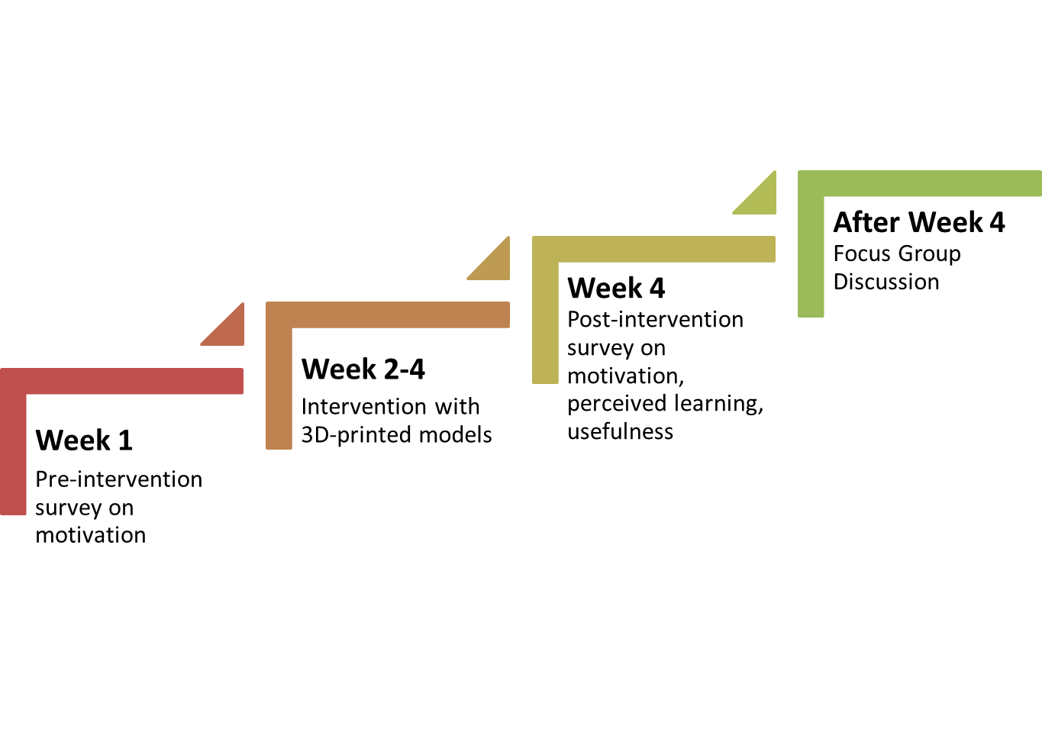

**Results and Discussion**

***Motivation***

Paired t-tests were applied to measure the change in learners’ motivation using the pre- and post- intervention survey of overall motivation, TV and SE. There was a significant increase in learners’ overall motivation scores between pre-survey (M = 3.71, SD = [0.39]) and post-survey motivation scores (M = 3.81, SD = [0.46]); t(88) = [-1.84], p = [0.034] ). Furthermore, there was also a significant difference between pre SE scores (M = 3.39, SD = [0.74]) and post SE scores (M = 3.61, SD = [0.76]); t(88) = [-2.79], p = [0.003]. However, there was no significant difference in pre TV scores (M = 4.04, SD = [0.36]) and post- TV scores (M = 4.02, SD = [0.44]); t(88) = [0.33], p = [0.372]. These results suggest that 3D-printed models significantly increase the SE aspect of motivation. It may be due to actuation of thinking process by model’s haptic perception when learners are immersed in kinaesthetic learning activities. Furthermore, the availability of the model throughout multiple learning phases enables them to visit and re-visit the spatial concept at any time throughout the day may lead to the engagement at the higher level of Bloom’s taxonomy (Michael & Coffman, 1956).

***Perceived learning***

Data shows more than 75% of the learners responded favourably (i.e., either agree or strongly agree) to the items that corresponded to perceptions of visualization of spatial concepts, recollection of information, and usefulness of the 3D models in their learning. Additionally, 78% of the learners reported that they would want to engage in this mode of learning where content is infused with 3D models and approximately 72% would recommend their peers to use 3D models in learning Chemistry. Since the means of all items were greater than the mid-point of their scale, there is positive response to the use of these 3D models in learning the Chemistry concepts as seen in Table 1.

Table 1: *Perceived learning and usefulness of the models*

|  |  |
| --- | --- |
| **Statement** | **Mean (N=87)** |
| I think 3D-printed models allowed me to visualize spatial concepts in organic chemistry more effectively | 4.11 |
| Use of 3D models will help me remember the concepts I learned about SN reaction mechanisms | 3.77 |
| Using 3D models added to my knowledge about substitution reactions | 3.90 |
| 3D models were useful for my learning of spatial concepts | 3.95 |
| I would recommend this tool (3D-printed models) to my peers and juniors | 4.00 |
| I want to engage in this mode of learning more often | 3.92 |

***Focus group discussion***

Thematic analysis was used to analyse how leaners view their experience with 3D models and three themes emerged- Interactive, Innovative and Interesting. FGD with learners further affirmed favorable responses towards the use of 3D models in the learning of Chemistry. Main benefits associated with the use of 3D-printed models include: 1) aid clarity through 3D visualization and hands-on experience; 2) assist recall concepts through colour coding; 3) fun through interactions which keeps learners awake. These are examples of students’ feedback acknowledging the benefits. “*ability to physically hold and move helps visualize stereochemistry of molecules better*” *(Student, Year 3); “hidden part of the molecule becomes apparent in 3D with visualization of hybridization at each atom” (Student, Year 3).*

However, top two challenges include fragile nature of the models and inability to see the spokes /bonds through the space-filled models unlike ball and spoke models. While comparing ball and spoke models, a student mentioned *“bond was not visible easily in space filled models” (Student, Year 3).* Hence, top suggestions included enhancing bond strengths and filament material properties.

3D-printed models were observed to establish an engaging teaching environment by facilitating meaningful communication in learner-centric classroom setting. A similar finding was reported by an earlier work of Tversky (2002).

**Conclusions**

The 3D-printed models could explain multiple concepts simultaneously like valency of carbon and nitrogen, planarity in aromatic heterocycles/ macrocycles, difference between covalent vs co-ordinate covalent bonds, different metal ions impart different color to the metal porphyrinate complex. Keeping uniform CPK color codes for all the subsequently exposed models enables learners’ understanding of the atomic connections. Similarly, these reusable CPK color coded 3D models help the learners to appreciate and visualize the 3D structure and shape of a drug/biomolecule as opposed to its 2D structure drawn on a white board. The concept of stereospecific binding of the drug (*l*-Cetirizine/*d*-tubocurarine) to its receptor site can be observed easily (Figure 2). By experiencing both the ball-and-spoke as well as space-filled models, the learners in organic chemistry students are able to visualize role of steric hindrance in reaction mechanisms.

From the data analysis, it can be concluded that the inclusion of 3D-printed models in kinaesthetic learning activities has the potential to increase learners' motivation with respect to SE. Furthermore, learners perceived these 3D printed models to be useful for learning spatial concepts as well as aid in easy recollection of information. Learners reported favourably to be engaged in such learning infused with 3D models. These models provide better visualization of chemical properties like aromaticity, color, chirality, stereospecific binding of ligands with receptors as well as the relative ease of SN2 Vs SN1 reaction mechanism. For an instructor, these 3D-printed models promote faster achievement of learning outcomes with reduced time required in explanations. This study has the potential to moot for continued use of the 3D models in curriculum delivery of Chemistry concepts.

It is envisaged that the simultaneous employment of 3D models together with a visualisation software may further enhance the effectiveness of teaching spatial concepts. With the 3D printing of models, instructors can easily prepare larger customizable, CPK color-coded models using readily available and economical filaments for classroom demonstrations without compromising the features on the surface.

Additionally, such 3D models can be used in the teaching of Chemistry concepts at secondary school level too. Consequently, these models may be used for science communication, public outreach, science centre and even decoration purposes of educational classrooms, museums and any other such facility.

The authors believe the textured 3D-printed models prepared in this study may provide concrete representations of computer generated images for learners who are blind or visually impaired. It is thus envisaged that this study has the potential to influence curriculum developers teaching spatial concepts to include customized 3D models in pursuit of achieving higher learner SE. Future work will also include testing the impact of the models on a larger number of students to increase the sample size.

**Implications for Teaching**

When teaching these concepts, faculty is encouraged to use activities incorporating the models to aid explanation. Moreover, as part of assessment students should be invited to propose explanations using these models to support their claims.

**Acknowledgements**

This research study has secured academic research funding from Republic Polytechnic.

**References**

Bandura, A. (1986). The explanatory and predictive scope of self-efficacy theory. *J. Soc. Clin. Psychol.*, *4*(3), 359-373.

Barzilai, S., & Blau, I. (2014). Scaffolding game-based learning: Impact on learning achievements, perceived learning, and game experiences. *Comput. Educ.*, *70*, 65-79.

Berry, R.Q., Bull, G., Browning, C., Thomas, C.D., Starkweather, G., & Aylor, J. (2010). Use of Digital Fabrication to Incorporate Engineering Design Principles in Elementary Mathematics Education, *Contemp. Issues Technol. Teach. Educ.*, *10*, 167–172.

Bhattacharyya, G., & Bodner, G. M. (2005). "It gets me to the product": How students propose organic mechanisms. *J. Chem. Educ.*, *82*(9), 1402.

Blackburn, R. A., Villa-Marcos, B., & Williams, D. P. (2018). Preparing students for practical sessions using laboratory simulation software. *J. Chem. Educ.*, *96*(1), 153-158.

Carroll, F. A., & Blauch, D. N. (2017). 3D Printing of Molecular Models with Calculated Geometries and p Orbital Isosurfaces. *J. Chem. Educ.*, *94* (7), 886−891.

Castro-Godoy, J. E. Argüello, M. M., & Daniel A. C. (2018). Unimolecular Nucleophilic Substitution (SN1): Structural Reactivity Evidenced by Colored Acid–Base Indicators Willber D. *J. Chem. Educ.*, *95* (10), 1827-1831.

Cevallos, M., Butler, J., & Stabile, D. (2020). Difficulties learning bones and muscles? Study at home with 3D‐Printed bones. *FASEB J.*, *34*(S1), 1-1.

Cooper, A. K.; Oliver-Hoyo, M. T. Creating 3D Physical Models to Probe Student Understanding of Macromolecular Structure. Biochem. Mol. Biol. Educ. 2017, 45 (6), 491−500.

Davis, F. D. (1989). Perceived usefulness, perceived ease of use, and user acceptance of information technology. *MIS Quarterly*, *13*(3), 319.

Diaz-Allen, C., & Sibbald, P. A. (2016). Using 3D Printing to Model Steric Interactions. *Chem. Educ.*, *21*, 10−12.

Dori, Y.J., & Barak, M. (2001). Virtual and Physical Molecular Modeling: Fostering Model Perception and Spatial Understanding. *J. Educ. Technol. Soc., 4* (1), 61-74.

Duncan, T. G., & McKeachie, W. J. (2005). The making of the motivated strategies for learning questionnaire. *Educ. Psychol.*, *40*(2), 117-128.

Gogal, K., Heuett, W., & Jaber, D. (2017). CHEMCompete: An organic chemistry card game to differentiate between substitution and elimination reactions of alkyl halides. *J. Chem. Educ.*, *94*(9), 1276-1279.

Griffith, K. M., de Cataldo, R., & Fogarty, K. H. (2016). Do-It-Yourself: 3D Models of Hydrogenic Orbitals through 3D Printing. *J. Chem. Educ.*, *93* (9), 1586−1590.

Grove, N. P., & Lowery Bretz, S. (2012). A continuum of learning: from rote memorization to meaningful learning in organic chemistry. *Chem. Educ. Res. Pract.*, *13*, 201−208.

Johnstone, A. H. (1991). Why is science difficult to learn? Things are seldom what they seem. *J. Comp. Assist. Learn.*, *7*(2), 75-83.

Johnstone, A. H. (1993). The development of chemistry teaching: A changing response to changing demand. *J. Chem. Educ., 70*(9), 701.

Jones, O. A. H., & Spencer, M. J. S. (2018). A Simplified Method for the 3D Printing of Molecular Models for Chemical Education. *J. Chem. Educ.*, *95* (1), 88−96.

Kaliakin, D. S., Zaari, R. R., & Varganov, S. A. (2015). 3D Printed Potential and Free Energy Surfaces for Teaching Fundamental Concepts in Physical Chemistry. *J. Chem. Educ.*, *92* (12), 2106−2112.

Lowe, R. K. (1999). Extracting information from an animation during complex visual learning. *Eur. J. Psychol. Educ.*, *14*(2), 225-244.

Michael, W. B., & Coffman, W. E. (1956). Book reviews: Taxonomy of educational objectives, the classification of educational goals, handbook I: Cognitive domain, by Benjamin S. Bloom (ed.). New York: Longmans, green and company, I956. 207 pp. *Educational and Psychological Measurement*, *16*(3), 401-405.

Minasian-Batmanian, L. C., Lingard, J., & Prosser, M. (2005). Differences in students’ perceptions of learning compulsory Foundation biochemistry in the health sciences professions. *Adv. Health Sci. Educ.*, *10*(4), 279-290.

Mohamed-Salah, B., & Alain, D. (2016). To what degree does handling concrete molecular models promote the ability to translate and coordinate between 2D and 3D molecular structure representations? A case study with Algerian students. *Chem. Educ. Res. Pract.*, *17*(4), 862-877.

Penny, M. R., Cao, Z. J., Patel, B., Sil dos Santos, B., Asquith, C. R. M., Szulc, B. R., Rao, Z. X., Muwaffak, Z., Malkinson, J. P., & Hilton, S. T. (2017). Three-Dimensional Printing of a Scalable Molecular Model and Orbital Kit for Organic Chemistry Teaching and Learning. *J. Chem. Educ.*, *94* (9), 1265−1271.

Richards, A. (2019). Teaching mechanics using kinesthetic learning activities. *Phys. Teach.*, *57*(1), 35-38.

Samide, M. J., & Wilson, A. M. (2014). Games, Games, Games; Playing to Engage with Chemistry Concepts. *Chem. Educ.*, *19*, 167−170.

Sousa Lima, M. A., Monteiro, Á. C., Melo Leite Junior, A. J., De Andrade Matos, I. S., Alexandre, F. S., Nobre, D. J., Monteiro, A. J., & Da Silva Júnior, J. N. (2019). Game-based application for helping students review chemical nomenclature in a fun way. *J. Chem. Educ.*, *96*(4), 801-805.

Stull, A. T., Gainer, M., Padalkar, S., & Hegarty, M. (2016). Promoting representational competence with molecular models in organic chemistry. *J. Chem. Educ.*, *93*(6), 994-1001.

Tversky, B. Prolegomenon to Scientific Visualizations. In Visualization in Science Education; Gilbert, J., Ed.; Models and Modeling in Science Education; Springer Netherlands: Dordrecht, Netherlands, 2005; pp 29−42.

Van Wieren, K.; Tailor, H. N.; Scalfani, V. F.; Merbouh, N. (2017). Rapid Access to Multicolor Three-Dimensional Printed Chemistry and Biochemistry Models Using Visualization and Three-Dimensional Printing Software Programs. *J. Chem. Educ.*, *94* (7), 964−969.

Wigfield, A., & Eccles, J. S. (1992). The development of achievement task values: A theoretical analysis. *Dev. Rev.*, *12*(3), 265-310.

**Approval Certificate**

You are required to submit the approval certificate for the purpose of maintaining and publicizing the record of the symposium. The copyright of all contents on your paper is reserved by the author(s) and/or the institution, even if you submit the approval certificate. The sentences on copyright holder(s) and the handling of papers are indicated on every page.