**PRACTICE OF INTELLECTUAL PROPERTY CREATION EDUCATION**

**USING THE TONGS MODEL OF OTSM-TRIZ**

Takayoshi Ohtsu* a

Department of Electrical and Electronics Engineering,

National Institute of Technology, Numazu College, Shizuoka, Japan

* a ohtsu@numazu-ct.ac.jp

**Abstract**

**National Institute of Technology, Numazu College established a club activity IP-TKY (Intellectual Property Terakoya) with the aim of future industrial human resources who will be responsible for Society 5.0 by using TRIZ. In particular, Tongs Model of OTSM-TRIZ, which fosters solutions to technical problems by understanding the ideal and reality and clarifying the difference between them, is practiced.**

**As practical examples, (1) Challenging Ene-1 GP which is the battery bicycle (KV-BIKE) race powered by 40 rechargeable AA batteries held at the International Racing Course in Suzuka Circuit and Mobility Resort Motegi. (2) Observation of deep-sea creatures and topography by shooting deep-sea images of Suruga Bay, the deepest bay in Japan. (3) To study the** **TRIZ’s 40 principle of invention, making a life-size model of coelacanth using educational 3D blocks (Artec block) to exhibit in Numazu bay deep sea aquarium. (4) Challenge the patent contests.**

**These activities were highly evaluated and were introduced at the commemorative event of World Intellectual Property Day (April 26,2022) of WIPO (World Intellectual Property Organization) Japan office. Furthermore, in collaboration with Suruga Bay Ferry, we produced a video introducing the charm of Suruga Bay by Riz Chitera, an original Vtuber related to intellectual property, and developed 3D model education materials to study deep sea　topography. In that activity, we tried to solve technical contradictions using** **the TRIZ’s inventive principles. We created a Suruga Bay educational program and held a Suruga Bay classroom for elementary and junior high school students at the Suruga Bay ferry and Izu Shirakabeso in order to revitalize the region, a new tourism model was created that added the value of intellectual property education to conventional tourism such as transportation and accommodation by practicing intellectual property creation education using the Tongs model of OTSM-TRIZ.**

**Keywords:***TRIZ, OTSM,*　*TONGS model, Problem Solving Intellectual Property, Creation Education, Izu, Suruga Bay, IP-TKY*

**Introduction**

In 2016, National Institute of Technology, Numazu College established a club activity IP-TKY (Intellectual Property Terakoya) with the aim of developing value-creating future industrial human resources who will be responsible for Society 5.0 by using TRIZ. TRIZ is an idea conception method born from the analysis of 2.5 million patents, and includes problem-finding tools such as the 9-screen method and problem-solving tools such as TRIZ’s 40 inventive principles. In particular, Tongs Model of OTSM-TRIZ, which fosters solutions to technical problems by understanding the ideal and reality and clarifying the difference between them, is practiced.

The main activities are (1) Taking advantage of the regional characteristics of the mobility industry, we are challenging Ene-1 GP which is the battery bicycle (KV-BIKE) race powered by 40 rechargeable AA batteries held at the International Racing Course in Suzuka Circuit and Mobility Resort Motegi. And the activity has cooperation with environmental energy education. (2) Conducting deep sea research activities in Suruga Bay, which is the deepest bay in Japan (water depth 2,500m), we are taking advantage of its regional characteristics. And, the results of these activities are cooperated with the activities of local governments and companies. (3) As part of the development of education materials based on regional characteristics, we are conducting program robot classes using 3D blocks (Artec block) and TRIZ educational activities. In 2021, in making a life-size model of coelacanth using educational blocks, we tried to solve the technical contradiction of shape and strength using the TRIZ’s inventive principles. These activities were highly evaluated and was introduced at the commemorative event of World Intellectual Property Day (April 26, 2022) of WIPO (World Intellectual Property Organization) Japan office. Furthermore, in collaboration with Suruga Bay Ferry, we produced a video introducing the charm of Suruga Bay by Riz Chitera, an original Vtuber related to intellectual property, and developed 3D model teaching materials to study deep sea topography. In that activity, we tried to solve technical contradictions using TRIZ’s 40 principle of invention. We created a Suruga Bay educational program and held a Suruga Bay classroom for elementary and junior high school students at the Suruga Bay ferry and Izu Shirakabeso. In order to revitalize the region, a new tourism model was created by adding value to conventional tourism such as transportation and accommodation by practicing intellectual property creation education using the Tongs model of OTSM-TRIZ. Furthermore, we are challenging patent contests by making use of the creativity cultivated through these activities.

**Educational Materials and Methods**

***Campus-wide intellectual property creation education***

National Institute of Technology, Numazu College is located in the eastern part of Shizuoka Prefecture, close to the Tokyo metropolitan area, surrounded by the region's unique characteristics such as Japan's highest mountain, Mt. Fuji, Japan's deepest bay, and the Izu Peninsula Geopark, and opened as a 1st term school in 1961. There are five specialized departments: mechanical engineering, electrical and electronic engineering, electronic control engineering, control information engineering, and material engineering, as well as a comprehensive system engineering course, with approximately 1,050 students studying there (Figure. 1).

The Department of Comprehensive System Engineering was established in 2012, and has three courses: Environmental Energy Engineering, New Functional Materials Engineering, and Medical and Welfare Equipment Development Engineering. Since 2009, as part of the "Pharma Valley Concept" promoted in the eastern part of Shizuoka Prefecture, our school has been responsible for human resource development in the medical equipment development engineer training program. In recent years, the Cabinet Office Intellectual Property Strategy Promotion Secretariat has been promoting intellectual property creation education in elementary, junior high, and senior high schools and technical colleges. In particular, INPIT (Industrial Property Information and Training Center) is promoting the ''Development Project for Intellectual Property Creativity, Practical Ability, and Utilization Ability'' for specialized high schools and technical colleges that will produce tomorrow's industrial human resources. Our school has been participating in this project since 2016, emphasizing intellectual property education from the perspective of developing local industries and developing human resources who will be responsible for Society 5.0. In order to promote intellectual property learning throughout the school, our school conducts a "spiral-up type" that continuously touches "intellectual property" according to the stage of growth at least once a year from first year students to advanced course students. A campus-wide intellectual property learning system has been constructed (Table 1). Since 2018, an intellectual property seminar has being held for all first-grade students by the teacher in charge. And in collaboration with the Japan Patent Attorneys Association, an intellectual property basic seminar for all second-grade students and an intellectual property application seminar for all third-grade students have being held. In addition, there is an intellectual property skills test and intellectual property learning through assignment research. Through these studies, all students' interest in intellectual property studies is increasing. Also, in the upper grades, in the compulsory subject "Society and Engineering" for all 4th grade students, we analyze the situation of local governments and companies a method of thinking about the problems found there using TRIZ as a weapon. We are conducting a curriculum that "proposes solution ideas that are conscious of utilization". The hierarchy of TRIZ education is shown in Figure 2. For students who want to learn more, there are assignment research and extracurricular activity ''Intellectual property TKY''.

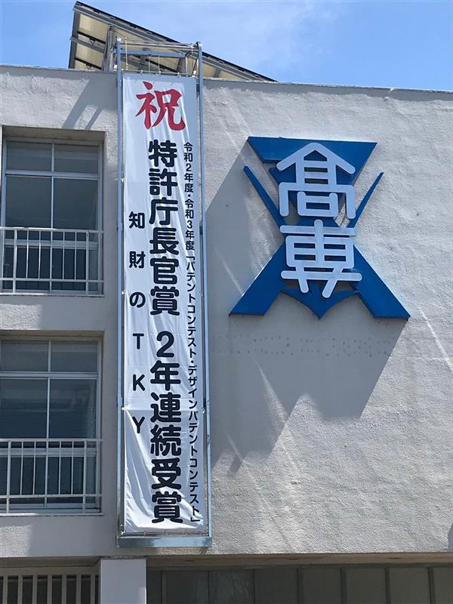

Figure 1 NIT, Numazu College

Table 1 Campus-wide IP creation education



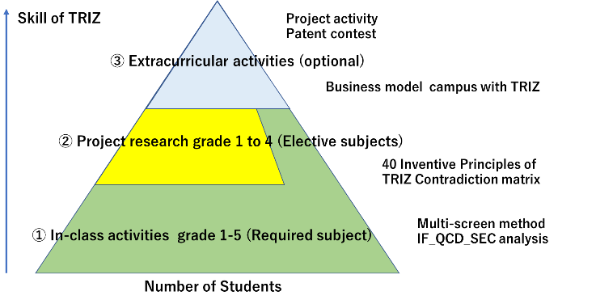

Figure 2 Contents of TRIZ education

*Intellectual property TKY*

In 2016, a special club as an extracurricular activity, "Intellectual Property TKY (Terakoya)" was established with the aim of developing value-creating future industry human resources who will be responsible for Society 5.0. Raise interest in intellectual property, analyze regional characteristics, and conduct intellectual property activities aimed at utilizing those regional characteristics as one's own business. It has regional characteristics represented by Mt. Fuji and Suruga Bay, and conducts activities in collaboration with local governments such as environment, energy, nature conservation, agriculture, fisheries, and tourism. In particular, through the challenge to the real thing, we aim to understand the difference between the ideal and the reality, and to practice the TRIZ Tongs model to work on the solution. There are three main activities, the first is the battery bicycle race, the second is the Suruga Bay deep sea survey, and the third is the development the education materials to learn the TRIZ and to create the added value. The KV-BIKE project utilizes the regional characteristics of the mobility industry, and uses 40 rechargeable AA batteries to compete in the Suzuka Circuit International Racing Course and the Twin Ring Motegi Super Speedway challenge and cooperation with local environment and energy education. The deep sea project is in collaborating with local governments and companies that make use of the deep sea survey activities of Suruga Bay, which makes use of the regional characteristics of Japan's deepest bay (2,500 m deep), and the contents of the survey. The education material development project is developing of 3D blocks with the theme of regional characteristics and developing of education materials to learn the TRIZ and to create the added value that make use of regional characteristics. In addition, using the creativity nurtured through these activities, we are also challenging patent contests.

1. *KV-BIKE project*

In the KV-BIKE Project, a battery-powered bicycle race, battery-powered bicycles equipped with 40 rechargeable AA batteries compete for a time attack over a course of about 2km and a total of points earned in a 1-hour endurance race. This battery-powered bicycle race takes advantage of regional characteristics and is used as educational materials for futuristic electric mobility and environmental energy education (Figure 3). Our school challenged the international racing course of Suzuka Circuit and the Twin Ring Motegi Super Speedway as a battery bicycle race. Energy management is the key to victory, and along with this, various ingenuity is required. For example, the position and angle of the saddle are adjusted so that the body is in a straight line to reduce air resistance. In 2021 and 2022, it has been selected as one of the 4 KV-BIKEs whose driving posture seems to be unduly tight.

*(2) Deep Sea Project*

Suruga Bay has a depth of 2,500 m. In Figure 4, the roadmap of our deep sea survey is shown. We developed a real-time monitoring system (DREAM_1) in 2016, reaching a depth of 100 m. After that, the first 4K video shooting system (PIXY) was newly developed, and in 2018, it succeeded in shooting 4K video at depths of 530m and 1030m from the sea surface. In 2019, Our project (Figure 5) used the second system (PIXY-II) with improved water pressure resistance, and succeeded in 4K shooting at a depth of 1530m and in 2021 at a depth of 1750m. Furthermore, in 2022, we developed the third system (PIXY-MONA), which enables long-time recording by further improving the water pressure resistance of the light and increasing the battery, and succeeded in 4K shooting at a depth of 2030m.The results are announced at the Zoological Society of Japan after the dates have been confirmed at the notary public office (Figure 6).

　　　　　Figure 3 KV-BIKE Project

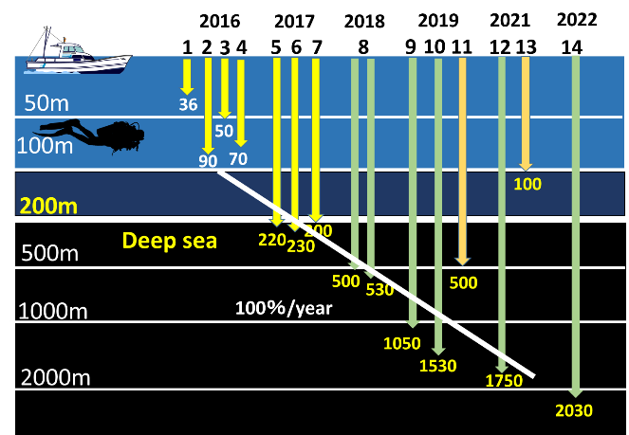

Figure 4 Deep sea survey road map

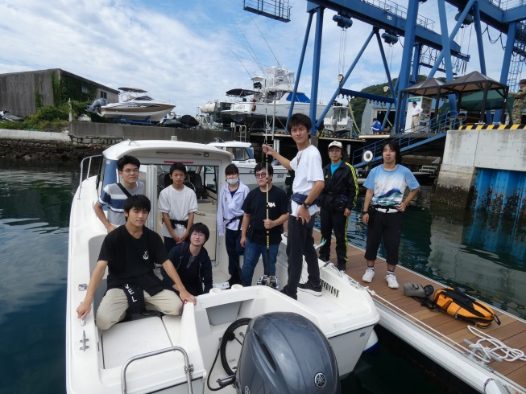

Figure 5 Deep sea project

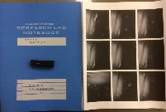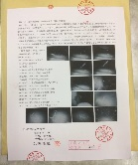

　 　Figure 6 Confirmation of date

*(3)* *Educational material development project*

In 2020, deep sea survey was restricted due to the impact of the corona disaster. Therefore, in order to express the charm of the deep sea, we decided to create a life-size model of the coelacanth, which is said to be the "fish that brings happiness" (Figure 7). In the first stage, it was designed with Microsoft's Minecraft (a 3D creation game), and then in the second stage, it was actually produced with 11,000 3D blocks (blocks for educational materials) from Artec. We wanted to freely shape what we thought, but we challenged the technical 　contradiction that strength is necessary with the TRIZ Inventive Principles, furthermore, we experienced practically that "value" is created in the work. The activities of this life-size 3D block model of the coelacanth were introduced at a commemorative event for World Intellectual Property Day of the World Intellectual Property Organization (WIPO) on April 26, 2022. The work was introduced at the LOVE NUMAZU event in Numazu City held at the commercial facility "Lalaport Numazu" in October 2020, and then exhibited at "Lalaport Numazu" for a month. From December 2020, it has been exhibited as the sixth coelacanth next to the real frozen coelacanth at the Numazu Deep Sea Aquarium. In addition, taking this opportunity, we are conducting research on the behavior observation of Bathynomus doederleinii with the Numazu Deep Sea Aquarium.

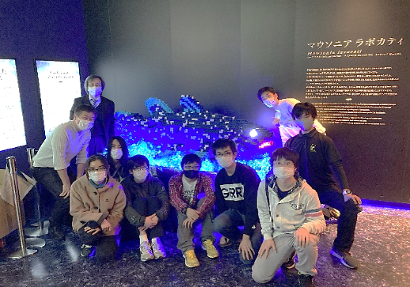

　　　 Figure 7 3D Block coelacanth

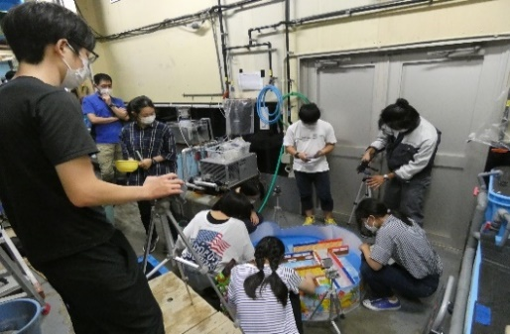

Figure 8 Observation of Bathynomus doederleinii

In collaboration with Suruga Bay Ferry, intellectual property Vtuber "Riz Chitera" produced a video introducing the charm of Suruga Bay. This is part of an on-board educational program that uses the results of the Suruga Bay deep sea survey efforts to convey the attractions of deep sea topography, deep sea creatures, and deep-sea heritage to elementary and junior high school students (Figure 9,10,11). In addition, as an educational material for Suruga Bay, we developed a Suruga Bay 3D model education material that can learn the topography of Suruga Bay. A technical contradiction during development, "It takes time (about 1 hour) to create the shape of Suruga Bay with a 3D printer. Also, we can't make a lot of them"　was challenged using the TRIZ 40 Inventive Principles. Consider with TRIZ Contradiction Matrix. We want to" make it easy" to make", but it takes "hours".　Consider solutions with TRIZ 40 Inventive Principles. Inventive principle 35: Principle of Parameters changes for liquid to solid, concentration, hardness and temperature. Inventive principle 28: Principle of Sensor utilization (replacement of mechanical method, another perception) for processing method. Inventive Principle 34: Principle of Exclusion regeneration for remove unnecessary parts. Inventive Principle 4: Asymmetry principle for make it easier to remove from the mold. As a result, create a reverse mold with a 3D printer, stamp it on clay, and create the shape of Suruga Bay. Figure 12 shows various prototypes, Table 2 shows the prototype results, and Figure 13 shows the relationship between ease of production and time. In particular, in response to a request from the Suruga Bay Ferry that they wanted to implement it in 10 minutes, as a result of examining Figure14, it was decided to use a case direct insertion type in Figure15. We created a Suruga Bay educational program and held a Suruga Bay classroom for elementary and junior high school students at the Suruga Bay ferry and Izu Shirakabeso in Figure 17 and 18.

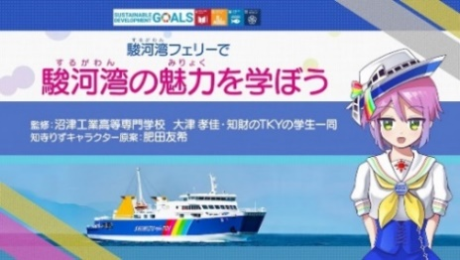

Figure 9 Suruga Bay educational video

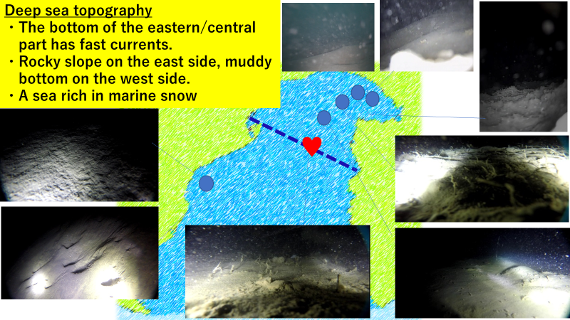

Figure 10 Deep sea topography

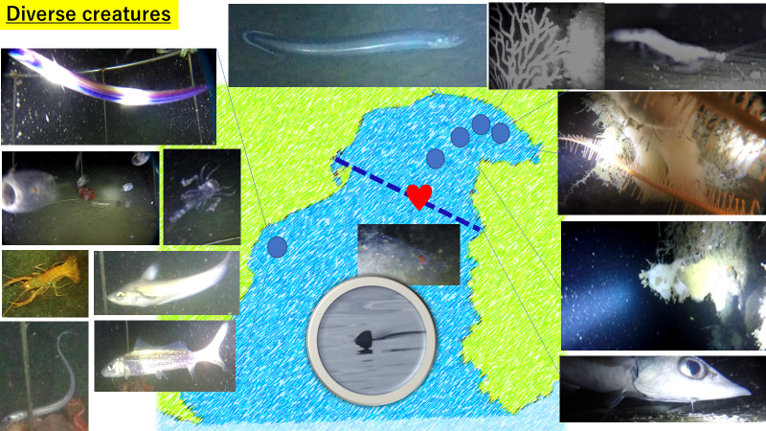

Figure 11 Deep sea creatures

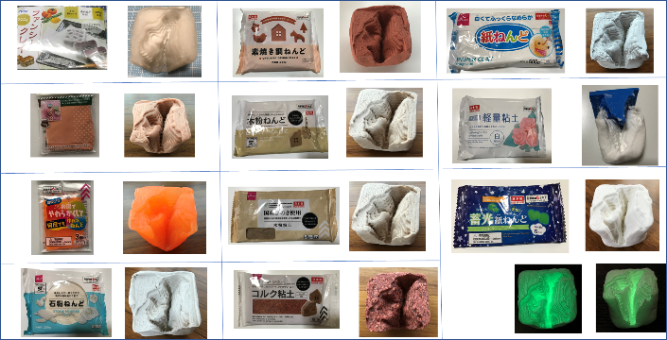

Figure 12 Suruga Bay Topographical Model

Table 2 Suruga Bay Topographical Model

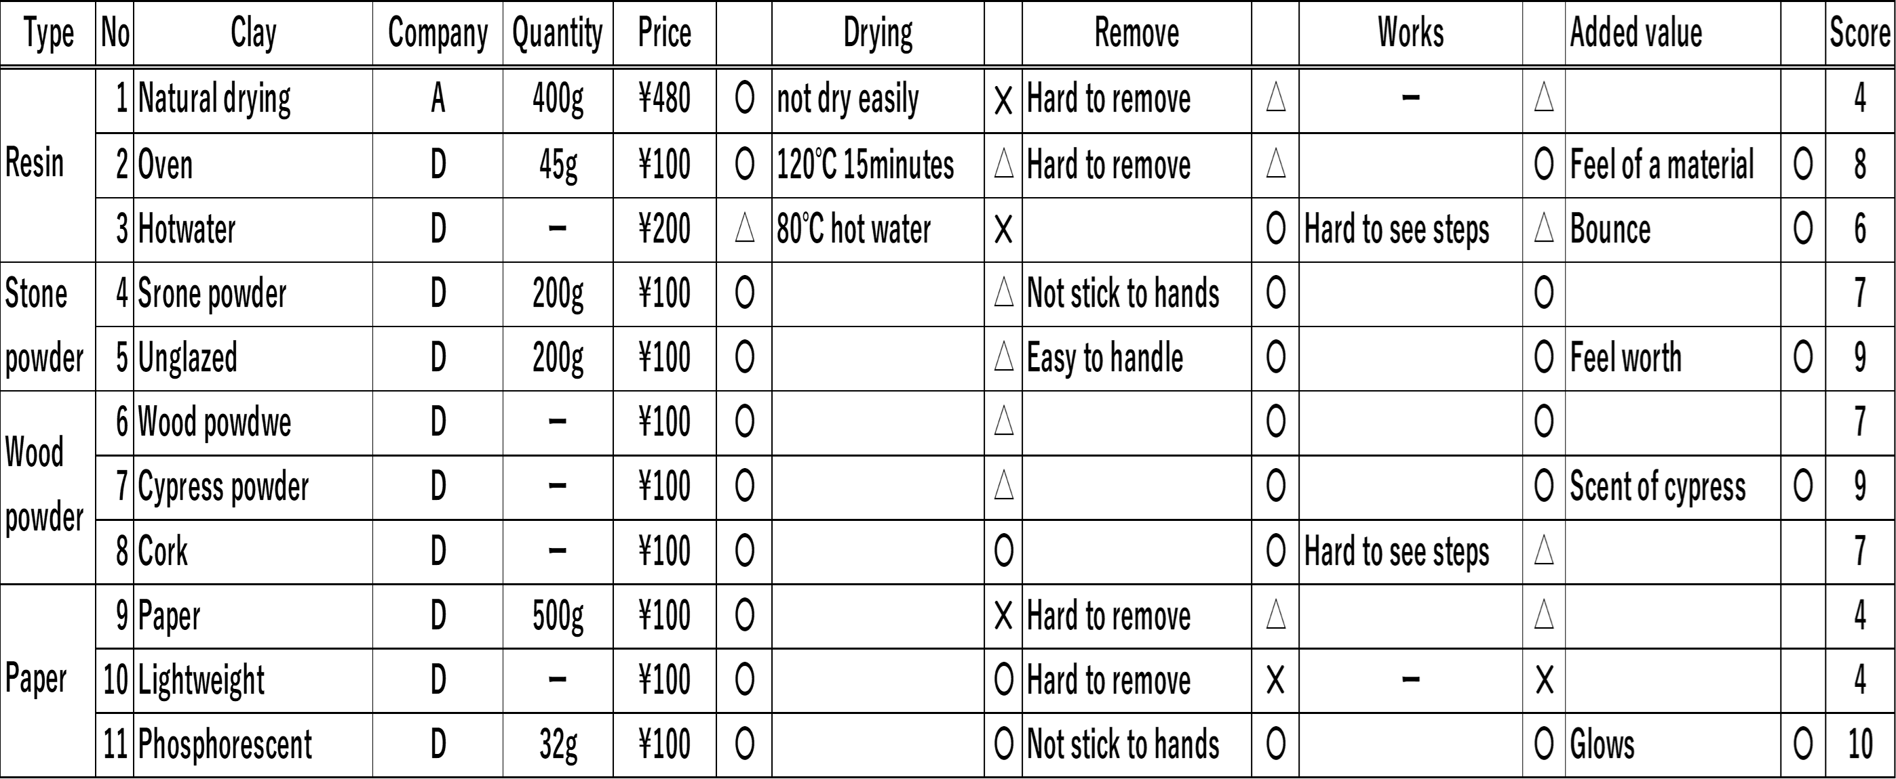

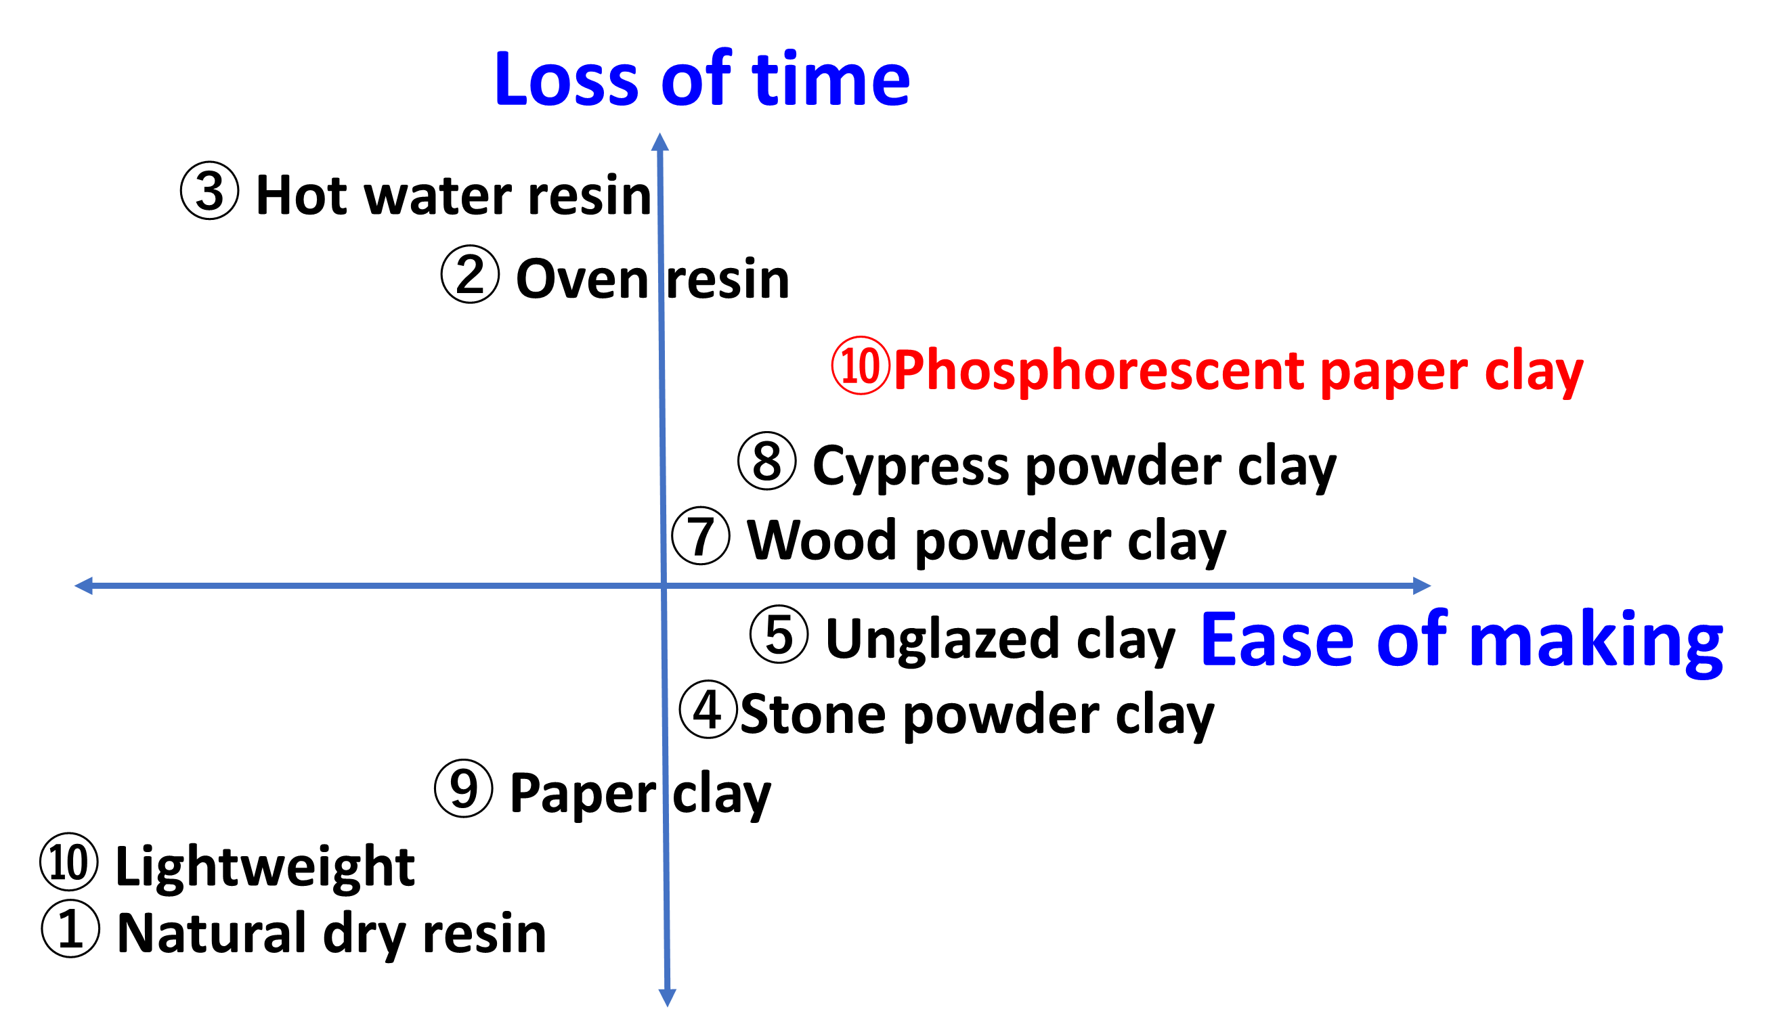

Figure 13 Ease of making and time

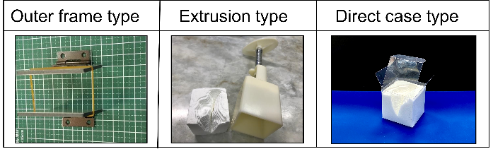

Figure 14 Study on how to make in 10 minutes

　　 　　　Figure 15 Suruga Bay topography model

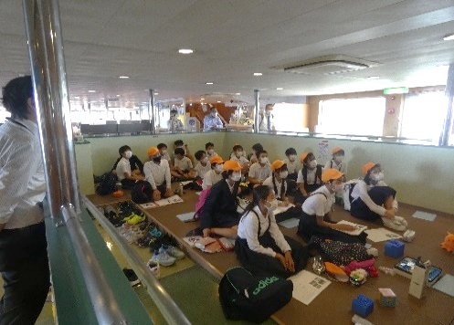

Figure 16 Suruga Bay Ferry

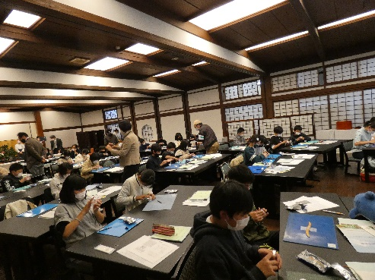

Figure 17 Izu Shirakabeso

**Results and Discussion**

*(1) KV-BIKE project*

In the university/technical college division of the Ene-1 GP Suzuka, we got second place in 2017 and third place in 2019. Also, at the Ene-1 GP Motegi, 2016 winner, 2017 winner (Class I "general / university / technical college" category "3rd place overall"), 2018 runner-up, 2019 3rd place, 2022 3rd place and 7 times Shining on the podium.

In addition, since 2018, we have been supporting the junior high school team of Mishima City with the support and cooperation of the Department of Electrical and Electronic Engineering. 2018 Ene-1 GP Suzuka Junior High School Champion (Class II “High School/Junior High School” Category “3rd Overall”), 2019 Champion, 2021 Champion, 2018 Ene-1 GP Motegi Junior High School Champion and 2019 Champion, In this way, the junior high school team has won the championship five times.

Figure 18 Technical college students and junior high school students working on KV-BIKE

1. *Deep sea project*

Presented at the 2019 Annual Meeting of the Zoological Society of Japan Chubu Branch. In the poster presentation, '' 100 to 200m deep sea survey in Numazu, Suruga Bay using a real-time system'' won the Excellence Award, and '' 500 to1500m deep sea survey in Numazu, Suruga Bay using a 4K video recording system'' won the competition chairperson award.

Furthermore, in the oral presentation, "Challenge to 1500m in the Suruga Bay Deep Sea by Numazu National College of Technology Students" won the Excellence Award and the Conference Chairman's Award. At the 2021 Annual Meeting of the Zoological Society of Japan, “Investigation of 1750m deep water in Suruga Bay using a compact 4K imaging system'' and 2022 Annual Meeting of the Zoological Society of Japan, “Deep sea topography and marine snow accumulation using a 3D model of Suruga Bay'' and “From deep sea research in Suruga Bay to production of on-board educational programs”, we received the Excellence Award. At the 2022 Annual Meeting of the Zoological Society of Japan Kanto Branch, we made a presentation titled "Suruga Bay 500-2030m topography and biological survey using a compact 4K imaging system".

*(3) Educational material development project*

The 3D block coelacanth will continue to be exhibited at the Numazu Deep Sea Aquarium in 2023. This creates value in terms of children's interest in deep sea creatures and interest in manufacturing. In addition, improvements have been made as a product that requires increased reliability through long-term exhibition. Observation of the turn alternation of Bathynomus doederleinii has led to a presentation at the Zoological Society of Japan. The Suruga Bay Education Program was used in the Suruga Bay Classroom for elementary and junior high school students at the Suruga Bay Ferry and Izu Shirakabeso. In collaboration with the Suruga Bay Ferry (transportation) and the inn (accommodation) on the Izu Peninsula, we proposed and constructed a new tourism model combining tourism and intellectual property creation education materials, with Suruga Bay as a campus for intellectual property creation education. Taking advantage of intellectual property creation activities, we challenged the patent contest and were able to win the Patent Office Commissioner's Award for the 2020 Hatogi Project (knife sharpener) and the 2021 Ryota Suzuki (rubber band gun) for two consecutive years.

**Conclusions**

Through the practice of the Tongs model through real challenges such as Suzuka Circuit, Twin Ring Motegi, Suruga Bay, and Numazu Deep Sea Aquarium, the following things were clarified.

(1) KV-BIKE is effective as environmental and energy education for technical college students, and it is also an effective activity for junior high school students to develop sharp human resources by working together with technical college students and junior high school students.

(2) The water depth of the Suruga Bay deep sea survey was able to realize a 100% inclination in one year. This is equivalent to the technological development of hard disks introduced in The Innovation's Dilemma, and is effective as an innovative human resource development.

(3) The 3D block coelacanth and the Suruga Bay model using TRIZ's inventive principle and contradiction matrix are asset as Suruga Bay teaching materials such as the Suruga Bay Ferry and Izu Shirakabeso are effective in creating added value for tourism as new tourism models.

(4) We were able to show two models of creative activities, group and individual, which are conscious of utilization, such as winning the Patent Office Commissioner's Award for two years in a row in the patent contest.

**Acknowledgements**

In promoting intellectual property creative education, I would like to express my deep gratitude to everyone at the Cabinet Office Intellectual Property Creation Education, WIPO Japan Office, Patent Office, Japan Patent Attorneys Association, Invention Promotion Association, INPIT, Shizuoka Prefecture, Numazu City, Mishima City, Suruga bay Ferry, Numazu bay Deep Sea Aquarium, Yamaha Marina Numazu, Izu Matsuzaki Marina, LaLaport Numazu, and Artec Co., Ltd.

**References**

Cabinet Office. (2019). *Intellectual Property Creation Education Pamphlet.*

*https://www.kantei.go.jp/jp/singi/titeki2/tizaikyouiku/pdf/s-1e.pdf*

INPIT. (2022). *Intellectual Property Learning Support for Tomorrow's Industrial Human Resources, Independent Administrative Institution Industrial Property Information and Training Center,*

https://www.inpit.go.jp/jinzai/educate/index.html

Japan Patent Office. (2019): *Intellectual property creation education for creating new things and things in a fun way Class guides for creating the future ~Examples and hints of learning instruction plans that can be started immediately in all subjects~*

Japan Patent Office (2021). *Patent Contest/Design Patent Contest Awards Ceremony Held.*

https://www.jpo.go.jp/news/ugoki/202103/031291.html

Nikolai Khomenko. (2013). *Inventive problem solving using the OTSM-TRIZ“TONGS” model.*

https://www.otsm-triz.org/sites/default/files /ready/tongs_en.pdf

Suruga Bay Ferry.(2022). *Introduction to Suruga Bay by Riz Chitera*.Youtube.

https://www.youtube.com/watch?v=J6Ir5mmX06s

Wedge (2022,March 26). Technical college students give shape to their ideas in the "intellectual creation cycle"

https://wedge.ismedia.jp/articles/-/26137?page=2

WIPO Japan Office. (2022). *Intellectual Property TKY (Terakoya) Project of Numazu National College of Technology.* *World IPDay 2022.*

https://c.connectedviews.com/01/Player/WIPOwebinars/?s=115553&a=false