**A PRELIMINARY STUDY ON THE EFFECTIVENESS OF ACTIVE-COLLABORATIVE LEARNING IN PRAGMATIC-BASED MECHANICAL ENGINEERING MODULE**

H. Kwong H.R.

School of Mechanical and Aeronautical Engineering, Singapore Polytechnic, Singapore, Singapore

henry_kwong@sp.edu.sg

**Abstract**

**This paper studies the effectiveness of Active-Collaborative Learning (ACL) in a pragmatic-based engineering module offered by the School of Mechanical and Aeronautical Engineering (MAE) in Singapore Polytechnic (SP). Being pragmatic is one of the essential components of Computer Aided Machining (CAM), a skillset that was addressed in one of the advanced modules in the second year of SP MAE studies. In essence, developing mastery in CAM requires students to attain the highest competency in the Bloom Taxonomy within the 15 weeks of study, which was often challenging for students. There have been few studies about the pedagogy in pragmatic-based modules as of this writing, which prompted the author to conduct research to develop a more comprehensive instruction method and find common ground with lecturers who teach modules of a similar nature. The implementation of ACL provided a two-way learning approach in the classroom setting, allowing for greater interactivity and knowledge exchange among students and lecturers. The two primary activities that facilitated ACL implementation were the pre-class preparation and the in-class activity. The pre-class preparation entails students to first complete the assigned tasks before attending the subsequent lesson. Knowledge-exchange-based activities were then incorporated into the in-class activity, making it more participatory and, as a result, attaining the ACL objectives. Quiz components of a total number of 208 entries were considered to determine the effectiveness of this approach. The findings indicated that ACL was effective as the quiz results revealed a positive correlation between the students went through ACL setup and the quiz scores. The statistical evidence that ACL was effective was supported by the fact that students who participated in ACL had higher mean of quiz scores than those in control group, along with a high t-value and low Cohen's ds value. Following the conclusion of the learning of one major skill, a student perception survey was included. The survey's feedback scores showed that students were getting better at understanding and applying their acquired knowledge of CAM. In conclusion, the higher degree of interactivity and knowledge exchange in ACL has produced a productive learning environment where the students are better able to comprehend and integrate the concept and subsequently complete the assignments.**

**Keywords:** *Pragmatic-based Module, Computer Aided Machining (CAM), Active Learning, Active-Collaborative Learning, Pragmatic*

**Introduction**

*“To teach is to engage students in learning”* (Christensen et al., 1991). That’s the essence of Active Learning pedagogy. Active learning differs from typical lecture-based teaching approaches in that it prioritizes student engagement, interaction, and collaboration. Bonwell and Eison (1991) discovered that after the active learning technique was imposed on their learning, the pattern of communication among the students in the class had significantly improved. As active learning promotes inclusivity and diversity in the classroom, learner-centred activities are becoming increasingly important, and it should be designed with the intention of enhancing the higher order cognitive skills among students in the Revised Bloom’s Taxonomy (RBT) pyramid (Anderson and Krathwohl, 2001; Bergmann and Sams, 2012).

In a typical active learning environment, students were grouped together so they could share ideas and learn from their peers instead than depending solely on lecturers to impart knowledge. (Ballen et al., 2017; Cho et al., 2021; Mason et al., 2013). This is the Collaborative Learning, one of the commonly used strategies in active learning. Collaborative learning is a joint learning between the students and teachers, where the efforts can come primarily from students, or the partnership between students and teachers (Smith et al., 1992). The introducing of this interdependency during classroom learning has increased the cognitive learning among students, which has created a positive hype in terms of intrinsic motivation to allow students to learn better (Järvenoja et al, 2020; Scager et al., 2016). The proliferation of peer teaching, especially in a tertiary education institution, accelerates the collaborative element among peers, provides students the necessary platform and motivations to lead the discussions in the classroom settings.

Studies have proved that by adopting the pedagogical revolution of active learning method in Science, Technology, Engineering and Mathematics (STEM) modules, students are able to master the subject well (Freeman et al., 2014), thereby closing the achievement gap between a below-average and above-average STEM student at the expense of supplementary classes (Theobald et al., 2020). This has motivated the author, together with only a few studies about the pedagogy in pragmatic-based modules as of this writing, to explore the possibility of adopting this pedagogy into the pragmatic-based Computer Aided Machining (CAM), a skillset that was addressed in one of the advanced modules in the second year of Singapore Polytechnic (SP) School of Mechanical and Aeronautical Engineering (MAE) studies.

Pragmatic-based lesson often drawn from a scientific or a technical discipline, emphasizing on philosophical or practical approach that highlights the practical consequences and usefulness of ideas or actions of real-world problem solving. Given the nature of pragmatic-based lessons, where students are required to put their plans into action at the conclusion of their studies, the learning curve is steep if they have little background information or expertise. This is apparent in the field of CAM, where students are required to fabricate the part at the end of their studies rather than just comprehend the theory.

CAM, one of the leading technologies deployed in Precision Engineering industries, is defined as a use of software to introduce toolpaths to control a Computer Numerical Control (CNC) machine to automatically perform the subtractive machining operations and thus, enable the end user to have a highly precise and accurate part. Understanding the basic principle of machining is thus crucial for assuring the production of extremely precise parts while maintaining their safety and effectiveness in terms of cost and time. When programming in CAM, learners must be able to envision the cutter movement during the actual cutting process as well as the shape of the materials after each cutting operation, which may be difficult if they are unfamiliar to this technology. As shown in Figure 1 below, developing mastery in CAM requires students to attain the highest competency in the Bloom Taxonomy within the 15 weeks of study, which raises the bar for learners to master this skillset both conceptually and practically.

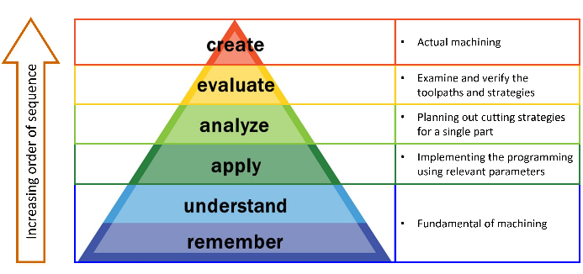

Figure 1: Detailed CAM process distribution based on Revised Bloom’s Taxonomy, remodeled with model from Vanderbilt University Center for Teaching under Common Creative Attribution license

This paper researched on active-collaborative learning (ACL) in CAM module. The groups involved in this study were the SP Year 2 Diploma in Mechanical Engineering (DME) students. A study was carried out to differentiate the outcome of quizzes results between the two groups, with surveys and questionnaires conducted after the completion of learning of a major skillset. Two area of concerns were addressed in this paper:

(a) The ACL improved students’ performances in terms of assessments scores.

(b) The ACL was able to engage and motivate students to learn better prior and during class.

**Methodology**

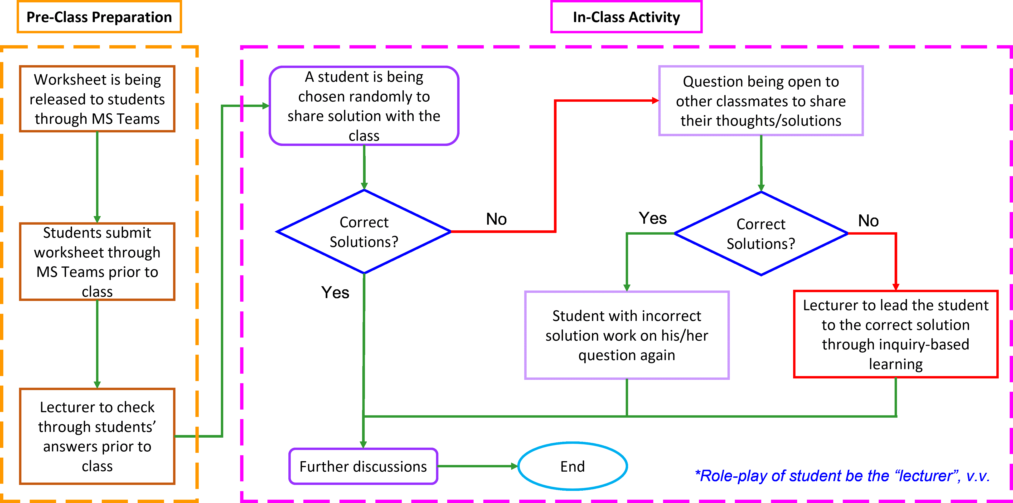

Figure 2: ACL Concept Flowchart

Figure 2 illustrates the concept flowchart of the active-collaborative method that the author has deployed in this study. Two primary activities were deployed to facilitate this implementation: the pre-class preparation and in-class activity. Microsoft (MS) Teams was the main communication platform for all assignment submissions.

The objectives for pre-class preparation were:

• To enable students to summarize the lecture contents after reviewing.

• To enable students to apply the fundamentals that they have learnt to perform toolpath programming operations.

The objectives for in-class activity were:

• To enable students to explain and justify their solutions, prompting a recall process of what they have learnt.

• To enable students to cross-refer their solutions with their peer, reflecting about where were the similarities and differences between the solutions.

• To enable students to respond to their peers’ queries, allowing them to have a better peer-to-peer learning.

• To allow lecturer to gauge the student’s level of understanding with a role-swapping activity.

*Pre-class preparation:*

Students were told on the objectives of the activities during the first class so that they were more appreciative of the activities and therefore boost their involvement and commitment to both the pre-class and in-class activities (Deslauriers et al., 2019; Owens et al., 2020; Prince et al., 2006). In order to show an unbiased selection process for presenters, students were informed of the procedure and ground rules.

Worksheet was distributed through MS Teams in advance and students were required to submit their solution through MS Teams prior to the class.

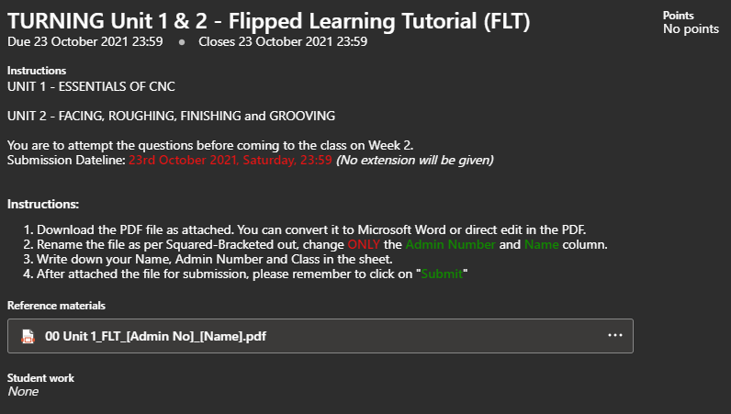

Figure 3: Screenshot of instructions using Microsoft Teams

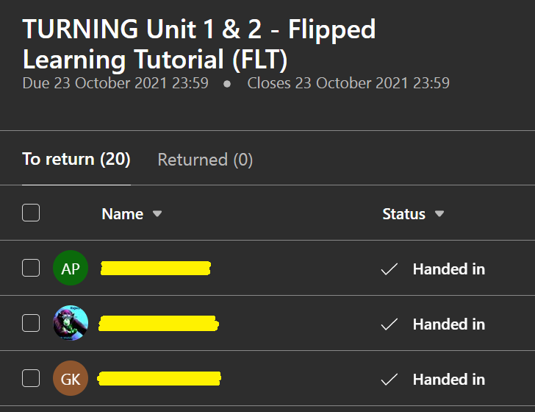

Figure 4: Sample of Students submission from Lecturer point-of-view

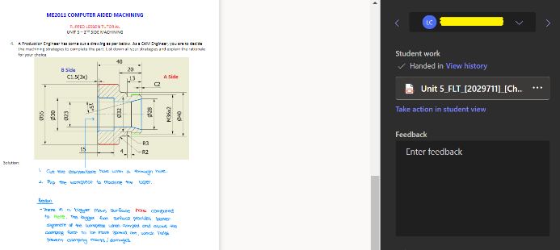

Figure 5: Example of student's work, from Lecturer POV in MS Teams

Questions in the worksheet should be designed in a way that students were able to recall *(lower order cognitive skill),* analyse and apply *(higher order cognitive skills)* about what they had learnt in theory.

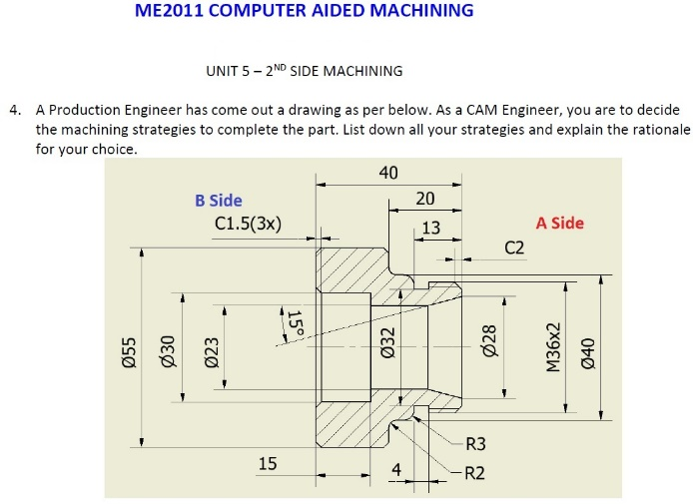

Figure 6: Example of Higher Order Thinking Skills question

*In-class activity*

The collaborative element was introduced to involve the student-to-student learning and teacher-to-student sharing. Students were the focus of the class, leading the teaching session by describing the "what" and "how" to the posed question. In this design, the lecturer played more of a facilitator role, supplementing the presenter's missing points and directing the presenter to the appropriate solution through a series of scaffold questions if the solution offered was incorrect.

Students were often chosen at random by Wheel of Fortune to play the "lecturer" role, in which he or she would share lead the class discussion, regardless of the accuracy of his or her solutions. Nonetheless, students were strongly encouraged to volunteer to share their solutions with their peers so that they may learn from one another. Quoting from Bergmann *“…But when learning is in the hands of the students and not in the hands of the teacher, real learning occurs.”* (Bergmann and Sams, 2012, pg. 111). Following the sharing, the selected presenter will be given some time to address any questions raised by classmates. It is worth noting that the lecturer has the option of role-playing as a student during the classroom activities setup and posting some questions that the lecturer believes necessary or capable of improving the student's understanding. Through this role-swapping activity, the lecturer would be able to provide timely feedback since he/she gained a better insight of the degree of understanding among students, thus, directing them to the correct solutions through inquiry-based learning.

**Results and Discussion**

*Quiz results analysis*

A total of 208 entries *(N=208)* were recorded, where two main groups consisted of control group *(n=103)* and experimental group *(n=105).* To access the effectiveness of new approach, only the quizzes scores were used for the analysis in this study. Surveys feedback and questionnaires scores were being recorded after the completion of learning of a major skill. The primary objective of included surveys was to observe and reflect on how students coped with their studies with active-collaborative learning (ACL) in class together with the quiz results.

Hypothesis of this research was defined as: *ACL is able to improve student’s assessment score for pragmatic-based module.*

Homogeneity of variances was deployed to check the dependent variables before analysis. Confirming with F=1.38 *(p=0.05),* the null hypothesis stands, meaning that the variances between two samples of students are the same.

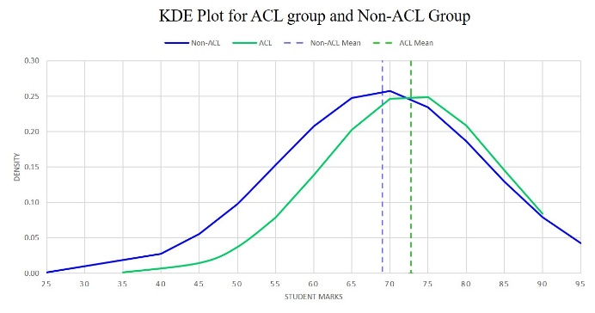

Figure 7: KDE Plot for the ACL group and non-ACL group

Kernel Density Estimation (KDE) graph with a bandwidth, h=2% was plotted. It showed that the ACL group achieved a higher mean *(72.0)* compared to the non-ACL group *(69.0)*. Independent sample t-Test *(95% confidence interval)* was carried out to further justify the results.

Table 1: Independent sample t-Test results between Experimental Group and Control Group

|  |  |  |
| --- | --- | --- |
| *Group* | Experimental | Control |
| *N* | 103 | 105 |
| *Mean* | 72.8 | 69 |
| *SD* | 11.6083 | 13.661 |
| *t* | 2.132* |  |
| *Cohen's ds* | 0.3 |  |
| *\*p<0.05* | | |

The standard deviation for experimental group *(mean=72.8)* was 11.6083 while for control group was 13.6610. Null hypothesis of the two group had no statistical difference was thus rejected *(p<0.05)*. A t-value of 2.132 *(p<0.05)* suggested that observation between two group was statistically significance, which further proved that ACL was indeed having an impact on the students’ studies. Cohen’s ds value was being calculated as 0.3, indicating that there was a small positive significant difference *(small effect size)* between the two groups (Cohen, 1988). The hypothesis for this research was then valid. Experimental group outperformed the control group, albeit with a small effect size d=0.3 *(p<0.05)*.

Based on the results obtained above, the hypothesis was accepted, ACL improved the students’ assessment score, albeit with a small effect size.

*Surveys feedback*

A student perception survey was conducted to investigate the relationship between how well students learned in ACL and their ability to apply the corresponding skills. Survey questions were designed to assess students' abilities to integrate lower and higher order thinking skills. in terms of Understanding, Applying and Analysing. Figure 8 and 9 showed the differences in score for control and experimental group in terms of feedback score for two major skills: CNC Turning and CNC Milling.

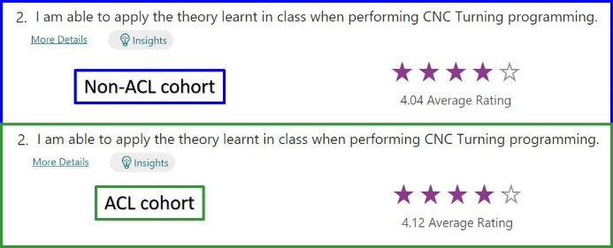

Figure 8: Survey score for CNC Turning

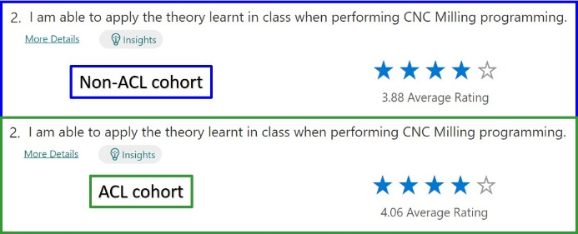

Figure 9: Survey score for CNC Milling

The feedback score indicated that students who participated in the ACL setting learnt more effectively. Increases in rating for both CNC Turning (from 4.04 to 4.12) and CNC Milling (from 3.88 to 4.06) indicated that students were able to recall the fundamentals of machining and apply them when planning cutting strategies. In accordance with the quiz results of the two groups of students, it was discovered that students who had participated in ACL activities were more capable of grasping the theory of CAM than those who had not. It further demonstrated how ACL was able to enhance the CAM learning environment for students.

*Questionnaire feedback*

A second student perception survey was also conducted to allow students to rate their ACL experience. To further understand the students' reactions and satisfaction with ACL, eight questions were conceived and produced.

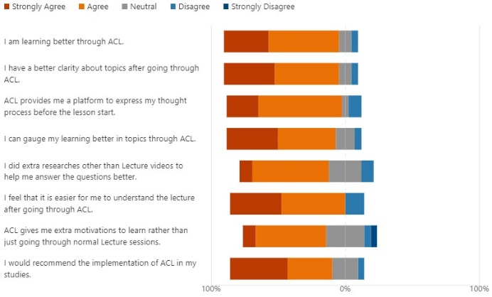

Figure 10: ACL Questionnaire results

Table 2 showed some of the constructive feedbacks given by students regarding their learning in the active-collaborative learning (ACL) approach.

Table 2: Feedback from students about implementing ACL in classroom setup

|  |
| --- |
| *“The ACL worksheet allows me to practice and implement the knowledge i've learned from the various topics. I feel that since its not graded doing it is more for your own benefit and i don't have to worry about getting the correct answers but instead more of getting the correct idea or understanding. Since we go through the tutorials in class also instead of just submitting for grading without going through i'm able to clarify any doubts I have on any questions to help further my understandings. Overall i think the ACL is beneficial in helping my learning and understanding of the various topics.”* |
|  |
| *“It gave us an opportunity to learn at our own pace which makes us learn better. We are also able to do additional research online if we do not understand any things rather than being blur blur in class.”* |
|  |
| *“It can be time consuming sometimes but it allows me to be more prepared for the next lesson. It is also one of the few times I actually learn something when at home.”* |
|  |
| *“i found it very helpful as i usually do not really pay too much attention to the online lectures but the ACL requires me to really look into it more rather than just briefly looking through it. also it points out questions i don’t understand where we can ask and clarify our questions.”* |
|  |
| *“Given the circumstances, ACL is definitely a viable solution. Making us submit PDF through msteams definitely has helped me understand the theory aspect a lot more. Going through the tutorial as a class the following monday is also a very good structure of this mastercam module, definitely has cleared alot of doubts that we have in mind. It has helped us with the quizzes a whole lot. Thanks Mr Henry”* |
|  |
| *“It was well implemented. However, it was through the lecture where we had to present, where i actually found interest to learn more. Overall, i found it to be a good approach still as it motivates me to be more self directed.”* |
|  |
| *“The active worksheet has allowed me to think more about the topic(s) and ensure that I do work instead of procrastinate which does considerable help when Mill/Turning Quiz as it gives us some examples/practise on topics …… Only downside is the increased weekly work load now we must watch video, do coursework, do Lab assessment and complete tutorial which I suppose say it’s fair enough given Computer aided machine is 6 credit module……”* |

While some students thought that ACL was adding extra loads to their already hectic schedule, the majority of them nevertheless expressed positive comments. Students, in particular, stated that ACL increased their intrinsic motivation, allowing them to be more self-directed and eager to go the extra mile by conducting their own research. This was reflected by the feedback scores for questions 5 and 7, which were designed to establish whether ACL was able to enhance motivations among students and so promote self-directed learning among students.

**Conclusions**

Learners in 21st century shouldn’t be taught using the pedagogy of 20th century (Suárez et al., 2021). Indeed, due to the rapid evolution of the internet, knowledge is now available at the touch of a button. In light of this, pedagogies should evolve to meet the contemporary profile of students, who are more technologically savvy.

In this pilot study, Active-Collaborative Learning (ACL) went under trial on SP DME Year 2 students who were taking CAM module. It leveraged from the current Flipped Learning setup to introduce an active and collaborative learning session during in-class activity. The hypothesis of this study was defined as ACL is able to improve student’s assessment score for pragmatic-based module. Based on the analysis of recorded quiz results, ACL group was performing better than the non-ACL group, where it saw an increasing of mean from 69.0 to 72.8. The result was statistically significant, albeit with a small effect size of 0.3 *(p<0.05)*. Students were able to apply their theory knowledge more effectively when programming the cutting path, as evidenced by an increase in positive replies on the post-learning survey. An increasing score from 4.04 to 4.12 for CNC Turning and 3.88 to 4.06 for CNC Milling were recorded, showing that the students were learning better in ACL setup. Questionnaires feedbacks were largely positive among students implementing ACL in their studies. This study received a surprising response from students, as intrinsic motivation enhanced and encouraged them to be more self-directed, resulting in better learning than the traditional approach.

**References**

Anderson L. W. & Krathwohl D. R. (2001). A taxonomy for learning, teaching, and assessing: A Revision of Bloom’s Taxonomy of Educational Objective. New York: Longman.

Ballen, C.J., Wieman, C., Salehi, S., Searle, J.B., Zamudio, K.R. (2017). Enhancing diversity in undergraduate science: self-efficacy drives performance gains with active learning. CBE life sciences education, 16(4), ar56. https://doi.org/10.1187/cbe.16-12-0344

Bergmann, J., & Sams, A. (2012). Flip your classroom: Reach every student in every class every day. International Society for Technology in Education; ASCD.

Bonwell, C. C., & Eison, J. A. (1991). Active Learning: Creating Excitement in the Classroom. ASHE-ERIC Higher Education Report, Washington DC: School of Education and Human Development, George Washington University.

Cho, H.J., Zhao, K., Lee, C.R., Runshe D. & Krousgrill C. (2021). Active learning through flipped classroom in mechanical engineering: improving students’ perception of learning and performance. IJ STEM Ed 8, 46. https://doi.org/10.1186/s40594-021-00302-2

Christensen, C. R., Garvin, D. A., & Sweet, A. (1991). Education for judgment: The artistry of discussion leadership. Boston, Mass: Harvard Business School Press

Cohen, J. (1988). Statistical Power Analysis for the Behavioral Sciences (2nd ed.). Hillsdale, NJ: Lawrence Erlbaum Associates, Publishers.

Deslauriers, L., McCarty, L., Miller, K., Callaghan, K., & Kestin, G. (2019). Measuring actual learning versus feeling of learning in response to being actively engaged in the classroom. Proceedings of the National Academy of Sciences, U.S.A. 116. https://doi.org/10.1073/pnas.1916903117

Freeman S., Eddy S. L., McDonough M., Smith, M. K., Okoroafor N., Jordt H., Wenderoth M. P. (2014). Active learning increases student performance in science, engineering, and mathematics. Proceedings of the National Academy of Sciences, U.S.A. 111, 8410–8415. https://doi.org/10.1073/pnas.131903011

Järvenoja H., Malmberg J., Törmänen T., Mänty K., Haataja E., Ahola S. & Järvelä S., (2020). A Collaborative Learning Design for Promoting and Analyzing Adaptive Motivation and Emotion Regulation in the Science Classroom. Front. Educ. 5:111. https://doi.org/10.3389/feduc.2020.00111

Mason, G. S., Shuman, T. R., & Cook, K. E. (2013). Comparing the effectiveness of an inverted classroom to a traditional classroom in an upper-division engineering course. IEEE Transactions on Education, 56(4), 430–435. https://doi.org/10.1109/TE.2013.2249066

Owens, D.C., Sadler, T.D., Barlow, A.T. & Smith-Walters, C. (2020). Student Motivation from and Resistance to Active Learning Rooted in Essential Science Practices. Res Sci Educ 50, 253–277. https://doi.org/10.1007/s11165-017-9688-1

Prince, M. & Fedler, R. (2006). Inductive teaching and learning methods: Definitions, comparisons, and research bases. Journal of Engineering Education, 95 (2), 123–38.

Scager, K., Boonstra, J., Peeters, T., Vulperhorst, J., & Wiegant, F. (2016). Collaborative Learning in Higher Education: Evoking Positive Interdependence. CBE life sciences education, 15(4), ar69. https://doi.org/10.1187/cbe.16-07-0219

Smith, B. L., & MacGregor J. (1992). Collaborative Learning: A Sourcebook for Higher Education. University Park, PA: National Center on Postsecondary Teaching, Learning, and Assessment (NCTLA). 9-22.

Suárez, F., Mosquera Feijóo, J.C., Chiyón, I., & Alberti, M.G. (2021). Flipped Learning in Engineering Modules Is More Than Watching Videos: The Development of Personal and Professional Skills. Sustainability 2021, 13, 12290. https://doi.org/10.3390/su132112290

Theobald E. J., Hill M. J., Tran E., Agrawal S., Arroyo E. N., Behling S, Chambwe N., Cintrón D. L., Cooper J. D., Dunster G., Grummer J. A., Hennessey K., Hsiao J., Iranon N., Jones L., Jordt H., Keller M., Lacey M., Littlefield C. E., et al. (2020). Active learning narrows achievement gaps for underrepresented students in undergraduate science, technology, engineering, and math. Proceedings of the National Academy of Sciences, U.S.A. 117. https://doi.org/10.1073/pnas.1916903117