**Development and Implementation of Short-term Environmental Education Programs on PM2.5 Using a Portable Sensor**

Takeshi Ito *a, Tomonari Masuzaki a，Takashi Noguchi a， Kotaro Mori a，Hirohisa Oneda a， Wataru Okamoto b，Takayuki Yamazaki b，Yutaka Matsum b

a National Institute of Technology (KOSEN), Yuge College, Ehime, Japan

b Institute for Space-Earth Environmental Research, Nagoya University, Nagoya, Japan

*E-mail: t.ito@yuge.ac.jp

**Abstract**

**In recent years, studies and analyses on fine particulate matter (PM2.5) have been conducted, and environmental education on PM2.5 has become increasingly important. However, there are few reports on environmental education materials on PM2.5 that can be conducted in a short time. National Institute of Technology, Yuge College (NITYC) is located in Kamijima Town in the Seto Inland Sea, where** **high concentrations of PM2.5 have been observed despite the island's remote location. Therefore, we proposed and implemented several environmental education programs using a portable sensor for PM2.5 measurements developed at Nagoya University.**

**First, we observed the differences in PM2.5 concentrations between different fuels when burning rocket stoves. It was confirmed that combining pine cones with firewood as fuel resulted in a decrease in PM2.5 concentration and efficient combustion.**

**The cause of the high PM2.5 concentration in Kamijima Town is not only long-range transboundary air pollution but also from local pollution such as field burning. Therefore, we used a portable sensor to measure the PM2.5 concentration in Kamijima Town regularly by bicycle and created a PM2.5 distribution map to analyze the air pollution in Kamijima Town. At the beginning of the measurements, stable readings were difficult to obtain due to vibrations from the road and sunlight. However, using a box to shield the light and cushioning material made it possible to obtain stable measurements. These experiments and measurements were carried out by NITYC students and allowed them to deepen their understanding of the atmospheric environment through discussion and analysis.**

**Finally, we conducted an outreach class at an elementary school by combining small PM2.5 measurements with traditional gas detection tubes. NITYC students were the main teachers and gave lectures and explanations. The NITYC students and elementary school students who participated in these activities showed a great interest in the atmospheric environment, including PM2.5.**

**Keywords:** *Fine particulate matter（PM2.5）, Environmental education, Portable sensor for PM2.5 measurements,, Creation of PM2.5 distribution maps,*

*outreach class*

**Introduction**

In recent years, air pollution such as fine particulate matter (PM2.5) from China has been attracting attention, and analysis and research on this issue are being conducted in many fields. In this context, environmental education on PM2.5 is becoming increasingly important, but there are still few reports on environmental education materials on PM2.5 that can be implemented in a short-term. National Institute of Technology, Yuge College (NITYC) is located in Kamijima Town in the Seto Inland Sea, has been conducting research since 2012 on PM2.5 measurements and its impact on students' health. As a result, high concentrations of PM2.5 have been observed. These results have been reported not only in Kamijima Town but also in most around of the Seto Inland Sea, and research is currently underway to determine the cause.

Under these circumstances, Nagoya University has provided us with a portable sensor for PM2.5 measurements developed jointly by the university and Panasonic. This portable sensor uses the light scattering method, and because of its high performance and palm-size, it can be used for simple measurements anywhere . We propose an educational program using this portable sensor and report on the results of its implementation.

**Measurement of PM2.5 Concentration Using a Rocket Stove**

A rocket stove is a device that incorporates a chimney, such as an L-shaped pipe into 18-liter square can or pail and uses the natural heat rise to achieve efficient combustion with less fuel and smoke. As such, they are environmentally friendly and have attracted much attention since they were used in the Great East Japan Earthquake. We have studied the development of small rocket stove education materials that can be used in the classroom, as well as their use in times of disaster, such as shower and power generation . While rocket stoves are known for their ability to burn various types of fuel, the combustion process differs depending on the fuel used. When rocket stoves are used in evacuation centers during a disaster, there is concern about PM2.5 pollution from the smoke. Changes in atmospheric PM2.5 are long-term, and there are few examples of short-term PM2.5 concentration measurements for environmental education. Therefore, for the education and fuel selection during disasters, we investigated the measurement of PM2.5 concentration changes due to differences in fuels using a portable sensor.

We used a typical rocket stove using a pail and different fuels, including firewood, chopsticks, driftwood, pine cones, and bamboo (Figure 1).

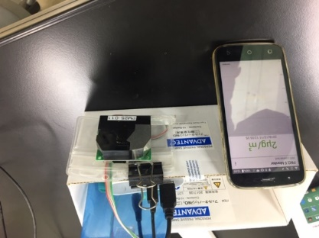

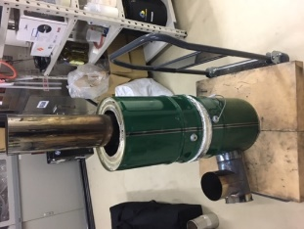

Figure 1. Rocket stove and portable sensor for measurement of PM2.5 concentration

The results are shown in Table 1. A significant change in PM2.5 values was observed when the fuel was changed. It was confirmed that the system can be used in the class for a measurement of PM2.5 concentration in a short period of time. While bonfires emit more than 30 μg/m3 of PM2.5, when disposable chopsticks and firewood were used, PM2.5 concentrations were low, around 10 μg/m3, a range suitable for use in evacuation centers. When bamboo was used, combustion was stronger, but PM2.5 concentrations were higher, ranging from 8 to 20 μg/m3. When driftwood was used, PM2.5 concentrations ranged from 20 to 60 μg/m3, which is not suitable for use in evacuation centers. When pine cones were used as fuel, the fire power was stronger and there was almost no PM2.5 emission. Combined with pine cones, the concentration of PM2.5 was less than 30 μg/m3 even in driftwood. Additionally, when the length of the chimney was doubled, PM2.5 concentrations were even lower (Data not shown). By changing the combination of fuels and the length of the chimney, stable combustion with relatively low PM2.5 values was possible, and it was confirmed that the fuels can be used sufficiently in evacuation areas.

Table 1. PM2.5 concentration changes due to differences in fuels

|  |  |
| --- | --- |
| Fuels | PM2.5 concentration (μg/m3) |
| Pine cones | ~ 5 |
| Chopsticks / Firewood | ~ 10 |
| Bamboo | 8 ~ 20 |
| Driftwood | 20 ~ 60 |
| Pine cones + Driftwood | ~ 30 |

**Creation of PM2.5 distribution map of Kamijima Town**

Various causes of the high PM2.5 observed in the Seto Inland Sea have been considered, including the influence of the region's geography, pollution from nearby factories and ships, and transboundary pollution from the continent. In addition, open burnings are still being conducted in Kamijima Town, which is considered a local source of high PM2.5 concentration. Therefore, to analyze the causes and construct a more experiential environmental education, we measured PM2.5 in Kamijima Town using a portable sensor and create a distribution map of PM2.5 concentration. Conventionally, the creation of a distribution map using the portable sensor is done by walking, which requires time to measure a long distance. In addition, cycling is popular in Kamijima Town. Therefore, in this study, we measured once a week at a rate of 6 to 7 minutes per kilometer by bicycle around a cycling course. Initially, there were many cases of sudden increases in the measurements. we considered to be caused by the sunlight and the slight vibration of the bicycle due to the road. To resolve this issue, we created shade by placing the device in a box and used a mat made of glass wool to reduce vibrations, enabling more stable measurements (Figure 2). The PM2.5 concentration and GPS date stored on a tablet device were processed in Excel, and a distribution map was created using the web service GPS Visualizer (Figure 3).

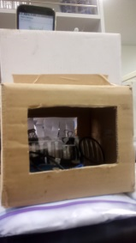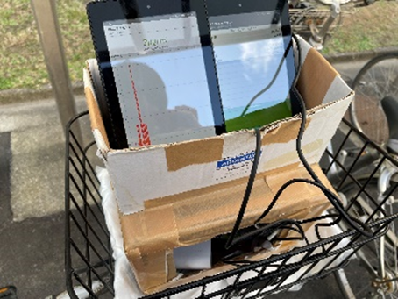

Figure 2. The PM2.5 measurement by bycicle

Based on the distribution maps, we discussed with the students to deepen their knowledge of the atmospheric environment. The following is a brief summary of the results.

・Higher PM2.5 concentrations were observed in areas near the port, as well as in secluded areas and uphill locations.

・High PM2.5 concentrations were observed at the waste treatment center and the sewage treatment center.

・The difference in PM2.5 concentrations between high and low was more clearly observed in winter than summer.

・Locations suspected of open burning showed higher PM2.5 concentrations.

・In higher altitude areas, higher PM2.5 concentrationswere observed.

These results were reported to the elementary school students as described in the next chapter, and not only the NITYC students, but also the elementary school students deepened their knowledge of air pollution in Kamijima Town.

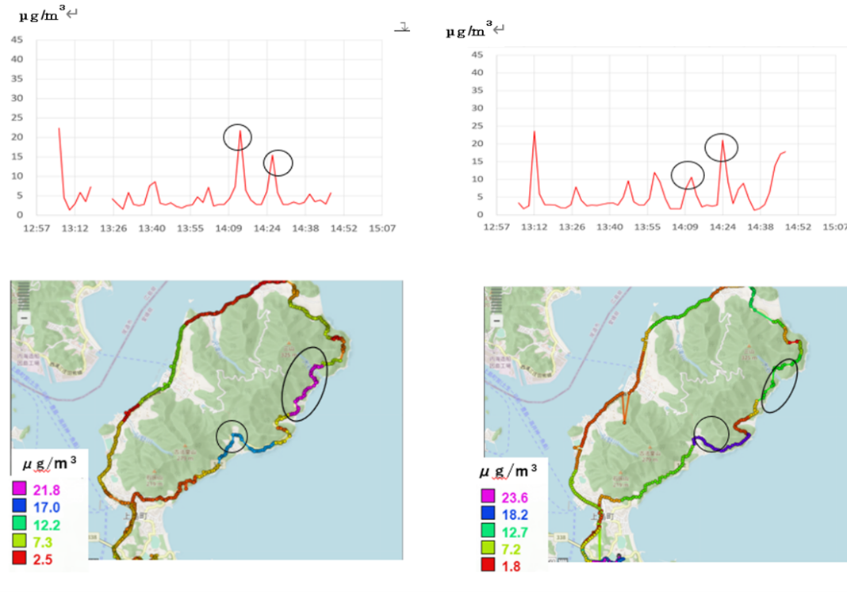

Figure 3. A example of the distribution maps created

**Outreach class by NITYC students at elementary school**

There is only one elementary school on Yuge Island, where NITYC is located, and environmental education in remote areas is limited. In addition, there are few reports on hands-on atmospheric education for elementary school students on PM2.5. Therefore, NITYC students conducted preliminary learning on PM2.5 and delivered outreach class using portable sensor. The lessons were held for fifth-graders in 2021 and 2021. The lesson content was proposed by the students. The participating students were first- to third-year students of the science club and students involved in the experiments in the previous chapter, in addition graduates of the elementary school. It was a refreshing activity for the students who taught.

The class was conducted in a lecture format, combining an introduction to the atmospheric environment of Kamijima Town with experiments. Gas measurements included measuring PM2.5 concentration using portable sensors and measuring the concentrations of carbon dioxide, oxygen, and carbon monoxide using gas detection tube devices (GasTech). Atmospheric measurements were conducted not only in the classroom and schoolyard but also measuring car exhaust and incense smoke (Figure 4,5,6).

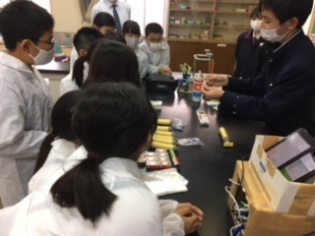

Figure 4. Lecture by NITYC students

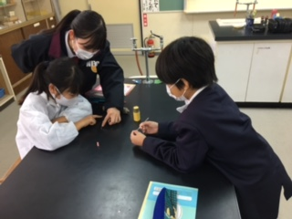

Figure 5. Gas measurements using gas detection tube devices

Figure 6. Atmospheric measurements in schoolyard and car exhaust

The results of the questionnaire from outreach class is shown in Table.7. As a result, a large number of students indicated that their interest in the environment and science was promoted, and none were not. Because the elementary students had not learnt about the composition of air and how to measure gases , so it can be seen that the majority understood the lecture, although some students stated that it was a little difficult for them to understand. Some of the free-response statements from the questionnaire are shown below. It is clear that the students took the lecture seriously.

・I was surprised that the concentration of PM2.5 was high even in Kamijima Town, which I thought was clean.

・I enjoyed using the gas detector tubes and portable sensor.

・the PM2.5 concentration increased due to car exhaust gas. It made me think more about environmental issues.

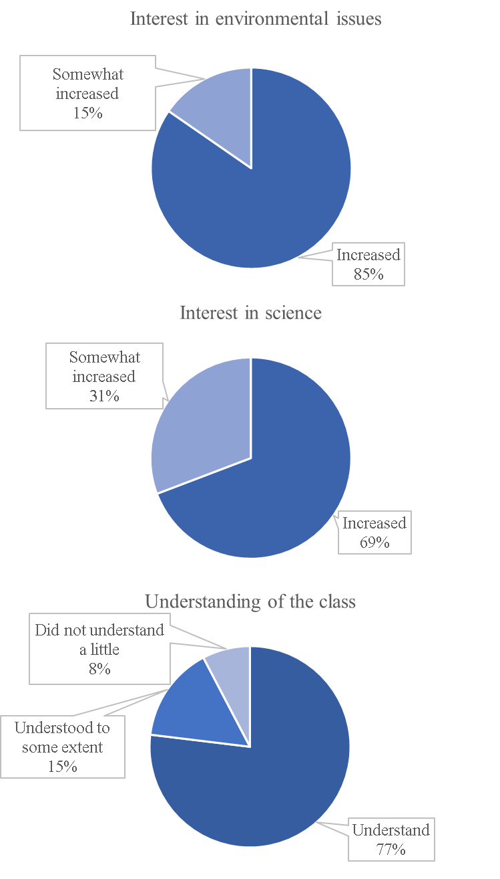 Figure 7. Results of the questionnaire from outreach class

**Conclusions**

NITYC　defines "remote island engineering" as activities to solve problems faced by remote islands from an engineering perspective in cooperation with local communities. These activities aim to develop human resources who can contribute to the "safety and security" of the local community through research and education in a wide range of fields, including disaster prevention, IoT, robotics, energy, logistics, environment, and welfare, as well as volunteer work for the community. This activity is also an activity to learn about the atmospheric environment of Kamijima Town, to share information with community and to find solutions to the problem. Based on the distribution map, it is possible to use it for controlling sources of PM2.5, such as field burning. In the future, there is an expectation to develop an application that can inform users about locations where high concentrations of PM2.5 are predicted by integrating it with real-time atmospheric conditions. This application can be utilized in activities such as cycling and jogging. In addition, disaster prevention and the environment are very closely linked. In a disaster, water availability is important, and at the same time it is necessary to know the water environment. Air pollution is also a concern in disasters, and this activity also involved measuring PM2.5 in combination with rocket stoves. This activity is part of a series of activities that also take water environment and other disaster prevention into consideration, and will be continued in the future.

**Acknowledgements**

The projects were supported by a subsidy from the Nakatani Foundation for Advancement of Measuring Technologies in Biomedical Engineering. And this project was made possible through the generous cooperation of Kamijima Town Yuge Elementary School.

**References**

Y. Yoda, H. Takagi, J. Wakamatsu, T. Ito, R. Nakatsubo, Y. Horie, T. Hiraki and M. Shima (2017), Acute effects of air pollutants on pulmonary function among students: a panel study in an isolated island, *ENVIRONMENTAL HEALTH AND PREVENTIVE MEDICINE*, 22, Article number: 33.

T. Nakayama, Y. Matsumi, K. Kawahito, Y. Watabe (2018), Development and evaluation of a palm-sized optical PM2.5 sensor, *AEROSOL SCIENCE AND TECHNOLOGY*, Vol. 52 (1), 2-12.

T.Ito, Y. Ito, S. Iwasaki, H. Ichimori, H. Okano, K. Tada and J. Yano (2019). Teaching materials of rocket stoves for environmental education and investigation of educational effect, *Jounal of JSEE*, Vol. 67 (4), 86-90.

T.Ito, S. Ishida, (2019). Activity of scientific experiment club based on remote island engineering, *The 13th International Symposium on Advances in Technology Education 2019*, 564-568.

H. Fukuda, T. Masuzaki, T. Ito, T. Tabusa, M. Tada,

K. Kuzume, (2021). Human Resource Development of the IoT Engineers Based on the Remote Island Engineering, *14th International Symposium on Advances in Technology Education*.