SELF-PHY: AN EXAMPLE OF COLLABORATION BETWEEN INSTITUTE, INDUSTRY AND NON-GOVERNMENT & NON-PROFIT ORGANIZATION IN DEVELOPING HEALTHCARE SYSTEM

WONG Chi Tin^{*,a}, LAU Yiu Wing ª, JEANG Wai Leung ª and TSO Kar Ho ª

ª Department of Information Technology, Hong Kong Institute of Vocational Education (Tuen Mun), Hong Kong, China

*ycsky@vtc.edu.hk

Abstract

Self-Phy is a physiotherapy exercises learning platform developed by Vocational Training Council’s students under the Project Based Learning framework with the support from industry and Non-Government & Non-Profit Organization (NGO&NPO) during coronavirus period. The collaboration between academic, industry, NGO&NPO plays an important role in nurturing young talents as it offers a valuable opportunity for students to learn and adopt the state-of-art technologies from the industry and understand the needs of society by the events organized by NGO&NPO to better refine their solutions to the problems. The purpose of this study is to present the project details of Self-Phy, collaboration framework of Self-Phy between institute, industry and NGO&NPO during the coronavirus period, and to propose a post corona virus era collaboration framework in order to enhance the quality of engineering education as well as suggesting future research directions.

Keywords: Artificial intelligence education, industry institution collaboration, physiotherapy, healthcare system, project-based learning

Introduction
Project-based learning (PBL) is one of the popular teaching and learning method to promote self-directed, self-regulated and self-reflecting learning in order to cultivate students' positive values and attitudes to overcome with the challenges of the 21st Century. Vocational Training Council (VTC) in Hong Kong has adopted Project based learning in recent years to encourage students to design, develop and implement solutions to solve real-world problems.
Self-Phy is a physiotherapy exercises learning platform developed by VTC’s students under the PBL framework with the support from industry and Non-Government & Non-Profit Organization (NGO&NPO) during coronavirus period.
The project team identified that Hong Kong has a high demand of physical therapist, the ratio between registered physiotherapist and patient is 1:3800. Of the 3800 patients, each physiotherapist treats an average of 662 elderly people. The average queening time of physical therapist service in public hospital is about 33 weeks. If the patients can pay for the high medical fee, they can change to private hospital to purchase physical therapist services. However, the medical fee of physical therapist services is a bit expensive to elderly if they decided to visit private hospital instead of public hospital. There is a trade-off between the queening time and money in selecting physical therapist services in public or private hospital.
Pointing to the situation of Hong Kong, the project team designed and developed a healthcare system “Self-Phy” to solve the problem of long queening time for physical therapist services in public hospital. Self-Phy uses artificial intelligence technologies to distinguish whether the patient's movements are standard, records and reminds the patient whether s/he has completed the daily physiotherapy exercises. This software can provide guidance for patients who have turned to home physiotherapy training because of the pandemic, avoiding the impact of wrong postures on the treatment effect, and making physiotherapy no longer limited by time and place.

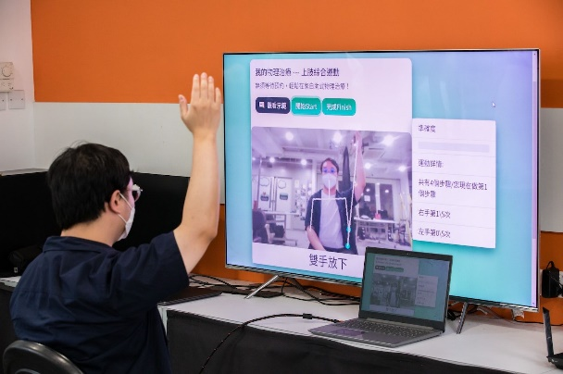

Figure 1: Demonstration of Self-Phy

Literature Review

With the competition on the development of new technologies are increasing tremendously in recent decades, which forces all industrial sectors are more likely to recruit high skilled and qualified graduates as they can bring more value to the company and help the company to survival in today’s highly competitive environment (Ramakrishnan & Yasin, 2011). On the other side, technical institute, and students both notified that the importance of developing students’ skills and technological options as early as possible in order to fulfil the needs in the job market. Institute and industry collaboration in developing projects is one of the best ways to train students and transform students to be a work ready talent.
The concepts of institute and industry collaboration was first introduced by Sunderland Technical College in Northern England in 1903, which was known as the “Sandwich Program” (Zhao & Wang, 2008). The collaboration between Institute and industry has existed for more than ten decades, especially in the area of technology. However, there is still a missing research gap focusing on developing healthcare system by the collaboration between institute and industry in the context of Hong Kong especially with the participation of NGO&NPO (Samuel & Omar, 2015).
Thus, the objective of this study is to investigate and fill the research gap of the collaboration framework between three parties for the coronavirus period and post corona virus era for the artificial intelligence-based healthcare system.

Collaboration Framework

The Self-Phy project started from September 2021 as a final year project of Higher Diploma in Software Engineering (SE) students. The Self-Phy project team consists of 4 SE students, industrial partner, and NGO&NPO. The role of students in this project is to design and develop a prototype according to the input from industrial partner and NGO&NPO. The role of industrial partner in this project is to provide technical support and training to students that enhance students’ technical skills, while the role of NGO&NPO in this project is to line up students with potential users by organizing different learning activities which allows students to design user-centred and user-friendly project prototype.
Basically, the collaboration framework is similar to the traditional Software Development Life Cycle (SDLC), which consist of four phrases: (1) Planning, (2) Analysis, (3) Design and (4) Implementation. The first task is to select an appropriate software development methodology. There are serval software development methodologies could be chosen for a project such as system prototyping, iterative development, Parallel development etc. Since the number of development team members of Self-Phy project were small and the project scope and size were relatively small when comparing to the actual project in the market. Therefore, the project team decided to adopt agile development model throughout the SDLC as we think the efficiency and effective of communication with industrial partner and NGO&NPO is the most important part in developing a hight quality project prototype.
Agile model is a popular Software Development Methodology used to manage software development projects among start-up community as it provides high flexibly and extendibility during the system development life cycle. The visualization of the agile model as shown in figure 2 below. The project was conducting through collaborative development and ongoing improvements through iteration. In the agile development model, each iteration is considered a short-term "frame", typically lasting one to four weeks. Dividing the overall project into smaller parts helps minimize project risk and reduce overall project delivery time requirements (Tore & Torgeir, 2008). Each iteration involves a team going through the full software development lifecycle, including planning, requirements analysis, design, coding, and testing, before presenting a working product to customers (Mirko et al., 2019).

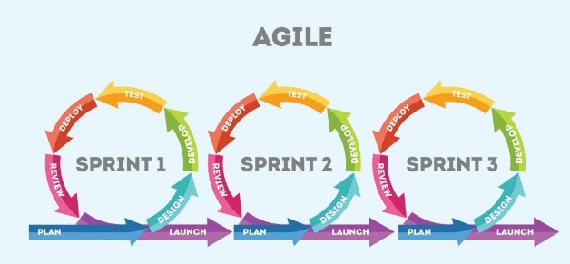
Figure 2: Agile Development Model (Sapna, 2022)

Before the actual development of the project, a clear and precise project plan is required under the agile development method as the method aims to break tasks into smaller iterations that do not directly involve long term planning for easy management. Therefore, a meeting with major stakeholders of this project was conducted including industrial partner, NGO&NPO and potential users in order to lay down the clear and precise project scope and requirements at the beginning of the development process. The meeting also clearly defined the number of iterations, the duration and scope of each iteration. After the meeting, a preliminary project plan was produced. There is a total of 11 iterations in the project and each iteration last for 4 weeks. Each iteration is also divided into two sub-iterations, for example of iteration 1, it has two sub-iterations, 1A and 1B. For the A iteration, technical meeting with industrial partner was conducted in order to confirm the output of this iteration and then student will start to implement the project protype of this iteration with the support from industrial partner, the A iteration last for 3 to 3.5 weeks depending on students’ school schedule. B iteration will start right after the end of A iteration, NGO&NPO and potential user will involve in this iteration and to give comment based on students’ project prototype to see whether it fits the needs of the potential users. The comments received from this iteration will become the input of next iteration and so on, which helps the quality of the project evolution throughout each iteration. Table 1 shows the summary of agile iteration of this project.

Table 1: Summary of agile iteration
Date | Iteration Number | Iteration Content
SEP 2021 | 1 | A. Technical meeting with industrial partner & prototype implementation (last for 3 to 3.5 weeks)  B. Project prototype showcase to industrial partner, NGO&NPO, and potential user
OCT 2021 | 2
NOV 2021 | 3
DEC 2021 | 4
JAN 2022 | 5
FEB 2022 | 6
MAR 2022 | 7
APR 2022 | 8
MAY 2022 | 9
JUN 2022 | 10
JUL 2022 | 11

Coronavirus issues is the important factor needs to be noticed throughout the project period. The project was started during the coronavirus period, and students were suggested to study online class at home and not allowed to back to school unless special approval in order to minimize the chance of infect. In other words, students can only communication with academic supervisor and industrial partner, and other stakeholders through video conferencing software such as Microsoft Team. Due to the pandemic situation in Hong Kong in 2021-2022, the face-to-face learning activities were limited. The NGO&NPO partners organized two activities for students understand the needs of the elderly and meeting with potential user in person which allows students to collect feedback from them directly to fine-tune the function of the project prototype. For example, the NGO&NPO organized a guided tour for students to visit Elderly Resources Centre of Hong Kong Housing Society as shown in figure 3, and a meeting with potential user in person as shown in figure 4. Through the event, students can explore more to the society, and they had a valuable opportunity to meet with potential user in person and to collect feedback from their side directly. Thus, students were able to find out more precise requirements of elderly apart from their initial idea and students would then be able to design and develop elderly-friendly and cost-effective related solutions. Table 2 shows the summary of the project details and collaboration framework.

Table 2: Summary of the project details and collaboration framework
Project Duration | 12 months  SEP 2021 to AUG 2022
Project area | Artificial Intelligence based Healthcare System
Project Team | 4 SE students from institute  1 industrial partner  1 NGO&NPO partner
Software Development Model | Agile Model
Number of iterations | 11
Duration of each iteration | 4 weeks

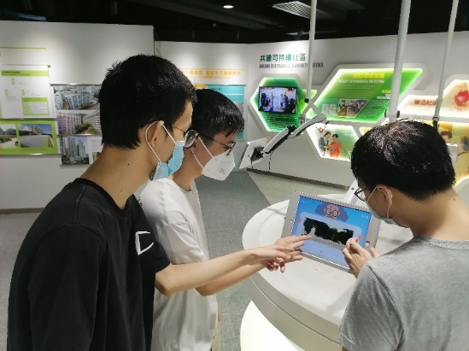
Figure3: Visiting Elderly Resources Center of Hong Kong Housing Society
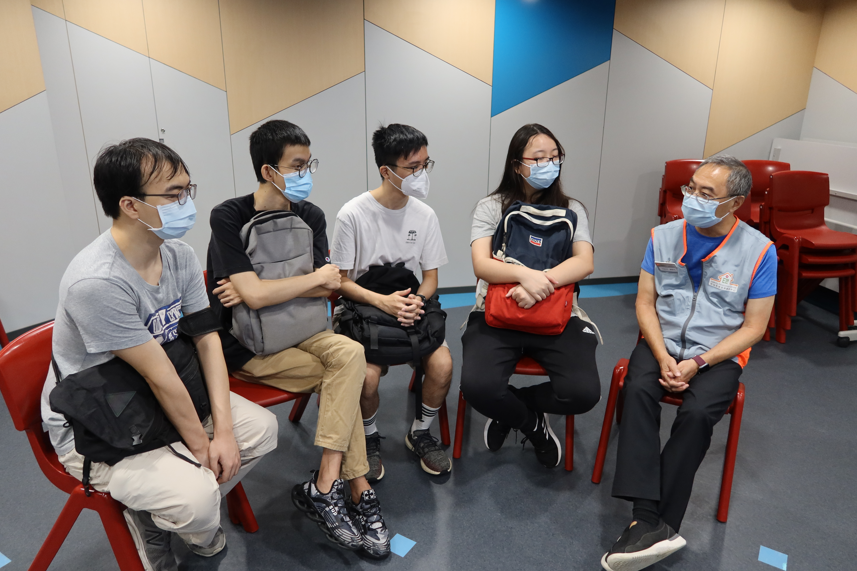
Figure 4: Meeting with potential user in person

Collaboration Result

The project has been completed successfully on August 2022 with the support from industry and NGO&NPO. All tasks listed on the project scheduled were completed successfully on time with no delay. The project team submitted the project prototype to join different ICT competitions in Hong Kong, which aims to receive valuable comments from the professional judges in order to know the rooms of improvement of the second version of Self-Phy. Finally, the project was received four awards in two public competitions in Hong Kong. The details are as follows:
1) Hong Kong Housing Society (HKHS) Gerontech Competition 2021/22: Gold Award, Best Creativity Award, Best Application Award
2) The Greater Bay Area STEM Excellence Award 2022 (Hong Kong) - A.I. Stream: Gold Award

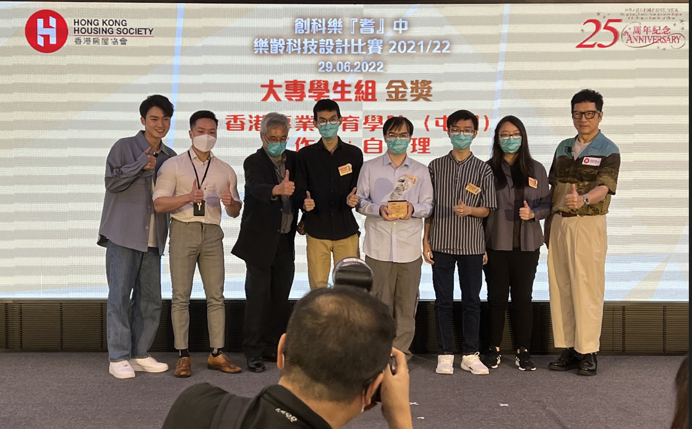
Figure 5: Award ceremony of Hong Kong Housing Society (HKHS) Gerontech Competition 2021/22

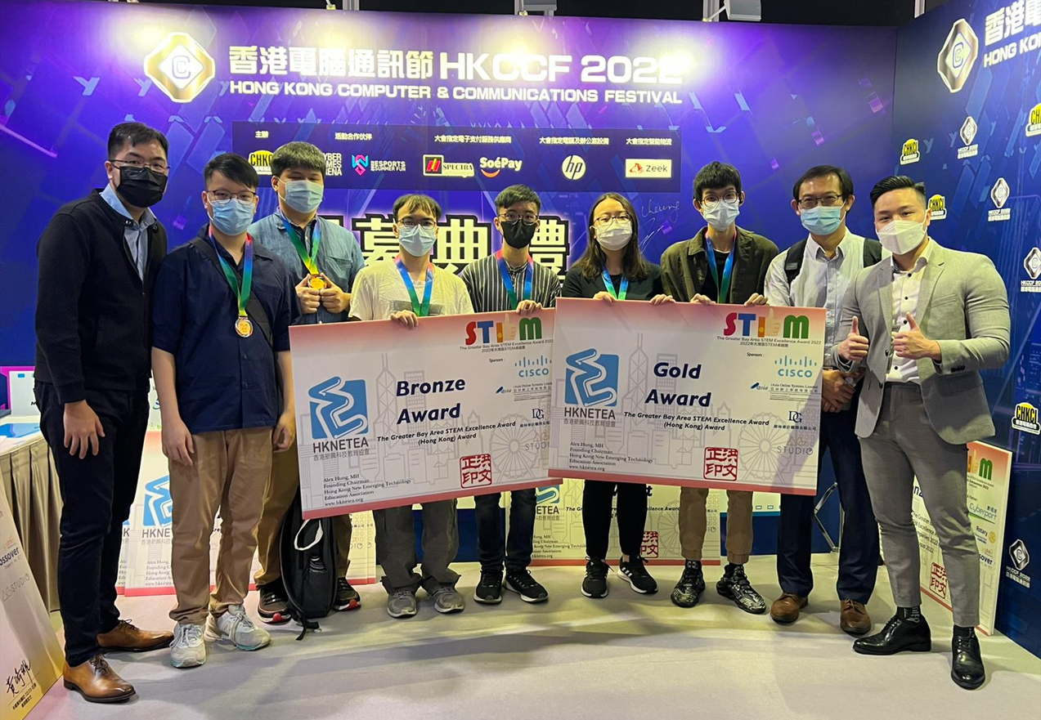
Figure 6: Award ceremony of the Greater Bay Area STEM Excellence Award 2022 (Hong Kong)

Because of the outstanding achievements of the project, the project team was also invited by the famous media in Hong Kong to join TV interview to introduce their project to the public and share their development experiences. The TV interview includes “Happy Old Buddies” on 29 September 2022 and “Innovation GPS” on 5 January 2023.


Figure 7: Screenshot of “Happy Old Buddies” on 29 September 2022

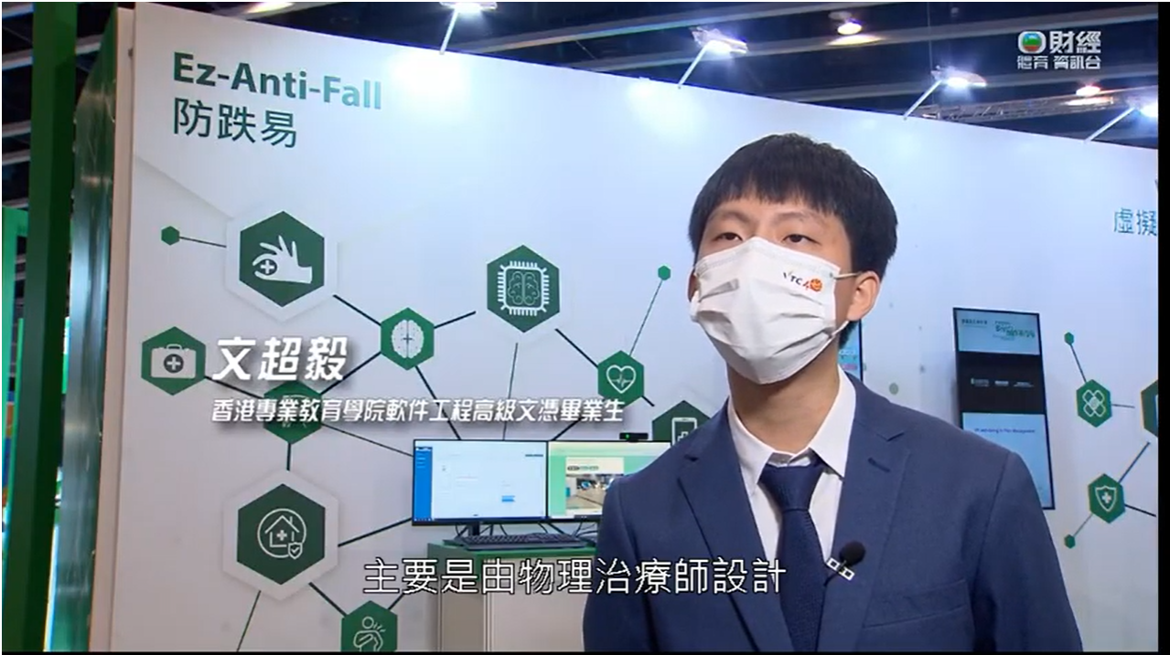
Figure 7: Screenshot of “Innovation GPS” on 5 January 2023

As discussed in the last section, the expected duration of the project is between September 2021 to August 2022. After received outstanding results in two ICT competitions and positive comments from the industry leader and professional judges, the project team decided to turn their idea to a real business. Four students established their own start-up company to further develop the second version of Self-Phy, which aims to provide HealthTech solutions to elderly people in order to reduce the pressure of health care system of Hong Kong and to make our society better, and the most important thing is that students could use their knowledge learned from school to give back to the society. The project was also admitted to the ideation programme of the Hong Kong Science and Technology Park (HKSTP) and received $HK$100,000 financial grant to support their company development, with one-year startup all-round support from designing a business model to finding investment and provide mentor for business advice.

Discussion

This study proposed a collaboration framework between institute, industry and NGO&NPO in developing healthcare system during the coronavirus period. Despite the project was completed successfully and obtained outstanding results, we believe that there is still room for improvement in future to enhance the quality of engineering education. Therefore, at the end of the project, an interview section with students, industrial partner and NGO&NPO was conducted in order to collect feedback and best practice of this collaboration.
After interviewing with stakeholders, it was found that from the perspective of industry and NGO&NPO, they are more preferring to provide support to student through the online meeting as they have time constraints because of their busy work schedule. With the adoption of online meeting, it can reduce the traveling time for industrial partner to travel form their company to the meeting site. The saved time could be used to provide more support to students. Second, from the perspective of students, even though the adoption of online meeting can save the traveling time, they reported that their sense of belongings of the project will be increased if they can report to the industrial partner and NGO&NPO in person at least once per month.
Before the pandemic, we did not imagine and explore the possibility to conduct project across the Internet. In the past, we just consolidate a common time for all project team members and then reserve a meeting venue before the meeting with project stakeholders in person. We spent a lot of time in the preparation of a face-to-face meeting and the traveling time as well. What if we can optimize the time spent in the preparation of meeting?
In the post coronavirus era, it is suggested that we can adopt bi-iteration approach to conduct the project collaboration, which means a face-to-face iteration comes first followed by an online iteration and so on and so forth. The main reason of why it is not suggested to keep everything online is that the sense of belongingness of students and other stakeholders to the project will be dropped a lot. Moreover, in order to balance the feedback from the students and industrial partner, it is also recommended that students could stay at industrial partner’ workplace one to two times per week to implement the project according to the school schedule and industrial partner’s schedule in order to let students experience life in the workplace which is beneficial for students to better prepare themselves to be an outstanding employee after graduation. Other institute in Asia regional may try to adopt the framework introduced in this study and the suggestion above or adapt the framework according to the culture of the country in order to better training for the next generation.

Limitation and future directions

In this study, there are some limitations that should be acknowledged, so that the research results can be interpreted with necessary caution. First, the research framework only tested on the area on Artificial Intelligence-based intelligence products, services, and systems, while other subject area may not be able to adopt the framework directly. Pointing to the limitation of this study, further research directions can be based on the framework proposed in this study, researchers can further explore and develop framework to adapt to the fast-growing ICT environment and conduct additional research to adapt the framework of this study according to the subject area, and to compare and evaluate the performance between newly developed framework and other collaborative framework.

Conclusion

In conclusion, the adoption of PBL and collaboration between academic, industry and NGO&NPO can address the societal needs and enhance the quality of engineering education, as demonstrated by the Self-Phy project. This paper presents the project details of Self-Phy, discuss the collaboration framework of Self-Phy between institute, industry and NGO&NPO during the coronavirus period, and to propose a post corona virus era collaboration framework. This study also highlighted the importance of developing a strong relationship between three parties by showing the Self-Phy project. It is convinced that the collaboration between three parties does bring more advantages than disadvantage to student and help institute produce quality graduates who can full fill the manpower needs in the job market and satisfy their future employers need.

References

Mirko P., Lenardo C. e S., Alexandre C., Felipe R., Renata S., Arthur F., Ednaldo D., Emanuel D.,
Danilo S., Kyller G., Kyller A., and Angelo P. (2020). Intelligent Software Engineering in the Context of Agile Software Development: A Systematic Literature Review. Information and Software Technology, 119, 106241.

Ramakrishnan, K. & Yasin, N. M. (2011). Higher learning institution - Industry collaboration: A necessity to improve teaching and learning process. 6th International Conference on Computer Science & Education (ICCSE), 1445-1449.

Samuel, A. & Omar, A.T. (2015). Universities-industry collaboration: A systematic review. Scandinavian Journal of Management, 31(3), 387-408.

Sapna, C. (2022). What is Agile?. LinkedIn Learning. Retrieved from https://www.linkedin.com/pulse/what-agile-sapna-choudhary?trk=articles_directory

Tore, D. & Torgeir, D. (2008). Empirical studies of agile software development: A systematic review. Information and Software Technology, 50(9-10), 833-859.

Zhao, W. & Wang, A. (2008). University-industry Collaboration for Software Engineering Teaching. Proceeding of the 9th International Conference for Young Computer Scientists, IEEE Computer Society, 2681-2685.

