**Developing an AI-powered Presentation Tool for Engineering Education Using Augmented Reality (AR) Technology**

Y.H. Kwok*,a ,W.H. Lui**,a, P.H. Ma***,b, S.P.Y. Hob, S.N. Dungb and C.O. Wongb

a Department of IT, Hong Kong Institute of Vocational Education (Sha Tin), Hong Kong

b 417 Technology Limited, Hong Kong

*kwokyuho@vtc.edu.hk, **luiwahong@vtc.edu.hk and *** info@417Tech.co

**Abstract**

**The COVID-19 pandemic has resulted in a growing demand for innovative online educational tools, particularly in the field of engineering. In response, a team of students from the Hong Kong Institute of Vocational Education (Sha Tin) has developed Present AR, an AI-powered presentation tool that enhances the virtual presentation experience for engineering education. The project has successfully transitioned into a start-up that has been funded by Hong Kong Science and Technology Park, and is currently collaborating with IVE to further develop the product.**

**Present AR is a presentation tool that leverages augmented reality (AR) technology and AI algorithms to create a highly interactive and engaging learning experience. The tool enables presenters to virtually interact with engineering models and diagrams, providing a more immersive and dynamic learning experience that can enhance understanding and retention of complex engineering concepts. One of the key features of Present AR is its AI-powered gesture recognition, which tracks the presenter's movements and integrates them seamlessly into the virtual environment, creating a more personalized and immersive learning experience.**

**The potential of Present AR to revolutionize engineering education lies in its ability to provide a more dynamic and interactive learning experience. For instance, a presenter could use Present AR to demonstrate the operation of a complex machine or process by virtually manipulating 3D models and providing detailed explanations, facilitating a more effective understanding of the machine or process than through traditional methods.**

**Furthermore, Present AR's interactive capabilities can also foster collaboration between students and instructors in virtual classrooms, allowing them to work together on projects and simulations in real-time. This approach can help students develop teamwork skills while providing a more engaging and effective learning experience.**

**The development of an AI-powered presentation tool like Present AR holds significant potential for engineering education in the post-pandemic era. By leveraging AR technology and AI algorithms, Present AR can offer a more dynamic and immersive learning experience, which can enhance understanding and retention of complex engineering concepts. Additionally, its interactive capabilities can facilitate collaboration and teamwork, providing a more engaging and effective learning experience for students. The tool's use of AI-powered gesture recognition allows for a more personalized and immersive learning experience, with the potential to improve the effectiveness of online engineering education. Further research could explore the potential applications of Present AR for other educational fields and settings.**

**Keywords:** *Present AR, virtual presentation, engineering education, interactive learning, immersive experience, gesture recognition, post-pandemic era*

**Introduction**

The COVID-19 pandemic has caused worldwide impact on education. Educational institutes are forced to shift from traditional face-to-face learning to remote and online learning environments (Aristovnik et al., 2020). This rapid transition has highlighted the need for innovative educational methods that can keep students engaged, motivated, and connected in these challenging times (Johnson et al., 2020). Though Passey (2021 et. al) addressed that these challenges about integrating technology in education are vital for ensuring successful implementation and positive student outcomes, there is also an opportunity to bring in other innovations to tackle the challenges.

In response to this need, our team observed that conventional online lectures, delivered through platforms such as Zoom or Microsoft Teams, often relied on static lecture notes and lacked the interactivity and engagement required to maintain students' attention and interest. This observation led us to explore the potential of Augmented Reality (AR) technology as a means to transform the online learning experience.

We proposed a novel system, Present AR, an AI-powered presentation tool for education that leverages AR technology to immerse learners into the lecture content and enable them to interact with virtual objects in the presentation. Present AR aims to provide a more engaging, interactive, and immersive learning experience compared to traditional online lectures.

The proposed system has garnered significant recognition for its innovative approach to enhancing engineering education. Present AR has been awarded in various competitions and has received positive feedback from educators, students, and industry experts.

Encouraged by this success, our team decided to commercialize the product and founded a start-up with a mission to revolutionize the way we learn by harnessing the power of AR and AI technologies. This paper presents a story of the development of Present AR, detailing its features, methodology, and the impact it has had on the educational landscape.

**Literature Review**

This literature review aims to provide insights into the development and applications of AR in education, particularly focusing on engineering education. Several studies have demonstrated the benefits of using AR as a learning tool, and this review will discuss those findings in detail.

*AR in Education*

Over the past few years, AR has emerged as a promising technology for educational purposes. AR is an interactive experience that overlays digital information and virtual objects onto the user's view of the real world (Azuma, 1997). In the context of education, AR has been found to be effective in increasing student engagement, motivation, and enhancing learning outcomes (Radu, 2014).

*Figure 1* presents one of the early applications of AR in education namely AR-Dehaes model (Billinghurst & Duenser, 2012), which focused on supporting collaborative learning in the classroom by providing hands-on experiences to students. The authors concluded that AR could significantly improve students' understanding of complex concepts, retention of information, and collaboration skills.



*Figure 1. Screen capture of AR-Dehaes (Billinghurst & Duenser, 2012)*

A meta-analysis by Santos et al. (2014) investigated the impact of AR on learning outcomes and found that AR-based interventions led to significant improvements in students' cognitive and affective outcomes. The study highlighted that AR could be particularly useful for teaching abstract concepts, as it allows students to visualize and manipulate virtual objects in real-time.

*AR in Engineering Education*

In recent years, AR has been increasingly applied to engineering education, where it has been shown to enhance students' understanding of complex concepts and improve their problem-solving abilities (Mora et al., 2017). For instance, AR has been used to teach civil engineering students about structural analysis and design (Wojciechowski & Cellary, 2013), allowing them to visualize forces and deformations in real-time.

Another study by Pogodaev et al. (2022) explored the use of AR in teaching electrical engineering concepts. Their findings indicated that AR-based learning environments significantly improved students' understanding of complex concepts, such as electromagnetic fields, compared to traditional teaching methods.

AR has also been found to be effective in enhancing students' spatial visualization skills, which are critical for engineering students (Bacca et al., 2014). In a study by Kaufmann and Schmalstieg (2003), the authors developed an AR system to teach geometry and found that students' spatial visualization skills improved significantly after using the system.

Moreover, AR has been used to support collaborative learning in engineering education. A study by Dünser et al. (2012) investigated the use of AR in a collaborative design project and found that AR significantly improved students' communication and collaboration skills.

*AR Innovation in Video-Conferencing*

In recent years, augmented reality (AR) innovation has also made significant strides in the realm of video-conferencing. Two notable studies have explored the potential of AR in enhancing video communication and live presentations. Saquib et al. (2018) conducted a study titled "Interactive Body-Driven Graphics for Augmented Video Performance," which revealed the technical capability to generate immersive real-time video processing for immersive and interactive graphics using human body tracking technology. (*Figure 2*) This development enables more engaging and dynamic video-conferencing experiences, transforming the way people communicate and collaborate remotely.

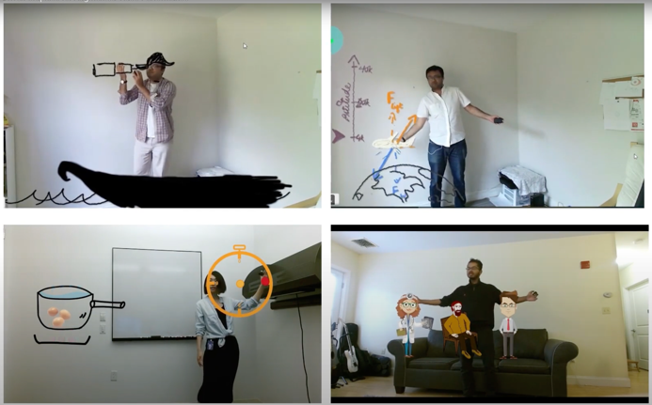

*Figure 2. Outcome of Saquib et al. (2018) Study*

Another ground-breaking solution was RealityTalk presented by Adobe and the University of Calgary in a study by Liao et al. (2022), which focused on building real-time speech-driven AR presentations for AR Live storytelling. This research showcases the potential of AR in creating more captivating and interactive live presentations, elevating the art of storytelling through the seamless integration of AR elements with real-time speech. These advancements in AR innovation for video-conferencing and live presentations not only enhance communication experiences but also open new possibilities for collaboration and interaction in various fields, including education, business, and entertainment.

**Feature of Present AR**

The literature reveals that AR has the potential to revolutionize engineering education by providing students with interactive and immersive learning experiences. AR has been found to enhance students' understanding of complex concepts, improve their problem-solving abilities, and strengthen their spatial visualization and collaborative skills. As such, the development of an AI-powered presentation tool for engineering education using AR technology seems to be a promising endeavor.

Therefore, the team decided employing the augmented reality technology, with the help of human-motion tracking AI technology to develop an education tool for creating lively presentation. Present AR is an innovative AI-powered presentation tool designed to enhance engineering education using AR technology. This section outlines the key features of Present AR, along with relevant references that support the effectiveness of these features in the context of e-learning.

*Built for iPad:* Present AR is specifically designed for the iPad, as iPads are widely adopted as a primary device for e-learning. The large touch-screen display of the iPad allows for a more immersive and interactive experience, making it an ideal platform for AR-based educational tools (Hwang & Tsai, 2011).

*AR Integration:* Present AR seamlessly integrates AR technology to overlay virtual objects and information onto the user's view of the real world (Dunleavy, 2014). This integration enables students to visualize and manipulate complex engineering concepts in real-time, enhancing their understanding and retention of the material (Martín-Gutiérrez et al., 2017).

*Interactive* Presentation with Natural Input: Presented in *figure 3, t*he application supports various natural input methods, such as human-motion tracking, voice control, and gesture control (Billinghurst et al., 2015). These features allow users to interact with the virtual objects in a more intuitive and engaging manner, fostering a more effective learning experience (Wu et al., 2013).

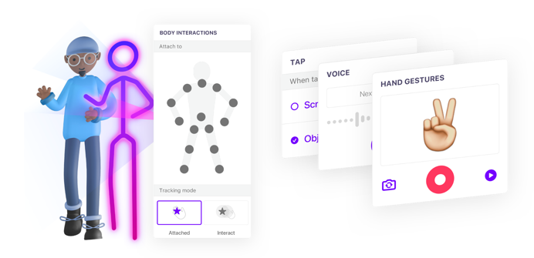

*Figure 3. Natural input supported by Present AR*

*Immersive Experience:* Present AR provides an immersive experience by enabling users to directly interact, as shown in *Figure 4*, with virtual objects (Radu, 2014). This interactivity promotes a deeper understanding of complex engineering concepts, as students can actively explore and manipulate virtual representations in a 3D space (Santos et al., 2014).

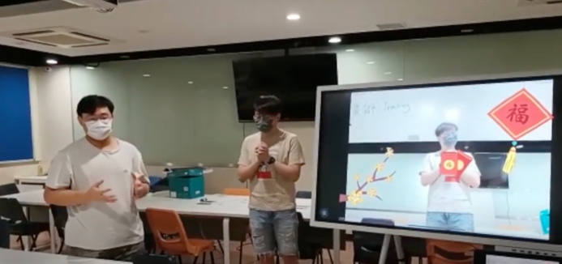

*Figure 4. Direct interaction between speaker and virtual subject in Present AR*

*No Coding Programming Interface:* The application features a user-friendly, no coding programming interface, allowing educators to easily create and customize interactive AR-based presentations without the need for extensive programming knowledge (Bacca et al., 2014). With the drag-and-drop no-coding user interface in *Figure 5*, this feature ensures that a wide range of educators can effectively utilize Present AR in their teaching practices.

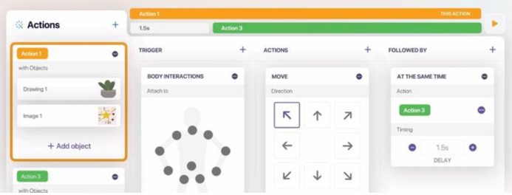

*Figure 5. No-coding programming interface of Present AR*

*Compatibility with Videoconferencing Tools:* Present AR is compatible with popular videoconferencing tools facilitating online learning and remote collaboration(Crompton & Burke, 2018). *Figure 6* demonstrates Present AR working with Microsoft Team in a pitching activity. This feature enables educators and students to engage in interactive and immersive AR-based learning experiences, even when they are physically separated.

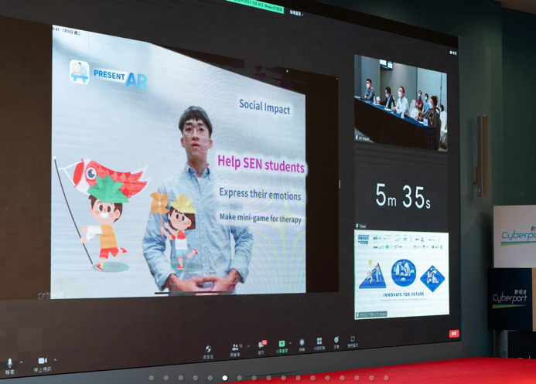

*Figure 6. Present AR team showcasing Present AR with video conferencing Tool.*

**Development Methodology**

The study employed the Scrum framework for the design and development of the mobile application, with a focus on incorporating feedback from educators and students, as well as gaining insights from competitions.

*Scrum Framework for Mobile Application Development*

Scrum is an agile project management framework that emphasizes iterative and incremental development, collaboration, and adaptability (Schwaber & Sutherland, 2017). The Scrum framework was chosen for this project due to its ability to facilitate rapid prototyping and continuous improvement, which is essential when developing innovative educational tools (AltexSoft, 2019).

Presented in *figure 7*, the Scrum process was divided into several sprints, each lasting two weeks. The sprints included planning, designing, development, testing, and review stages. Throughout the process, the Scrum team held daily stand-up meetings to discuss progress and address any challenges. This iterative approach allowed the team to continuously refine the mobile application and incorporate feedback from stakeholders.

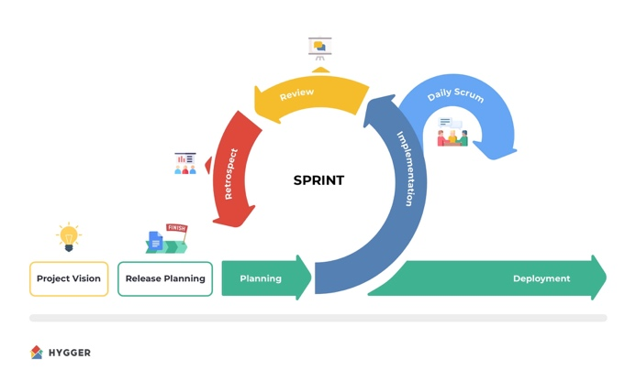

*Figure 7. Development Life Cycle of Scrum Methodology (Amoniac, n.d.)*

*Stakeholder Feedback and Retrospective*

To ensure the AR-based presentation tool met the needs of engineering educators and students, feedback was collected throughout the development process. The primary source of feedback was from software engineering teachers and students at the Department of IT, Hong Kong Institute of Vocational Education (Sha Tin). They were involved in providing feedback during the sprint reviews and were given opportunities to test and evaluate the mobile application.

Alongside this, the team participated in various competitions, presenting the mobile application to mentors and judges, who provided valuable feedback on the effectiveness and usability of the AR-based presentation tool. The insights gained from these competitions helped the team identify areas for improvement and refine the application further.

In both cases, the feedback was incorporated during the sprint retrospective, where the team analysed the comments and suggestions, prioritized them, and integrated them into the following sprint planning(Derby & Larsen, 2006). This continuous feedback loop allowed the team to develop a more effective and user-friendly AR-based presentation tool for engineering education.

This methodology enables the development to gather early feedback with the minimum viable product (figure 8.1) and figure 8.2 presents the improvement of present AR of the App Store version of Present AR.

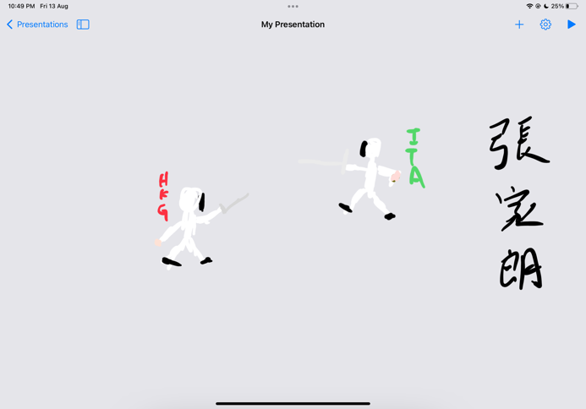

*Figure 8.1. Minimum viable product of Present AR*

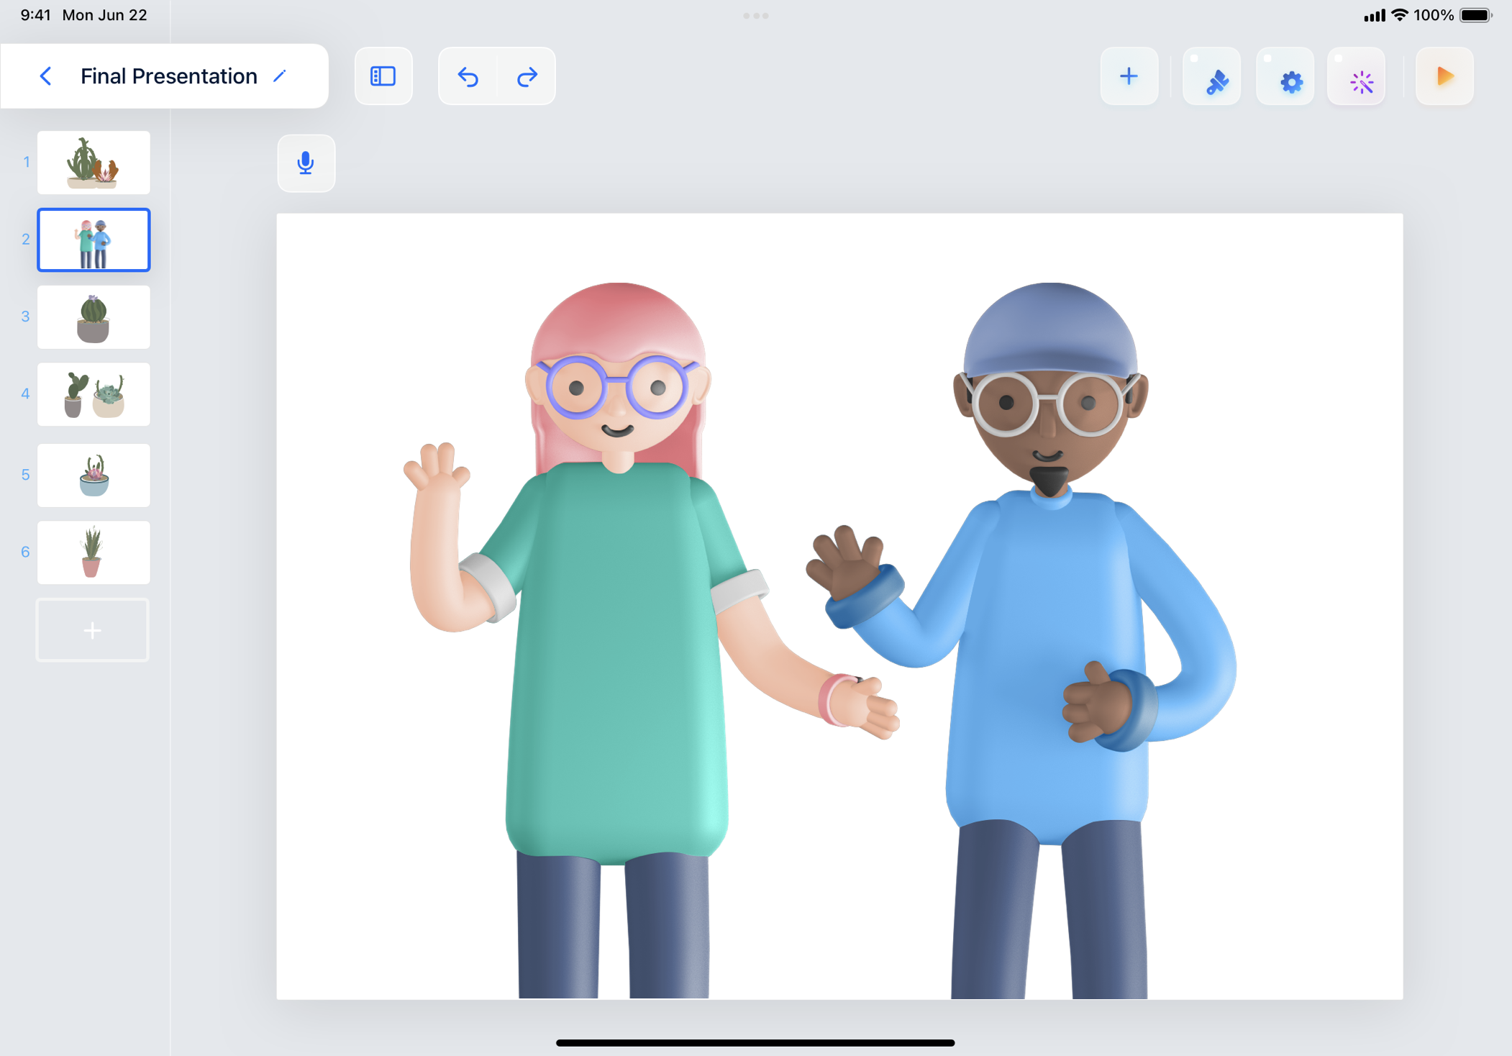

*Figure 8.2. App Store version of Present AR*

The Scrum framework was instrumental in the development of the AI-powered AR presentation tool. The iterative and incremental nature of Scrum allowed the team to quickly adapt to stakeholder feedback and refine the mobile application. By collecting and incorporating feedback from educators, students, and competition mentors and judges, the team ensured that the final product effectively addressed the needs and requirements of the target users.

**Findings at Pilot Study**

To evaluate the effectiveness and usability of Present AR, the company conducted a 3-weeks pilot study involving 50 teachers in the STEM (Science, Technology, Engineering, and Mathematics) area. These educators were invited to use Present AR for their presentations, and their feedback was collected through surveys to gauge their experience with the system. The results of the pilot study are presented in *Figure 9.*

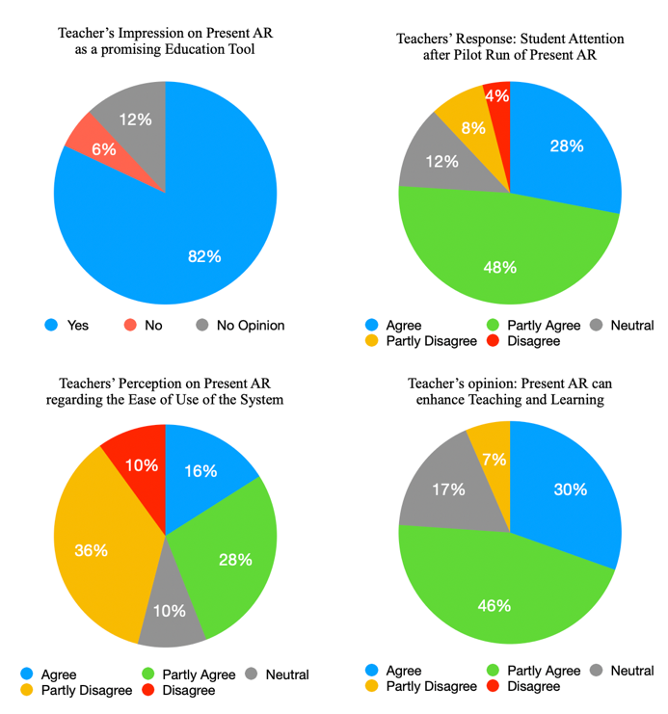

*Figure 9. Survey Results of Present AR Pilot Run*

*Interest in Present AR:* A significant majority of the teachers (82%) found Present AR to be interesting, indicating that the system has captured the attention of educators and is perceived as a promising educational tool.

*Student Attention:* 76% of the teachers observed that presentations using Present AR initially attracted the attention of their students, suggesting that the AR-enhanced presentations have the potential to engage learners more effectively than traditional presentations.

*Ease of Use:* However, 46% of the teachers reported that they found the tool difficult to use. This highlights the need for improved user interfaces and additional training resources to facilitate the adoption of Present AR among educators.

*Teaching and Learning Enhancement:* Finally, a strong majority of the teachers (76%) believed that the use of Present AR could enhance their teaching and learning experience. This positive feedback underscores the potential impact of Present AR on education and demonstrates the value of integrating AR technology into classroom settings.

The results of the pilot study provide valuable insights into the strengths and areas for improvement of Present AR. By addressing the concerns raised by the teachers and capitalizing on the positive aspects of the system, the development team can continue refining Present AR to better cater to the needs of educators and learners, ultimately achieving the goal of revolutionizing the educational landscape.

**Achievements**

Present AR has garnered numerous accolades for its innovation and potential in the educational sector, including a Second-Class Award at the Mobile App Innovation Contest of the Greater China Region, a Gold Awardat the China Greater Bay Area 5G Application Innovation Contest, and the championship title at the Innovate for Future competition. Other achievements include a 1st Runner-up position at the Young Professional Exhibition and Competition, the Hong Kong Techathon 2023 championship, and a Gold Award at the Internet+ China Student Entrepreneurship Competition. The Hong Kong Science and Technology Parks Corporation (HKSTP) has provided seed funding from the Ideation Programming, enabling the transition from an educational project to a commercial venture and the establishment of 417Techn Limited, the company behind Present AR.

Collaborations with educational institutions have further strengthened Present AR's market position. These partnerships enable the team to understand the unique requirements of different educational environments and tailor the system accordingly, ensuring wide applicability and relevance.

Present AR is currently available on the Apple App Store, making it accessible to millions of users worldwide. This milestone showcases the team's dedication to bringing their innovative solution to the masses and signifies the potential impact Present AR can have on the future of education.

The numerous awards and recognitions, along with the successful commercialization of Present AR, serve as a testament to the system's potential to revolutionize the educational landscape. The team behind Present AR has demonstrated that, by adopting innovative technologies and methodologies, barriers can be overcome, and new horizons in education can be explored for the betterment of learners globally.

**Limitation**

Despite its numerous achievements and positive impacts on education, Present AR is not without its limitations. As with any technology, there are areas in which the system can be improved to better cater to the needs of its users. The following are some of the current limitations of Present AR:

*Lack of support for multiple presenters:* Present AR currently does not support multiple presenters within the same AR presentation, which might limit its applicability in certain educational scenarios where team presentations or panel discussions are common. Addressing this limitation by allowing multiple users to interact and present simultaneously could further enhance the collaborative and interactive nature of the learning experience.

*Hardware limitations:* Present AR is designed to work with the built-in camera of iPads, which could restrict its accessibility to users who do not own this specific device. Expanding its compatibility with a wider range of devices, including smartphones and other tablets, could increase its potential user base and make the technology more inclusive. And the app's performance is largely determined by the processing power of the iPad model it runs on. At present, the app runs best on iPad Pro M2, which may not be the most cost-effective option for some users. Optimizing the app for lower-end devices could make it more accessible and ensure a smooth user experience across various iPad models.

*Platform dependency:* Present AR is currently available only for iOS, as the development team has employed some platform-dependent frameworks such as the Vision framework and Apple Pencil framework. This limits the app's reach, as it excludes users of other operating systems like Android. Developing a cross-platform solution or employing platform-independent frameworks could help extend the app's availability to a broader user base.

While these limitations may present challenges, they also offer opportunities for further development and improvement of Present AR. By addressing these issues and continuously refining the system, the team can ensure that Present AR remains at the forefront of educational innovation and continues to provide engaging, interactive, and immersive learning experiences for students.

**Future Developments**

The future exploration of Present AR extends beyond its application in engineering education. One promising direction is to explore its potential in other disciplines such as biology, chemistry, and architecture. By integrating subject-specific content and models, Present AR can provide students with interactive and immersive learning experiences in these fields. This opens up opportunities to enhance understanding and engagement, allowing students to explore complex concepts in a hands-on and visually stimulating manner.

Furthermore, Present AR has the potential to serve as a captivating storytelling tool for primary and secondary school students. By combining augmented reality with narrative elements, Present AR can bring stories to life, creating an interactive and immersive storytelling experience. Students can engage with virtual characters, environments, and objects, fostering imagination, creativity, and language skills. This application of Present AR has the potential to revolutionize traditional storytelling methods and make learning more enjoyable and impactful for young learners. The team conducted exploratory discussion with schools’ management. And a principal of primary presented Present AR at the Senco-Masslink iPad BYOD Leadership Conference 2023 *(Figure 10)*. Present AR initially received positive feedback and the team is planning for further action in this sector.

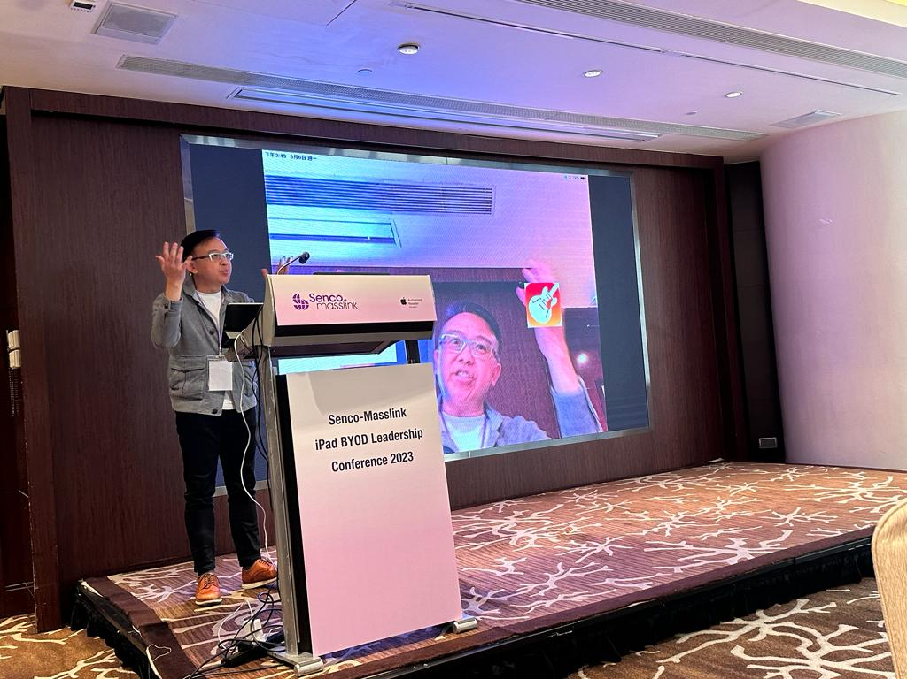

*Figure 10. Primary School Principal demonstrated Present AR at Senco-Masslink iPad BYOD Leadership Conference 2023*

In addition to its educational applications, Present AR holds promise in the commercial realm. One area where Present AR can be utilized is in roadshows and product presentations. By leveraging its augmented reality capabilities, Present AR enables companies to showcase their products in a more interactive and engaging manner. Virtual product models and visualizations can be shared, allowing potential customers to interact with and explore products in real-time, enhancing their understanding and connection with the offerings.

Moreover, Present AR can transform the landscape of meetings and presentations in the corporate world. By providing a dynamic and immersive platform, Present AR can enhance engagement and productivity in business meetings. Virtual participants can collaborate, share visual content, and interact with 3D models, making meetings more interactive and impactful. This opens up possibilities for enhanced communication, idea generation, and decision-making processes.

**Conclusions**

In conclusion, this paper has presented the development story of Present AR, an AI-powered presentation tool for education that utilizes Augmented Reality (AR) technology to enhance the learning experience. The COVID-19 pandemic has underscored the importance of innovative and engaging educational methods, as traditional face-to-face learning shifted to remote and online environments. Present AR was developed in response to the observed limitations of conventional online lectures and aimed to provide a more interactive and immersive learning experience.

The Scrum framework was adopted to develop Present AR, enabling rapid prototyping and continuous improvement. Throughout the development process, the team actively sought feedback from educators, students, and industry experts, incorporating their insights into the design and functionality of the system. This iterative approach, combined with the innovative features of Present AR, has resulted in a tool that effectively addresses the challenges faced by educators and students in the current educational landscape.

Present AR has received significant recognition for its innovative approach to enhancing engineering education, with positive feedback from various stakeholders and awards in competitions. The success of the system has led to the commercialization of the product and the founding of a start-up company, further emphasizing the potential impact of Present AR on the future of education.

Moving forward, the team will continue to refine Present AR and explore additional applications of AR and AI technologies in education. The ultimate goal is to revolutionize the way we learn and create more engaging, personalized, and effective learning experiences for students around the world. By combining cutting-edge technologies with a deep understanding of educational needs, Present AR serves as a promising example of how innovation can transform the way we teach and learn in the 21st century.

**References**

Aristovnik, A., Keržič, D., Ravšelj, D., Tomaževič, N., & Umek, L. (2020). Impacts of the COVID-19 pandemic on life of Higher Education Students: A global perspective. *Sustainability*, *12*(20), 8438. https://doi.org/10.3390/su12208438

AltexSoft. (2019, September 18). *Agile Project Management: Best practices and methodologies*. AltexSoft. https://www.altexsoft.com/whitepapers/agile-project-management-best-practices-and-methodologies/

Azuma, R. T. (1997). A survey of Augmented Reality. *Presence: Teleoperators and Virtual Environments*, *6*(4), 355–385. https://doi.org/10.1162/pres.1997.6.4.355

Bacca, J., Baldiris, S., Fabregat, R., Graf, S., & Kinshuk. (2014). Augmented Reality Trends in Education: A Systematic Review of Research and Applications. Journal of Educational Technology & Society, 17(4), 133-149.

Billinghurst, M., & Duenser, A. (2012). Augmented reality in the classroom. *Computer*, *45*(7), 56–63. https://doi.org/10.1109/mc.2012.111

Crompton, H., & Burke, D. (2018). The use of mobile learning in Higher Education: A systematic review. *Computers & Education*, *123*, 53–64. https://doi.org/10.1016/j.compedu.2018.04.007

Dunleavy, M. (2013). Design principles for augmented reality learning. *TechTrends*, *58*(1), 28–34. https://doi.org/10.1007/s11528-013-0717-2

Dünser, A., Grasset, R., & Billinghurst, M. (2008). A survey of evaluation techniques used in Augmented Reality Studies. *ACM SIGGRAPH ASIA 2008 Courses on - SIGGRAPH Asia ’08*. https://doi.org/10.1145/1508044.1508049

Derby, E., & Larsen, D. (2012). *Agile retrospectives making good teams great*. The Pragmatic Bookshelf.

Hwang, G.-J., & Tsai, C.-C. (2011). Research trends in Mobile and ubiquitous learning: A review of publications in selected journals from 2001 to 2010. *British Journal of Educational Technology*, *42*(4). https://doi.org/10.1111/j.1467-8535.2011.01183.x

Johnson, N., Veletsianos, G., & Seaman, J. (2020). U.S. faculty and administrators’ experiences and approaches in the early weeks of the  COVID-19 pandemic. *Online Learning*, *24*(2). https://doi.org/10.24059/olj.v24i2.2285

Kaufmann, H., & Schmalstieg, D. (2002). Mathematics and geometry education with collaborative augmented reality. *ACM SIGGRAPH 2002 Conference Abstracts and Applications*. https://doi.org/10.1145/1242073.1242086

Liao, J., Karim, A., Jadon, S. S., Kazi, R. H., & Suzuki, R. (2022). RealityTalk: Real-time speech-driven augmented presentation for AR Live Storytelling. *Proceedings of the 35th Annual ACM Symposium on User Interface Software and Technology*. https://doi.org/10.1145/3526113.3545702

Mora, C. E., Martín-Gutiérrez, J., Añorbe-Díaz, B., & González-Marrero, A. (2017). Virtual Technologies Trends in education. *EURASIA Journal of Mathematics, Science and Technology Education*, *13*(2). https://doi.org/10.12973/eurasia.2017.00626a

Passey, D., Brinda, T., Cornu, B., Holvikivi, J., Lewin, C., Magenheim, J., Morel, R., Osorio, J., Tatnall, A., Thompson, B., & Webb, M. (2021). Computers and education – recognising opportunities and managing challenges. IFIP Advances in Information and Communication Technology, 129–152. https://doi.org/10.1007/978-3-030-81701-5_5

Pogodaev, A., Muzyleva, I., Yazykova, L., & Kondratyev, S. (2020). The use of Augmented Reality Technologies in Electrical Engineering. *2020 2nd International Conference on Control Systems, Mathematical Modeling, Automation and Energy Efficiency (SUMMA)*. https://doi.org/10.1109/summa50634.2020.9280643

Radu, I. (2014). Augmented reality in education: A meta-review and cross-media analysis. *Personal and Ubiquitous Computing*, *18*(6), 1533–1543. https://doi.org/10.1007/s00779-013-0747-y

Santos, M. E., Chen, A., Taketomi, T., Yamamoto, G., Miyazaki, J., & Kato, H. (2014). Augmented reality learning experiences: Survey of prototype design and evaluation. *IEEE Transactions on Learning Technologies*, *7*(1), 38–56. https://doi.org/10.1109/tlt.2013.37

Saquib, N., Kazi, R. H., Wei, L.-Y., & Li, W. (2019). Interactive body-driven graphics for augmented video performance. *Proceedings of the 2019 CHI Conference on Human Factors in Computing Systems*. https://doi.org/10.1145/3290605.3300852

Schwaber, K., & Sutherland, J. (2017). The scrum guide. https://scrumguides.org/docs/scrumguide/v2017/2017-Scrum-Guide-US.pdf

Wojciechowski, R., & Cellary, W. (2013). Evaluation of learners’ attitude toward learning in Aries Augmented Reality Environments. *Computers & Education*, *68*, 570–585. https://doi.org/10.1016/j.compedu.2013.02.014

Wu, H.-K., Lee, S. W.-Y., Chang, H.-Y., & Liang, J.-C. (2013). Current status, opportunities and challenges of augmented reality in Education. *Computers & Education*, *62*, 41–49. https://doi.org/10.1016/j.compedu.2012.10.024