**A SELF-LEARNING SUPPORT SYSTEM BASED ON AN EYE-TRACKING ANALYSIS OF A DUAL TASK IN ENGLISH: PILOT STUDY (2)**

**SUPPORTING A STUDENT WITH DYSLEXIA**

Okuzaki Mariko *a and Moriya Kenji b

a NIT Hakodate College, General Department, Hakodate, Japan

b NIT Hakodate College, Department of Production System Engineering, Hakodate, Japan

*okuzaki@hakodate-ct.ac.jp

**Abstract**

**This is the second pilot study to create a self-learning support system based on an eye-tracking analysis of a dual task in English as a foreign language. In the previous study, four students were recruited as subjects with their agreement to use their experimental data for this research. Two subjects had scored above 500 on the TOEIC🄬test and the other two less than 300. Each subject participated in the experiment by solving the same question of TOEIC Listening Part 3 on a computer screen, and their eye-movements were recorded. Then, visualizing their eye-movements while listening to and reading English at the same time on the TOEIC🄬test, the students with lower TOEIC scores observed the patterns of their own irregular eye movements that seemed to indicate confusion, such as wandering or staying put while listening to and reading the text. Through the observation, they recognized the incomprehensible words or phrases that inhibit comprehension. In this second pilot study, one student with dyslexia was recruited as a subject who had a low TOEIC🄬test score after consenting to his data being used for research. The purpose of this pilot study was to examine the subject’s eye-movement data and determine the self-learning aspects by helping him trace his eye movements, examining his confusion, and enhancing his meta-cognition through the comparison of his data with a subject who had scored above 500 on the TOEIC🄬test. The subject participated in the experiment twice, once by solving the questions of the TOEIC Listening Part 3 and then, by doing "*kikiyomi*", which is known as listening while reading a text, on a computer screen on a different day. His eye-movements were recorded at both times. Then, visualizing the student’s eye movements, he observed the patterns of his own irregular eye movements that seem to indicate confusion, such as wandering and going backward while doing "*kikiyomi*" the text. Through the observation, he recognized his attitude that inhibits English listening comprehension.**

**Keywords:** *eye-tracking, kikiyomi, visualization, fixation, saccade*

**Introduction**

This is a pilot study of a self-learning support system based on an eye-tracking analysis of a dual task in English. The final aim of this research is to help students overcome any difficulty in not only solving TOEIC listening questions but also explaining their confusion with words. By visualizing an individual student’s eye movements while listening to and reading English at the same time on the TOEIC🄬test, students can observe the patterns of their own irregular eye movements that seem to indicate confusion, such as wandering, or staying put while listening and reading the text. Through this observation, they should recognize the incomprehensible words or phrases that inhibit comprehension. The eye-tracking analysis also raises the teacher’s awareness of the specific elements that prevent students’ comprehension during the dual task. Through the student-teacher interaction focusing on eye-tracking during the dual task as well as reading aloud practice, each student is encouraged to develop strategies for a better comprehension, so that they can continue to improve their learning attitude autonomously. Through conducting this meta-cognitive learning experiment and examining its validity, this research leads to establishing a unique self-learning support system fostering students’ autonomous learning attitude.

As a background of this research, NIT, Hakodate College started teaching its mandatory TOEIC e-learning course to all fourth-year Japanese students in 2018 (Okuzaki, Hirano, and Maruyama, 2020). All fourth-year Japanese students must acquire 330 or above in the first quarter and 350 or above in the second quarter of their fourth-year by taking a computer-based mock TOEIC examination to obtain the credits required for graduation.

In pilot study (1) (Okuzaki and Moriya, 2023), which entailed visualizing their eye movements while listening to and reading English on the TOEIC🄬test, the students with lower TOEIC scores observed the patterns of their own irregular eye movements that seemed to indicate confusion, such as wandering or staying put while listening and reading the text. Through this observation, they recognized the incomprehensible words or phrases that inhibit comprehension.

In this pilot study (2), one student with dyslexia was recruited as a subject with a low TOEIC🄬test score after consenting to their data being used for research. According to International Dyslexia Association, dyslexia is a specific learning disability that is neurobiological in origin, and it is characterized by difficulties with accurate and/or fluent word recognition and by poor spelling and decoding abilities. These difficulties typically result from a deficit in the phonological component of language that is often unexpected in relation to other cognitive abilities and the provision of effective classroom instruction. Secondary consequences may include problems in reading comprehension and reduced reading experience that can impede the formation of vocabulary and background knowledge ([https://dyslexiaida.org/definition-consensus -project/](https://dyslexiaida.org/definition-consensus%20-project/)). The student had been reasonably accommodated since his first year in NIT, Hakodate College, and cooperated with this research to understand his disability.

The subject participated in this experiment based on his personal schedule. Before the experiment, he was briefed about the experiment by the teacher, and after obtaining his consensus, the experiment was conducted.

**Purpose**

This pilot study aimed to examine the subject’s eye- movement data and determine the self-learning aspects by helping him trace his eye movements, examining his confusion, and enhancing his meta-cognition through the comparison of his data with those of a subject who had scored above 500 on the TOEIC🄬test.

**The Environment and Procedure of the Experiment**

The experiment was conducted with Tobii Pro Nano produced by Tobii. under the same conditions as the pilot study (1). Tobii Pro Nano (Figure 1) is a screen-based eye tracker that captures gaze data at 60 Hz and is designed for fixation-based studies. This easy-to-use, robust research system is an ideal entry point for those considering beginning eye-tracking research or those wishing to take their eye-tracking research out of the lab environment (<https://www.tobii.com/ja/products/>eye-trackers/screen-based/tobii-pro-nano). This tool was used mounting on a Toshiba Dynabook equipped with Intel Core i7 (Figure 2). The experimental device was set on a table in front of Okuzaki’s laboratory screened off from a corridor (Figure 3). Each experiment was recorded using two video cameras with different angles.

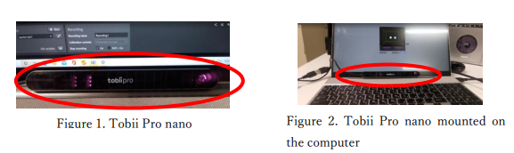

Figure 1. Tobii Pro Nano

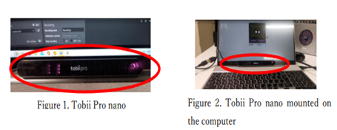

Figure 2. Tobii Pro Nano mounted on the computer

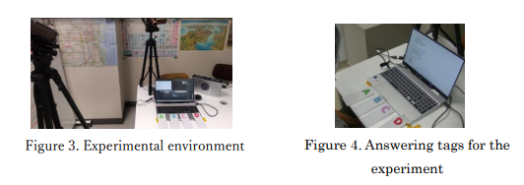

Figure 3. Experimental environment



Figure 4. Answering tags for the experiment

Once the teacher said “HAI,” a subject pushed the computer's enter key to switch the scene on the screen. By observing the statements and choices on the screen, the teacher played a CD for a listening question. In this experiment, the questions examined were obtained from the Listening Part 3 from 68 to 70 in the new official workbook of TOEIC🄬test (2005). In the TOEIC🄬test, one answer should be chosen from four choices and then marked on an answer sheet. However, in this experiment, a subject was required to pick up a card from A, B, C, and D in front of the computer (Figure 4) and show it to the camera while listening to the question statement, four choices, and then a pause before the next question statement.

The location and angle of the computer screen, as well as the subject's chair, were controlled to conduct the experiment with all the subjects under the same condition. Figure 5 shows how the subject's eyes were detected by Tobii Pro Nano. The center of the computer screen illustrates how Tobii Nano Pro reflects the subject's eye sight on the screen. The two white dots represent the subject's eyes, and as long as they stay inside the inner square marked by the yellow lines, the experimental data are valid. Each subject was required to maintain their eye positioning and sitting posture before the experiment started.

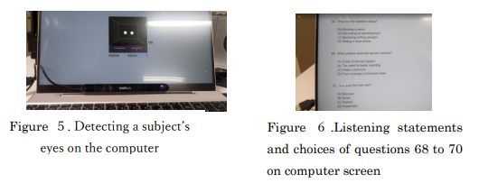

Figure 5. Detecting a subject's eyes on the computer

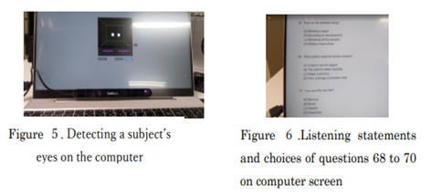

Figure 6. Listening statements and choices of questions 68 to 70 on computer screen

**Experimental Process**

In this study, two experiments dealing with a dual task in English were conducted with the subject. The first experiment was the same as the one held in the pilot study (1): answering questions 68 to 70 of TOEIC🄬test Listening Part 3 for about 100 seconds. Question statements and choices were displayed on the computer screen (Figure 6).

The recording of the listening questions was edited by the researcher, and the subject started listening to the explanation of Part 3 before the actual conversation and question statements. The following is the transcript of the actual listening CD used for this experiment. Each squared number indicates how much time has passed in blocks of 10 seconds.

*You will hear some conversations between two people. You will be asked to answer three questions about what the speakers say in each conversation10. Select the best response to each question and mark the letter A, B, C, or D on your answer sheet20. Conversations are spoken only one time and will not be printed in your test book.*

*Questions30 68 to 70 refer to the following conversation.*

*(Woman) Have you finished putting together that advertisement yet? We really need to run it40 in the next couple of days.*

*(Man) I’ve just got a couple of questions for you about it. I listed two job openings for reporters. Is there anything else?*

*(Woman) We50 need to advertise for another assistant, too ―for clerical support. We haven’t had enough help lately.*

*(Man) And the reporters need to send us writing samples, right?60 You know, given the current job market, I’m very optimistic about who we’ll get.*

*No.68 What are the speakers70 doing?*

*(pause)*

*No.6980 What problem does the woman mention?*

*(pause)90*

*No.70 How does the man feel?*

*(pause)100*

*Go on to the next page.*

The second experiment was to examine how the subject reads a text on the screen following the English to which he listens. According to Gerbier, Bailly, and Bosse (2018), this action is described as reading while listening to texts (RWL), which is a promising way to improve the learning benefits provided by a reading experience. Kadota and Noro (2010) describe this action as "*kikiyomi*" in Japanese. The experiment was thus conducted using the text and the model English recording that the subject had learned in the second fiscal year of NIT, Hakodate College. Figure 7 shows the actual display used in this experiment.



Figure 7. The text for "*kikiyomi*" on a computer display

**The subjects' TOEIC®test data**

This study's subject is indicated as Subject ①to compare the data with Subject ②, who participated in the the same experiment in the previous study (Okuzaki and Moriya, 2023). Table 1 shows each subject's total TOEIC🄬test scores. At the time of the experiment, Subject ① was a third-year student and Subject ②was a fourth-year student of NIT, Hakodate College.

Table 1. Subjects' TOEIC®test data

|  |  |  |  |  |
| --- | --- | --- | --- | --- |
| Subject | Experi-mental date | TOEIC total  score | Listening score/ Reading score | TOEIC test date |
| ① | 12.13.2022 | 170 | 85/85 | 09.30.  2020. |
| ② | 12.21.2021 | 510 | 295/215 | 04.10.  2021. |

**Results of and Considerations on the First Experiment**

Figure 8 shows the comparison of each subject’s heat map. The data were acquired for 80 seconds while the subjects were taking the TOEIC listening test.

The heat map visualizes how much attention a subject pays to the screen while answering the listening test by color temperature (Tobii Pro AB, 2022). The more focused and gazed area is indicated as red and the less focused and gazed one as green. The heat map comparison indicates that Subject ② has more high-color temperature areas than Subject ①. Furthermore, based on the portions of the colored area, Subject ① seemed to pay less and less attention to the middle and lower parts of the screen while Subject ② seemed to pay attention to the upper, middle, and lower parts of it.

|  |  |  |
| --- | --- | --- |
| Subject | ① | ② |
| Heat map |  |  |

Figure 8. Heat maps of two subjects for 80 seconds during the TOEIC listening test

Fugures 9 and 10 show the gazing plots of subject ① and subject ②, respectively of the first 80 seconds during the TOEIC listening test. The gaze plot illustrates how long the gazing time is by the size of a circle (Tobii Pro AB, 2022), and the movement direction and distance are shown by the line between each circle (Tobii Pro AB, 2022). Each gazing plot has a number to indicate the plot's order in the total gazing actions. The last gazing plot number is recognized as the total gazing number.

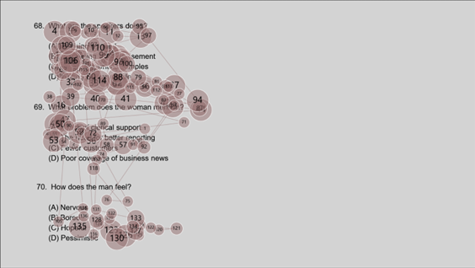

Figure 9. The enlarged view of Subject ①'s gazing plot

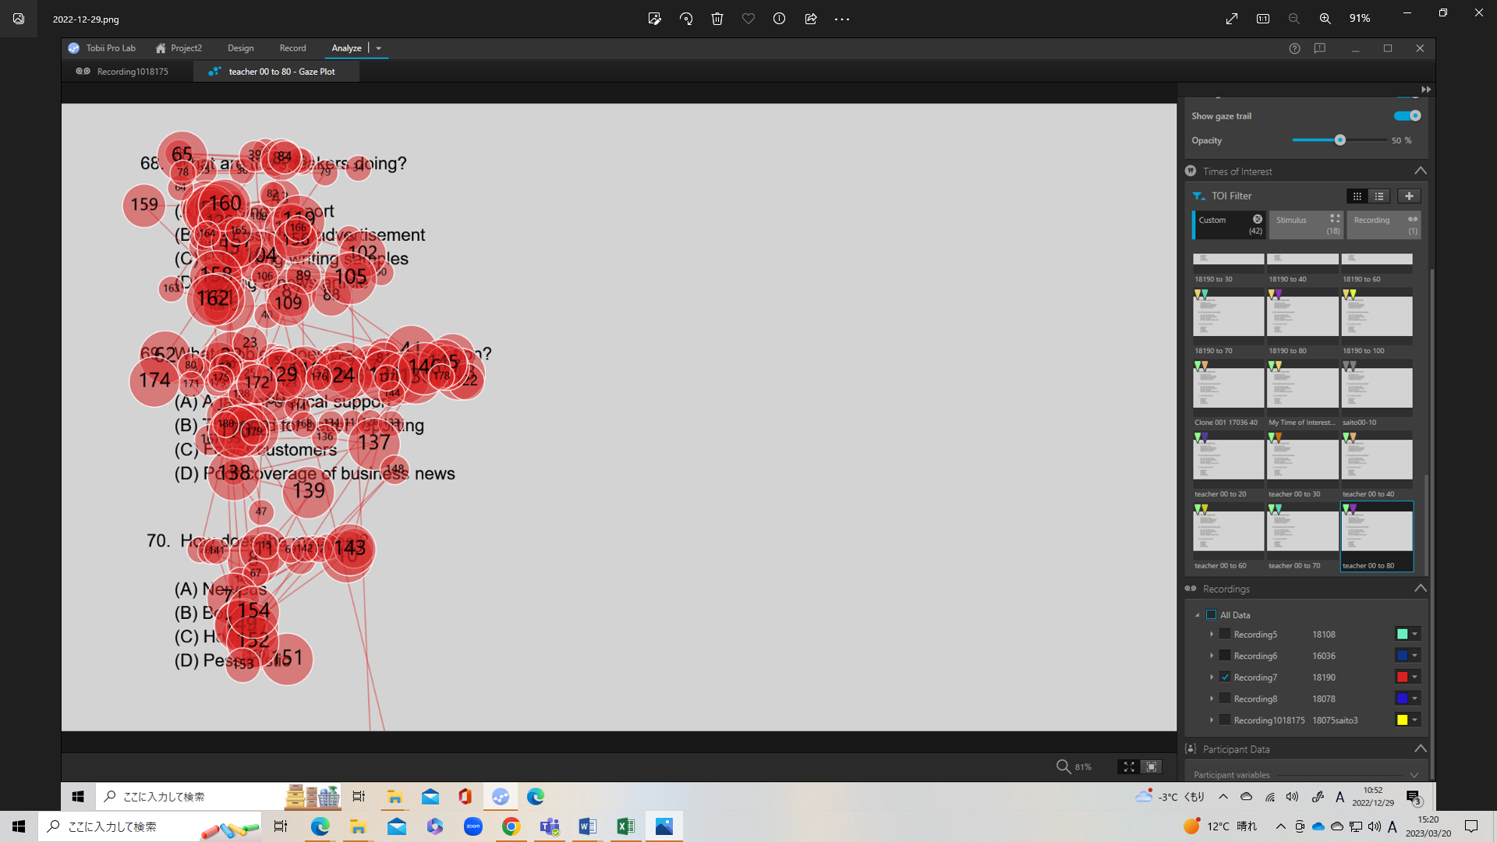

Figure 10. The enlarged view of Subject ②'s gazing plot

Underwood and Batt (1996) state that when reading English, a reader fixes their eyes from left to right repeating a small saccade, and at the right edge, their eye conducts a return sweep. However, when reading a difficult paragraph, some readers return their eyes to the place they once read, which is explained as a regression phenomenon. By checking the number on each gazing plot in Figure 9, it is considered that more regressions occurred when Subject ① was reading the text of the TOEIC listening test on the screen than when Subject ② was doing the same shown in Figure 10.

Figure 9 shows that the total gaze plots of Subject① are 135 (explicated by the blue arrow on Figure 9). By observing the gazing plots in Figure 9, it is clear that the subject's eyes were moving roughly and repeatedly up and down in a wide range with longer saccades and skipping questions 69 and 70. Therefore, it is assumed that Subject ① might have guessed the answers of 69 and 70 without activating written and aural information.

On the other hand, the total gazing plot number of Subject ② are 180 (explicated by the arrow in Figure 10), which means that Subject ② gazed to the screen 45 times more than Subject ①. The plots of Subject ② are rather connected with shorter saccades, which means the eyes are moving faster from left to right with a shorter fixation time. Furthermore, the gaze plots are more focused on written information with less gaps. It is assumed that Subject ② guessed the answers depending on written information.

**Results of and Considerations on the Second Experiment**

The second "*kikiyomi*" experiment was conducted to be done just once 1 week after the first experiment only with Subject ①. Figure 11 shows the gazing plots of the second experiment the first time.

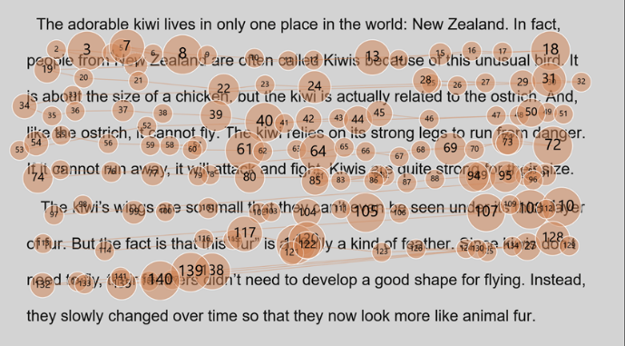

Figure 11. First gazing plots of Subject ① during "*kikiyomi*" experiment

At the second last line of the paragraph, the regression occurred, and Subject ① could not follow the text along with its narration. Then, Subject ① requested the second trial of the same "*kikiyomi*" experiment. Figure 12 shows the gazing plots of the second experiment the second time.

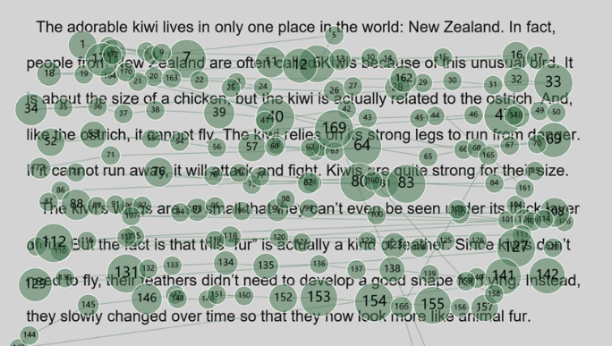

Figure 12. Second gazing plots of Subject ① at "*kikiyomi*" experiment

At the end of the first "*kikiyomi*" experiment, the examiner asked Subject ① for feedback of on it, and Subject ① answered that he had found himself lost in the second last line of the paragraph. He could not verbalize the reason immediately; however, he seemed to have confused *feathers* in the line as *feather* in the third last line and had regressed from the second last line to the upper line to look for the word *feather* while listening to the narration. In the second "*kikiyomi*" experiment, he had not fixated on *feathers* and had finished reading at the speed of the narration. After these experiments, Subject ① was able to read the whole text and pronounce *feather* with the correct Japanese meaning.

**Student's self-awareness focusing on eye-movements in the experiments**

Four weeks (including winter vacation) after the two experiments, Subject ① reviewed the experimental data regarding his eye-movements in the dual task in English with the examiner and admitted that they show three features: (1) bias of gazing location, (2) answers given without written information, and (3) regressions occurring during listening comprehension. Consequently, Subject ① proclaimed that when he performs a dual task in English, he patiently keeps moving the eyes from left to right toward the bottom even though he gets confused. He realized that when he is lost in the meaning and does regressoins on the text, he misses new information to be acquired through listening comprehension.

One month later, he scored 350 (Listening score: 255; Reading score: 95) on the TOEIC mock test and obtained the credit of Practical English1A required for graduation from NIT, Hakodate College.

**Coclusion**

The subject participated in the experiment twice, once by solving the questions of TOEIC Listening Part 3 and next, by doing "*kikiyomi*" on a computer screen on a different day. His eye-movements were recorded both times. Then, visualizing his eye-movements, he observed the patterns of his own irregular eye-movements that seemed to indicate confusion, such as wandering and going backward while listening to and reading the text. By observing his eye-movements, he recognized his attitude that inhibits English listening comprehension, and consequently, he achieved the minimum total score on the TOEIC mock test required for graduation from NIT, Hakodate College.

According to Koike et al. (2008), listening skills do not only play the most fundamental role by allowing a listener to comprehend and correctly respond to what a speaker says, but they also help the listener acquire, control, and improve speaking, writing, and reading skills. They also claim that listening skills are highly transferred to other skills in English learning. If this experimental support worked to improve Subject ①’s listening skill, the reading score would have increased as well; however, it did not. Therefore, it cannot be argued that this experimental support directly worked to improve the subject’s listening and reading skills for the TOEIC🄬test.

**Next Steps**

According to Kadota (2012), a student who studies English as a second language must make a phonological code by reading written input, similar to a phonological code formed by listening to vocal input. Then, he suggests that shadowing and reading aloud practice is effective as training for forming phonological codes autonomously. On the other hand, O'ki and Izumi (2015) suggest that accelerated speech dictation is more learner-friendly than shadowing. The study's next step is to find out a better self-training practice combining shadowning and reading aloud practice with accelerated speech dictation through examining how subjects eye-movements change after training.

The final goal of this research is to establish a unique self-learning support system fostering students’ autonomous learning attitude through conducting this meta-cognitive learning experiment and examining its validity. According to Strohmaier, MacKay, Obersteiner, and Reiss (2020), in mathematics education research, eye tracking seemed particularly beneficial for studying processes rather than outcomes, for revealing mental representations, and for assessing subconscious aspects of mathematical thinking. Focusing on eye-tracking analysis of dual tasks on TOEIC🄬test, it is expected to develop self-learning strategies for students to acquire a better comprehension skills, so that they can continue to improve their learning attitude autonomously.

**Acknowledgements**

This pilot study was conducted with the help of JSPS (Grant number 20K00796). We are grateful for the cooperation of the student who participated in this experiment after understanding the purpose of this research.

**Additional Statement**

We publish this research with the approval of the student’s parent. This research has also been approved as making adequate provisions for the safety and privacy of subjects by the Life Ethics Committee of Hakodate National College of Technology.

**References**

Educational Testing Service (2005). *TOEIC🄬test new official workbook*, The Institute for International Business Communication TOEIC Operating Committee．

Gerbier, E., Bailly, G., and Bosse, M.L. (2018). Audio-visual synchronization in reading while listening to texts: Effects on visual behaviour and verbal learning, *Computer Speech & Language*, 47, 74-92.

International Dyslexia Association. (n.d.). Definition Consensus Project. Retrieved from <https://dyslexiaida.org/definition-consensus-project/>

Kadota, S. (2012). *Shadowing, Reading Aloud and Science of Language Acquisition*, Cosmopia Co. Ltd.

Kadota, S. and Noro, T. Eds. (2010). *How the Mind Works in EFL Reading*, Kuroshio Publishing Co. Ltd.

Koike, A., Terauchi, M., Kinoshita, K. and Narita, M. Eds. (2008), *Current Research of English as a Second Language Acquisition*, Taishukan.

O’ki, T. and Izumi, Y. (2015). Shadowing vs. Accelerated Speech Dictation: Which improves Learner’s Decoding Skill? *Hakuoh Journal of the Faculty of Education,* 9(1), 227-243.

Okuzaki, M., Hirano, T., and Maruyama, H. (2020). Classroom Study of 4SM Kosen Students, NIT, Hakodate College for TOEIC E-Learning in 2018, *The Council of College English Teachers*, Vol. 39, 1-8.

Okuzaki, M., and Moriya, K. (2023). A Self-Learning Support System Based on an Eye-Tracking Analysis of a Dual Task in English: Pilot Study (1), *The Council of College English Teachers*, Vol. 42, 81-90.

Strohmaier, A. R., MacKay, K.J., Obersteiner, A., and Reiss, K.M. (2020). Eye-tracking methodology in mathematics education research: A systematic literature review, *Educational Studies in Mathematics,* 104, 147-200. https://doi.org/10.1007/s10649-020-09948-1

Tobii Pro Lab User Manual, vol.2 (2021).

Retrieved November 25, 2021, from: https://www.tobiipro.com/siteassets/tobii-pro/user-manuals/tobii-pro-nano-user-manual.pdf/?v=1.0.5

Tobii Pro AB (2022). Tobii Pro Lab User's Manual (Version 2.3). Tobii Pro, Danderyd, Sweden.

Tobii Pro AB (2023). Products. Retrieved May 7, 2023 from <https://www.tobii.com/ja/products/eye-trackers/screen-based/tobii-pro-nano>

Underwood, G., and J. Batt. (1996). *Reading and Understanding*. Blackwell Publishers.